2025-2026 EĞİTİM ÖĞRETİM YILI
…………………………………………………………………LİSESİ
10th GRADE ENGLISH BEP EXAM
2nd Semester - 1st Exam by ingilizcepedia
Adı Soyadı: ________________________________ | Sınıf: ______ No: ______

S1. Boşlukları kutudaki doğru kelimelerle doldurun. (5x5=25 puan)
have / has / ever / never / just

1. ________ you ever visited Antalya? ________________
2. Yes, I ________ . I visited Antalya last summer. ________________
3. My sister has ________ been to London. She wants to go. ________________
4. ________ you ever tried Turkish coffee? — No, I haven’t. ________________
5. I have ________ finished my homework. I can play now. ________________

S2. Metni okuyun ve Doğru (D) veya Yanlış (Y) yazın. (5x5=25 puan)

A Trip to İstanbul
My name is Elif. I have visited İstanbul three times. Last month, I booked a hotel room. I said: “I’d like to book a double room, please.” I asked for directions to the museum: “How can I go to the museum?” A man said: “Go straight and turn left.” I have never been to London, but I want to go next year. I have just finished planning my next trip!

1 | Elif has visited İstanbul three times. | ( )
2 | She booked a single room at the hotel. | ( )
3 | She asked for directions to the museum. | ( )
4 | Elif has been to London before. | ( )
5 | She has just finished planning her next trip. | ( )

S3. Tabelaları doğru kurallarla eşleştirin. Kutulara harfi yazın. (5x5=25 puan)

a) You must wear a seatbelt.
b) You mustn’t use your phone.
c) You mustn’t swim here.
d) You should go to the hospital.
e) You mustn’t drive faster than 50.

1  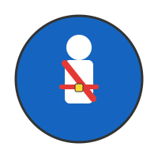  ( ) | 2  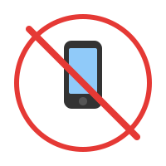  ( ) | 3    ( )
4    ( ) | 5  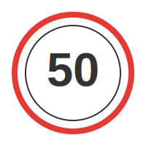  ( )

S4. Doğru cevabı seçin. A, B veya C’yi daire içine alın. (5x5=25 puan)

1. You look sick. You ________ see a doctor. A) must B) should C) mustn’t
2. “________ you please give me a hand?” A) Should B) Must C) Could
3. ________ you ever been to Paris? A) Have B) Has C) Do
4. If you don’t study, you ________ fail the exam. A) won’t B) will C) must
5. You ________ use your phone in class. It’s not allowed. A) should B) must C) mustn’t

Mahir BARUT ………………………
İngilizce Öğretmeni Okul Müdürü

