**1- Try to draw the shortest route from Van to İzmir on the map by visiting the destinations given below in a mixed order (15p ) There may be more correct answers than one. E10.5.R1. Students will be able to make use of written instructions in order to draw a route.**

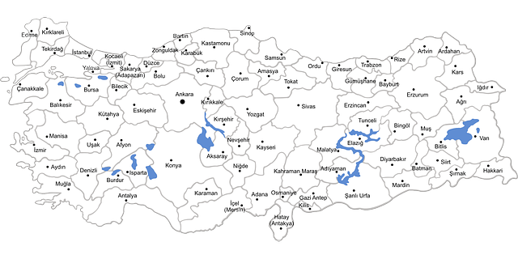

Topkapi Palace - Ephesus – Pamukkale - Sumela Monastery – Cappadocia - Palandöken - Lake Van - Atatürk’s Mausoleum

**2- Imagine you recently spent a holiday in one of the destinations given above in first question. Write an email to your friend describing your holiday experiences. Include the following details: (5x4=20) E10.5.W1. Students will be able to write an e- mail to a friend about their holiday experiences.**

1- Where you went and how you got there. (5p)

2- One or two landmarks or attractions you visited (5p)

3- What you enjoyed most and why. (5p)

4- One challenge or funny moment you faced during the trip. (5p)

To

SubJect

Students’ own answers





**3 Answer the questions by writing about what may happen if you don’t obey the rules according to the paragraph. (5x5=25p)** E10.6.R1. Students will be able to identify the advice, rules and regulations in a text.

In many places, there are rules that we must follow for everyone's safety and comfort. At school, we must listen to the teacher and do our homework. If we don't, we can not learn what we need and may get bad grades. In traffic, drivers must follow the traffic lights and signs. If a driver doesn’t stop at a red light, it can cause accidents. In the library, we must be quiet. Noise disturbs others who are trying to read or study. At a sports match, fans must respect the players and other fans. If they don’t, it can cause fights and spoil the fun for all. Finally, at work, we must complete our tasks and respect our coworkers. If we don't, we can not do our job well. So we may even lose our job. Following rules in all these places helps everything go smoothly and keeps everyone safe and happy.

***

1.What happens if the students don't listen to the teacher?

We can’t learn and may get bad grades

2.What can happen if drivers don’t stop at red lights?

It can cause accidents

3.What happens if you make noise in the library?

We disturb the others in the library.

4.What can happen at a sports match if fans don't respect each other?

It can cause fights and spoin the fun for all

5.What may happen if you don’t complete your tasks at work?

We can lose our jobs

**4- Write an advice letter for Tom’s problem (5x4=20)** E10.6.W2. Students will be able to write an advice letter about youth problems

Dear Tom, (**Example of a possible answer)**

I understand you. Here's a bit of advice that might help you. First, try to prepare everything you need for school the night before. Second, you could aim to catch an earlier bus. Lastly, make sure you're going to bed early enough to get the rest you need. Give these tips a try, and I'm sure you'll see improvement.

Best wishes,

Debbie

Dear Debbie,

I have a problem with being late to school often. My house is far, and I have to take the bus, which sometimes comes late. I try to wake up early, but I'm not a morning person, and it's hard for me. My teacher gets upset when I arrive late, and I feel bad about it. I need to fix this but still get enough sleep. Can you give me some advice on what to do?

Tom

**5. Answer the questions about the paragraph below. (5x4=20p)** E10.7.R1. Students will be able to evaluate a text to classify various cuisines around the world.

**. (5x4=20p)**

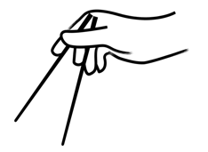

People all over the world eat different kinds of food. In Italy, people enjoy pasta like spaghetti and pizza with cheese and tomatoes. In Mexico, tacos and burritos are very popular; they are made with tortillas and can have meat, beans, or vegetables inside. In China, rice and noodles are in many meals, and they use chopsticks to eat. In India, curry is a favorite dish and it is often spicy. Japanese food includes sushi, which is rice with fish or vegetables. All these foods are special in their own country and are now loved by people everywhere.

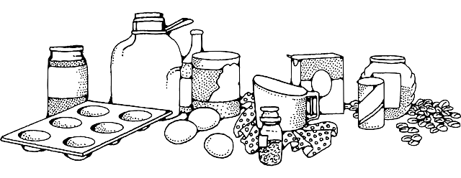

1.What are two popular dishes that people enjoy in Italy?

In Italy, people enjoy pasta like spaghetti and pizza

2.What ingredients can you find inside tacos and burritos in Mexico?

You can find meat, beans, or vegetables.

3.What do people in China use to eat rice and noodles?

They use chopsticks to eat

4.What are two components that are typically included in sushi in Japan?

It includes rice with fish or vegetables

Mahir BARUT ………………………

İngilizce Öğretmeni Okul Müdürü