10th

Name/Surname: …………………………………….….

Circle your class x below Student No:……………..

Writing & Reading Oturumu (%50) 100/ …………

Speaking (%25) 100/……….…

Listening (%25) 100/ …..….…

|  |  |  |  |  |  |  |  |
| --- | --- | --- | --- | --- | --- | --- | --- |
| **A** | B | C | D | E | F | G | H |

**1- Try to draw the shortest route from Van to İzmir on the map by visiting the destinations given below in a mixed order (15p ) There may be more correct answers than one.**

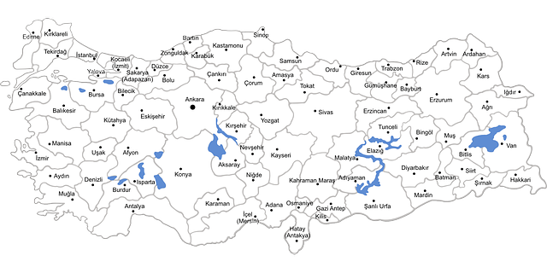

Topkapi Palace - Ephesus – Pamukkale - Sumela Monastery – Cappadocia - Palandöken - Lake Van - Atatürk’s Mausoleum

**2- Imagine you recently spent a holiday in one of the destinations given above in first question. Write an email to your friend describing your holiday experiences. Include the following details: (5x4=20)**

1- Where you went and how you got there. (5p)

2- One or two landmarks or attractions you visited (5p)

3- What you enjoyed most and why. (5p)

4- One challenge or funny moment you faced during the trip. (5p)

To

SubJect





In many places, there are rules that we must follow for everyone's safety and comfort. At school, we must listen to the teacher and do our homework. If we don't, we can not learn what we need and may get bad grades. In traffic, drivers must follow the traffic lights and signs. If a driver doesn’t stop at a red light, it can cause accidents. In the library, we must be quiet. Noise disturbs others who are trying to read or study. At a sports match, fans must respect the players and other fans. If they don’t, it can cause fights and spoil the fun for all. Finally, at work, we must complete our tasks and respect our coworkers. If we don't, we can not do our job well. So we may even lose our job. Following rules in all these places helps everything go smoothly and keeps everyone safe and happy.

***

**3 Answer the questions by writing about what may happen if you don’t obey the rules according to the paragraph. (5x5=25p)**

1.What happens if the students don't listen to the teacher?

……………………………………………………………………………………………………………..

2.What can happen if drivers don’t stop at red lights?

……………………………………………………………………………………………………………..

3.What happens if you make noise in the library?

……………………………………………………………………………………………………………..

4.What can happen at a sports match if fans don't respect each other?

……………………………………………………………………………………………………………..

5.What may happen if you don’t complete your tasks at work?

……………………………………………………………………………………………………………..

**4- Write an advice letter for Tom’s problem (5x4=20)**

Dear Debbie,

I have a problem with being late to school often. My house is far, and I have to take the bus, which sometimes comes late. I try to wake up early, but I'm not a morning person, and it's hard for me. My teacher gets upset when I arrive late, and I feel bad about it. I need to fix this but still get enough sleep. Can you give me some advice on what to do?

Tom

**5- Answer the questions about the paragraph below (5x4=20)**

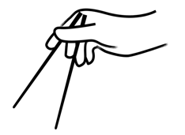

People all over the world eat different kinds of food. In Italy, people enjoy pasta like spaghetti and pizza with cheese and tomatoes. In Mexico, tacos and burritos are very popular; they are made with tortillas and can have meat, beans, or vegetables inside. In China, rice and noodles are in many meals, and they use chopsticks to eat. In India, curry is a favorite dish and it is often spicy. Japanese food includes sushi, which is rice with fish or vegetables. All these foods are special in their own country and are now loved by people everywhere.

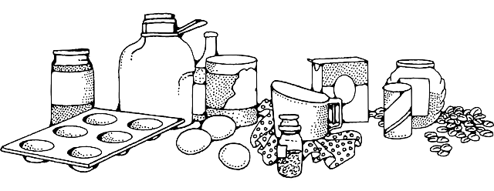

1.What are two popular dishes that people enjoy in Italy?

…………………………………………………………………………………………………………………

2.What ingredients can you find inside tacos and burritos in Mexico?

…………………………………………………………………………………………………………………

3.What do people in China use to eat rice and noodles?

…………………………………………………………………………………………………………………

5.What are two components that are typically included in sushi in Japan?

…………………………………………………………………………………………………………………

Mahir BARUT ………………………

İngilizce Öğretmeni Okul Müdürü