**1- Read the passage "Planning the Perfect Holiday" and fill in the table below by classifying the words or phrases mentioned in the passage under the correct categories. (12x2=24p) E10.5.R2. Students will be able to classify different vacation types in a reading passage.**

People enjoy different types of holidays depending on their interests. Some book a luxury cruise to sail across the ocean and relax on a beautiful ship. Others prefer an adventure holiday, where they can climb mountains or go rafting in wild rivers. Many nature lovers choose ecotourism, staying in forests to learn about wildlife. When planning, some people use a travel agency to book their trip, while others arrange car hire to drive to their destination. Finding the right accommodation, like a hotel or a campsite, is also important. During the holiday, some people sunbathe on the beach to relax, while others go on a sightseeing tour to visit famous landmarks. Many tourists love to go sightseeing in cities like Paris, buy souvenirs to remember their trip, or simply admire the view from a mountain top.

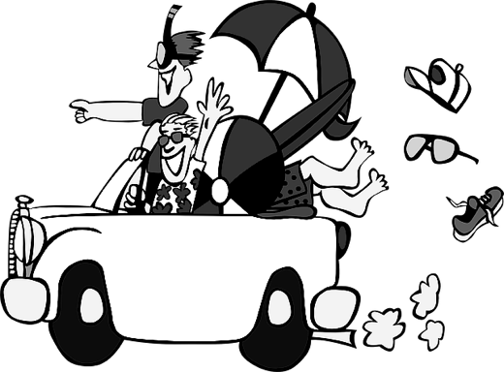

| **Types of Holiday** | **Holiday Activities** | **Travel Arrangements** |
| --- | --- | --- |
| 1. Luxury cruise | 5. Sunbathe | 9. Travel agency |
| 2. Adventure holiday | 6. Go sightseeing | 10. Car hire |
| 3. Ecotourism | 7. Buy souvenirs | 11. Destination |
| 4. Sightseeing tour. | 8. Admire the view | 12. Accommodation |

**2- Read the passage "The Evolution of Technological Devices" and answer the following questions (4x4=16) E10.8.R1. Students will be able to scan a text about the evolution of technology for specific information.**

**The Evolution of Technological Devices**  
Technology has changed a lot over the years. In the 1980s, people used big, heavy computers that could only do simple tasks like writing documents. These computers had no internet, so sharing information was slow and difficult. By the 2000s, laptops became popular because they were smaller and lighter, making it easier to work anywhere. In 2007, the first iPhone was released, introducing smartphones that could connect to the internet and take photos. Today, most people use smartwatches, which can track fitness, send messages, and even make phone calls. Modern devices are faster, more powerful, and help us stay connected all the time

1. In which decade did people use big, heavy computers?

…People used big, heavy computers in the 1980s…

2. Why did laptops become popular in the 2000s?

…because they were smaller and lighter…….

3. In which year was the first iPhone released?

…The first iPhone was released in 2007…..

4. What can smartwatches do today?

They can track fitness, send messages, make phone calls..

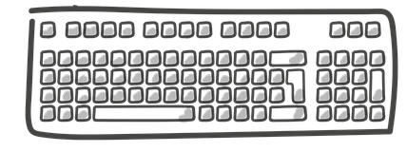



© 2025 ingilizcepedia All rights reserved.

**3.** Netiquette, or internet etiquette, refers to the rules of polite behavior online. Write a cause-and-effect paragraph about the importance of netiquette. (20p) E10.8.W1. Students will be able to write a cause and effect paragraph about the importance of netiquette.

STUDENT’S OWN ANSWERS

**4- Read the passage "Modern Heroes and Heroines" and guess the meaning of the two underlined words using the context clues in the text. ( 2x5=10p) E10.9.R1. Students will be able to guess the meaning of unfamiliar vocabulary using contextual clues from a text about modern heroes and heroines**

Valor means

bravery or courage, especially in a challenging or difficult situation…………………………..

Ingenios means

very clever, creative, or smart, especially in inventing or solving problems…………….

Greta Thunberg, a young climate activist who showed incredible **valor** when she started protesting for the environment at the age of 15, even though many people criticized her. Her courage inspired millions to join climate strikes, making her a global leader for the planet. Another modern hero is Tim Berners-Lee, who is known for his **ingenious** work in technology. In 1989, he invented the World Wide Web, which connects people around the world through the internet, showing his amazing ability to create new solutions.

**5. Imagine that you are a hero or heroine who saves the day in an exciting situation. Write a paragraph describing yourself as this hero or heroine. In your paragraph, include the following (3X10=30)** E10.9.W1. Students will be able to write a paragraph imagining themselves as a hero/heroine.



STUDENT’S OWN ANSWERS

• An introduction explaining who you are as a hero/heroine

• A description of the situation where and how you save the day.

• A conclusion describing how people react to your heroic actions.

Mahir BARUT …………………

İngilizce Öğretmeni Okul Müdürü