2025-2026 ACADEMIC YEAR
10th
……………………………………………………HIGH SCHOOL
10th GRADE 2nd Semester - 2nd Exam (Scenario 1) by ingilizcepedia
Name / Surname: ________________________________ | Class: ______ Number: ______
Q1. Read the text and fill in the table. (20 points)

Three Famous Cuisines

There are many delicious cuisines around the world. In Turkish cuisine, kebab is prepared with spices and herbs. First, the meat is chopped and seasoned. Then, it is grilled over a fire. It is served with rice and salad. In Italian cuisine, pizza is one of the most popular dishes. The dough is mixed and baked in a hot oven. Finally, fresh ingredients like cheese and tomatoes are added on top. In Japanese cuisine, sushi is a traditional dish. The rice is boiled and cooled. Next, it is served with fish and vegetables. Each cuisine has its own regional flavours and customs.

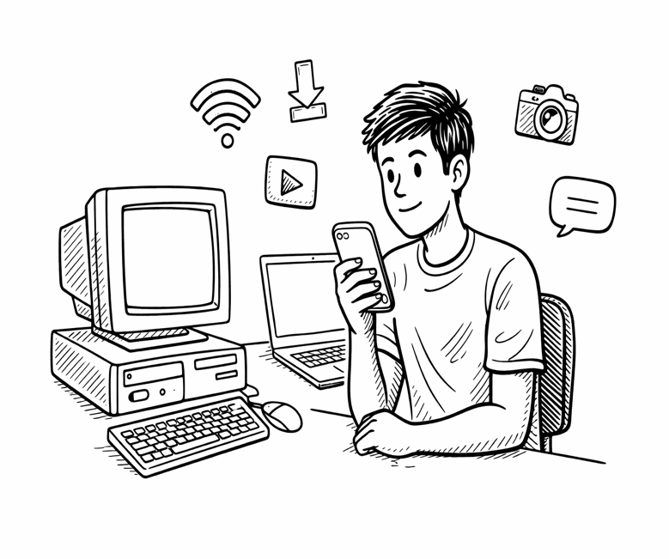
The Evolution of Communication Technology
Communication technology has evolved rapidly over the past few decades. In the 1990s, people used desktop computers that were large and expensive. They could only browse the internet with slow connections. Then, in the early 2000s, laptops became popular because they were portable and wireless. People started to download music and stream videos online. Smartphones, which were invented around 2007, changed everything. These advanced devices allowed people to connect with others, upload photos, and use applications anywhere. Today, digital platforms that we use daily continue to develop. Innovative gadgets evolve so fast that last year's model already looks outdated.
a) What kind of computers did people use in the 1990s?
___________________________________________________________________________
b) Why did laptops become popular in the early 2000s?
___________________________________________________________________________
c) When were smartphones invented?
___________________________________________________________________________
d) What can people do with smartphones?
___________________________________________________________________________
e) How fast do innovative gadgets evolve today?
___________________________________________________________________________
Cuisine | Famous Dish | First Step | Cooking Method | Served With
Turkish | (1) ____________ | The meat is chopped and seasoned. | It is grilled over a fire. | (4) ____________
Italian | pizza | (5) ____________ | (2) ____________ | Cheese and tomatoes are added.
Japanese | sushi | (3) ____________ | It is served with fish and vegetables. | fish and vegetables

Q2. Read the text and answer the questions. (20 points)
Q3. Read the text and answer the questions. (20 points)
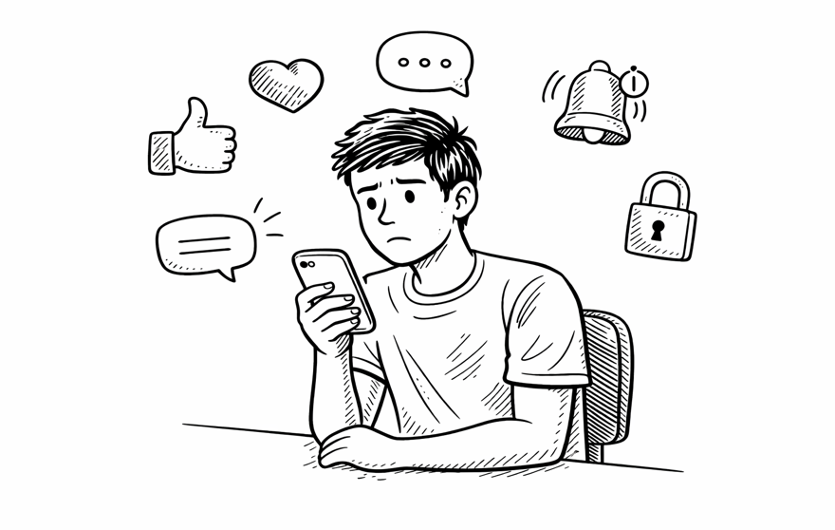
The Effects of Social Media on Teenagers

Social media has both positive and negative effects on teenagers. Students can share their projects and subscribe to educational profiles. However, many teenagers spend hours browsing posts, so they cannot focus on their homework. Experts say social media is addictive because it gives instant likes and comments. Privacy is another concern. Netiquette, which means polite online behaviour, is something every user should learn.

İngilizce Öğretmeni Okul Müdürü
Mahir BARUT ..........................
MY HERO / HEROINE
Hero Name | (your choice)
Superpower | (your choice)
Mission | (your choice)
Wish | (your choice)
Why admirable? | (your choice)

Write your paragraph here. Use 'If I were...' and 'I wish...' structures.
_________________________________________________________
_________________________________________________________
_________________________________________________________
_________________________________________________________
_________________________________________________________
_________________________________________________________
_________________________________________________________
_________________________________________________________
Q5. Look at the information card and write a paragraph. Imagine yourself as a hero/heroine. (20 points)
a) What is Sophie's role model's job?
___________________________________________________________________________
b) Where does Sophie wish to volunteer?
___________________________________________________________________________
c) What would Sophie donate to children in need?
___________________________________________________________________________
d) What would Sophie rescue people from if she were a superhero?
___________________________________________________________________________
A Modern Heroine's Wishes
Sophie is a 16-year-old student who admires selfless people. Her biggest role model is a brave doctor who dedicates her life to helping others. Sophie wishes she were old enough to volunteer at a hospital. She says, 'If I had more time, I would donate books to children in need.' If she were a superhero, she would rescue people from natural disasters.
Q4. Read the text and answer the questions. (20 points)
a) What can students share on social media?
____________________________________________________________
b) Besides addiction, what is another concern about social media?
____________________________________________________________
c) Why do experts say social media is addictive?
____________________________________________________________
d) What does the word 'netiquette' mean?
____________________________________________________________

