11th
Name/Surname: …………………………………….….
Circle your class x below Student No:……………..

Writing & Reading Oturumu (%50) 100/ …………
Speaking (%25) 100/……….…
Listening (%25) 100/ …..….…

A | B | C | D | E | F | G | H

1 Answer the questions according to the paragraph given below (4x5=20p)

"If only I had pursued astronaut training instead of medicine," sighed Dr. Lisa as she gazed at the stars through her office window. She often thought about her childhood dream of becoming an astronaut and how she had chosen medicine to please her parents. "I wish I had followed my passion and joined NASA," she whispered. Her friend Mark, a high school teacher, shared similar regrets. "I always wanted to be a pilot," he said. "I even got accepted into flight school, but I chose teaching because it felt safer. Now I wish I had taken the chance to fly."

- What career does Dr. Lisa regret not pursuing?
…………………………………………………………………………………………………………….
- What does Dr. Lisa wish she had done instead of becoming a doctor?
…………………………………………………………………………………………………………….
- What does Mark regret about his career?
……………………………………………………………………………………………………….….
- What does Mark wish he had done instead of becoming a teacher?
………………………………………………………………………………………………………….
- What do Dr. Lisa and Mark have in common?
……………………………………………………………………………………………………….…

2 Criticise the woman in the picture using the structure "should + have + past participle" according to the paragraph and the sentences given below (4x5=20p)

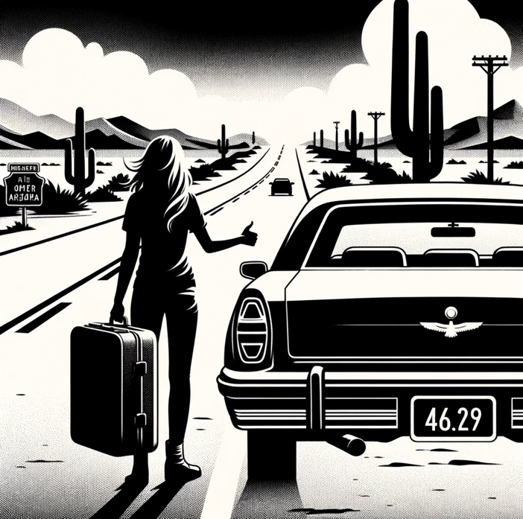
She was driving through the Arizona desert when her car suddenly broke down. She had been enjoying the scenic route, not realizing that the engine was overheating. As the car came to a halt, she got out, feeling the heat of the desert sun. She opened the car door and stood by the roadside, hoping to hitchhike for help. She had a suitcase with her, as she was on her way to visit a friend. Unfortunately, she had forgotten to charge her phone before leaving, leaving her unable to call for assistance. So there she waited, alone on the empty road, surrounded by the vastness of the desert.

E.g. She drove her car alone, without a friend.
She shouldn’t have set on the road alone

1.She didn’t check the oil level before her trip.
………………………………………………………………………………………………
2. She didn’t charge her phone fully.
………………………………………………………………………………………………
3. She didn’t plan her route to include more frequent stops.
………………………………………………………………………………………………
4. She forgot to take her car for maintenance.
………………………………………………………………………………………………

3 Ask for a refund from a Tech company by writing a letter of criticism. You can use the information given below.(30p)

Product name: SmartOrganizer Pro App
Receiver:
TechWave Solutions Customer Support

COMPLAINTS
Poor Technical Support:
App Crashes:.
Battery Performance
Synchronization Issues.

REASONS
The answers from Support were too slow and not very useful.
It crashes especially when accessing the calendar feature.
The app causes the phone's battery to run out quickly.
It fails to sync effectively with my email and contacts

4 Answer the questions About Cappadocia according to the paragraph given below.(5x6=30p)

Cappadocia is a famous tourist destination located in central Turkey, renowned for its stunning landscapes. It features unusual rock formations known as "fairy chimneys" due to their distinctive shapes. Long ago, people ingeniously carved homes, churches, and even entire cities into these rocks. One of the highlights in Cappadocia is the hot air balloon rides, which have become a signature attraction. Early in the morning, the sky fills with colorful balloons, offering a breathtaking view of the area from above. This experience not only provides an unparalleled perspective of the unique geological wonders but is also a favorite among visitors, making it a must-do activity when exploring Cappadocia.

1. Where is Cappadocia located?
……………………………………………………………………………………………….
2. What are the unusual rock formations in Cappadocia called?
……………………………………………………………………………………………….
3. What did people carve into the rocks of Cappadocia?
…..……………………………………………………………………………………………….
4. What is one of the main attractions for tourists in Cappadocia?
….……………………………………………………………………………………………….
5. When do the hot air balloons usually fly in Cappadocia?
………………………………………………………………………………………………….

Mahir BARUT ………………………
İngilizce Öğretmeni Okul Müdürü

