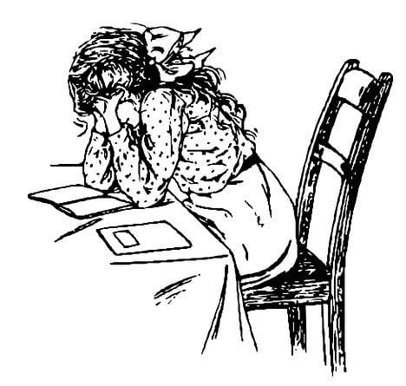

**1. Write 4 regrets from the paragraph given below.**  E11.5.R1. Students will be able to analyze a text to distinguish the expressions used to express wishes, regrets and unreal past.

Looking back, there are things I wish I had done differently. If only I had taken my studies more seriously—my career could have been better. I also wish I’d traveled in my 20s while I had the freedom; now it’s much harder. Another thing I regret is never learning to swim—it would have been so useful. I often think about how I shouldn’t have lost contact with my childhood friends; we could still be close today. Finally, I really regret not saving money earlier instead of wasting it on things I didn’t need. Life would be easier now if I’d been smarter with my choices.

1. Not taking studies seriously. *(I wish I had taken my studies more seriously)*
2. Not traveling in their 20s. *(I wish I’d traveled in my 20s)*
3. Never learning to swim. *(I regret never learning to swim)*
4. Losing contact with childhood friends. *(I shouldn’t have lost contact…)*

Or ; (5) Not saving money earlier. *(I regret not saving money earlier)*



**2 Arrange the scrambled sentences into a single, well-structured paragraph by putting them in the correct order below in the box.** E11.8.R1. Students will be able to analyze a text involving different kinds of extreme sports to reorder the scrambled paragraphs.

For example, base jumping involves leaping off cliffs or buildings with a parachute, while big-wave surfing challenges riders to face massive ocean waves.



Unlike traditional sports, extreme sports often involve high speed, danger, and adrenaline rushes.

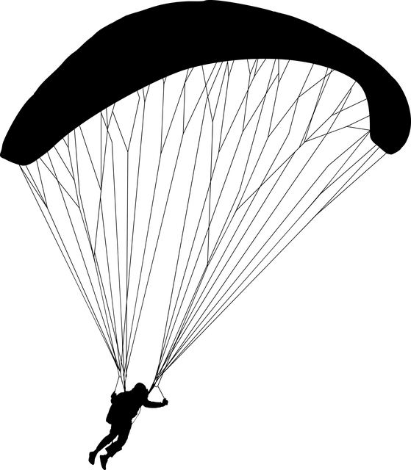

Extreme sports are adventurous activities that test a person's courage and skills.

These activities attract thrill-seekers who enjoy pushing their physical and mental limits.

Some popular extreme sports include rock climbing, snowboarding, and white-water rafting.



*Extreme sports are adventurous activities that test a person's courage and skills. Unlike traditional sports, extreme sports often involve high speed, danger, and adrenaline rushes. Some popular extreme sports include rock climbing, snowboarding, and white-water rafting. For example, base jumping involves leaping off cliffs or buildings with a parachute, while big-wave surfing challenges riders to face massive ocean waves. These activities attract thrill-seekers who enjoy pushing their physical and mental limits.*

**3. Imagine you have interviewed a local environmental activist named Jack Green about her efforts to promote renewable energy in your town. During the interview, Write a short report according to Jack shared the following points. ( 25p)** 11.8.W1. Students will be able to write a report on the interview they have made.

• She started her activism five years ago after noticing the town’s high energy costs.

• Her main project is installing solar panels in public buildings like schools and libraries.

• She faced challenges, such as lack of funding and resistance from some community members.

• Last year, her project successfully reduced energy costs in three schools by 30%.

• She plans to expand the project to other towns next year.



Answers may be as follows

I interviewed Jack Green, a local environmental activist, about his renewable energy efforts. Jack began his activism five years ago to reduce high energy costs. His main project installs solar panels in schools and libraries, though he faced challenges like lack of funding. Last year, he reduced energy costs in three schools by 30%. Jack plans to expand to other towns next year. I think his work is impressive because it helps the environment.

**4. Answer the questions according to the news article given below. (5x5=25p)** E11.9.R1. Students will be able to scan online and printed newspaper articles about well-known people to find out personal details**.**

**Emma Watson Talks About Her Life in New Interview**  
Emma Watson, the beloved actress known for playing Hermione Granger in the Harry Potter movies, shared some personal details in a recent interview. She was born on April 15, 1990, in Paris, France, but grew up in Oxford, England. At the age of 11, she started acting in the first Harry Potter film, which made her a global star. Watson loves education and graduated from Brown University in 2014 with a degree in English literature. She is also passionate about helping the environment and supports a charity called "Green Earth" to protect forests. Now, at 35 years old, Watson lives in London and enjoys her favorite hobby, which is yoga, to stay relaxed and healthy.



1.Where was Emma Watson born?  
**Answer:** Emma Watson was born in Paris, France.

2. At what age did Emma Watson start acting in the first *Harry Potter* film?  
**Answer:** She started acting in the first *Harry Potter* film at the age of 11.

3. In which year did Emma Watson graduate from Brown University?  
**Answer:** She graduated from Brown University in 2014.

4 What is the name of the charity Emma Watson supports to help the environment?  
**Answer:** The name of the charity Emma Watson supports is "Green Earth."

5 What is Emma Watson’s favorite hobby?  
**Answer:** Her favorite hobby is yoga.

Mahir BARUT ………………………

İngilizce Öğretmeni Okul Müdürü