ANSWER KEY

12th

**1- Read paragraph given below and answer the questions about Sarah's music preferences. (20p)**

**(5x5=25)**

Sarah’s music preferences have been deeply influenced by her family's diverse tastes. Growing up in a household where her father cherished classical music and her mother was a fan of 70s rock, Sarah developed a unique blend of preferences that bridge these genres. On Sunday mornings, you could often find her listening to Beethoven’s symphonies, a tradition she adopted from her father. During family road trips, however, the car would resonate with the sounds of The Beatles and Fleetwood Mac, reflecting her mother's influence. As Sarah grew older, she also started exploring contemporary pop and indie music, adding to the eclectic mix she enjoyed with her siblings. This exploration was encouraged by her family’s open-minded attitude towards music, believing that each genre holds its own beauty and complexity. Her current playlist is a testament to her family’s musical heritage, blending the old with the new, and continuing to evolve as she introduces her own children to the classics she grew up with and the new hits of today.

1.What types of music did Sarah's parents enjoy?

… Sarah's father enjoyed classical music, while her mother was a fan of 70s rock

2.How did Sarah’s family influence her music preferences?

… Sarah’s music preferences were influenced by her father’s love for classical music and her mother’s enjoyment of 70s rock,

3. What specific music tradition did Sarah adopt from her father?

… Sarah adopted the tradition of listening to Beethoven’s symphonies on Sunday mornings from her father.

4. What did Sarah listen to during family road trips?

.… During family road trips, Sarah listened to The Beatles and Fleetwood Mac.

**2 Answer the questions according to the paragraph given below ( 5X6=30p)**

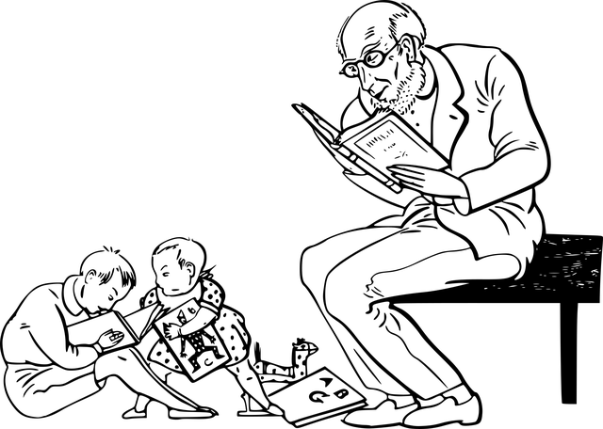

Many people think that in our digital age, reading books is less important. However, books are essential for deep learning and personal growth. While the internet offers quick information, it cannot replace the detailed knowledge that books provide. Books help us develop critical thinking because they present complex ideas that require reflection and analysis. This is something brief online articles or quick videos lack. Additionally, books improve our concentration and focus, training us to ignore distractions—a valuable skill in today’s fast-paced world. That’s why they are so important. Therefore, books are irreplaceable, as they strengthen our minds in ways that digital media cannot.

1. What does the paragraph say books provide that the internet cannot?

…… Books provide detailed knowledge.

2. According to the paragraph, why are books important besides providing information?

…… They help develop critical thinking and improve concentration.

3. How do books help with focus according to the paragraph?

…… Books present complex ideas that require deep thinking.

4. What does the paragraph suggest books help us improve?

…… Concentration and focus.

5. How do books help with focus according to the paragraph?

….. They train us to ignore distractions.

**3. Write an opinion essay about qualities of a good friend by stating reasons using the template givenn below. (60p)**

**. (5x4=20p)**



Intoduction **(10p)**

STUDENTS’ OWN ANSWERS

Body 1 ( 1 quality and at leaat one reason) **(10p)**

STUDENTS’ OWN ANSWERS

Body 2 ( 1 quality and at leaat one reason) (**10p)**

STUDENTS’ OWN ANSWERS

Body 3 ( 1 quality and at leaat one reason) (**10p)**

STUDENTS’ OWN ANSWERS

Conclusion (**10p)**

STUDENTS’ OWN ANSWERS

Mahir BARUT ………………………

İngilizce Öğretmeni Okul Müdürü