2025-2026 EĞİTİM ÖĞRETİM YILI
…………………………………………………………………LİSESİ
12. SINIF İNGİLİZCE BEP 2. DÖNEM 1. SINAV
CEVAP ANAHTARI by ingilizcepedia
1- Resimlere bakın ve kutudaki doğru teknolojiyi İngilizce yazın. (5x5=25p) (25p)
BEP: Students will be able to identify technology vocabulary with visual support.

1    laptop | 2  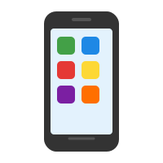  smartphone | 3    tablet
4  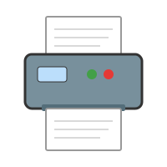  printer | 5  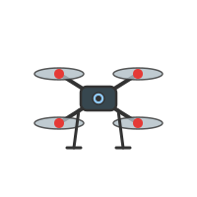  drone

2- Metni okuyun ve Doğru (D) veya Yanlış (Y) yazın. (5x5=25p) (25p)
BEP: Students will be able to understand texts about technology, future predictions and feelings.

Technology in Our Lives
My name is Zeynep. I think technology makes life easier. I use my smartphone every day to call my friends. I use the internet to do my homework. I think there will be flying cars in the future. Maybe robots will help us at home. I am going to study computer science at university. I am interested in technology and I feel happy when I learn new things about it.

1 | Zeynep thinks technology makes life harder. | YANLIŞ
2 | She uses her smartphone to call her friends. | DOĞRU
3 | She thinks there will be flying cars in the future. | DOĞRU
4 | She is going to study history at university. | YANLIŞ
5 | She feels happy when she learns about technology. | DOĞRU

2025-2026 EĞİTİM ÖĞRETİM YILI
…………………………………………………………………LİSESİ
12. SINIF İNGİLİZCE BEP 2. DÖNEM 1. SINAV
CEVAP ANAHTARI by ingilizcepedia
3- Teknoloji cihazlarını doğru kullanımlarıyla eşleştirin. (5x5=25p) (25p)
BEP: Students will be able to match technology to daily life uses.

1. internet → (b) to do homework
2. smartphone → (d) to call friends
3. printer → (a) to print documents
4. laptop → (e) to write essays
5. drone → (c) to take photos from the sky

4- Doğru cevabı seçin. (5x5=25p) (25p)
BEP: Students will be able to make predictions (will), express plans (going to), uncertainty (maybe) and opinions.

1. B) will be
2. B) is going to
3. B) Maybe
4. A) interested
5. C) useful

Mahir BARUT ………………………
İngilizce Öğretmeni Okul Müdürü

