2025-2026 EĞİTİM ÖĞRETİM YILI
…………………………………………………………………LİSESİ
12th GRADE ENGLISH BEP EXAM
2nd Semester - 1st Exam by ingilizcepedia

Adı Soyadı: ________________________________ | Sınıf: ______ No: ______

S1. Resimlere bakın ve kutudaki doğru teknolojiyi İngilizce yazın. (5x5=25 puan)
laptop / smartphone / tablet / printer / drone

1    ______________ | 2  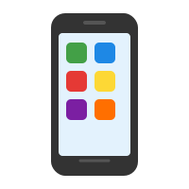  ______________ | 3    ______________
4    ______________ | 5  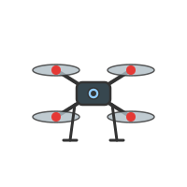  ______________

S2. Metni okuyun ve Doğru (D) veya Yanlış (Y) yazın. (5x5=25 puan)

Technology in Our Lives
My name is Zeynep. I think technology makes life easier. I use my smartphone every day to call my friends. I use the internet to do my homework. I think there will be flying cars in the future. Maybe robots will help us at home. I am going to study computer science at university. I am interested in technology and I feel happy when I learn new things about it.

1 | Zeynep thinks technology makes life harder. | ( )
2 | She uses her smartphone to call her friends. | ( )
3 | She thinks there will be flying cars in the future. | ( )
4 | She is going to study history at university. | ( )
5 | She feels happy when she learns about technology. | ( )

S3. Teknoloji cihazlarını doğru kullanımlarıyla eşleştirin. Cevap sütununa harfi yazın. (5x5=25 puan)

 | Cihaz / Teknoloji | Cevap | Kullanım
1 | internet | ( ) | a) to print documents
2 | smartphone | ( ) | b) to do homework
3 | printer | ( ) | c) to take photos from the sky
4 | laptop | ( ) | d) to call friends
5 | drone | ( ) | e) to write essays

S4. Doğru cevabı seçin. A, B veya C’yi daire içine alın. (5x5=25 puan)

1. I think there ________ flying cars in the future. A) is B) will be C) was
2. She ________ study computers at university. She already registered. A) will B) is going to C) maybe
3. “Will robots help us at home?” — “________, but I’m not sure.” A) No B) Maybe C) Never
4. I feel ________ when I use new technology. A) interested B) boring C) never
5. Smartphones are very ________. We use them every day. A) dangerous B) difficult C) useful

Mahir BARUT ………………………
İngilizce Öğretmeni Okul Müdürü

