CEVAP ANAHTARI

5th

**1- Answer the questions according to the dialogues given below.. (4x5= 20p)** E5.1.R1. Students will be able to read picture stories, conversations and cartoons about personal information.

**(5x5=25)**

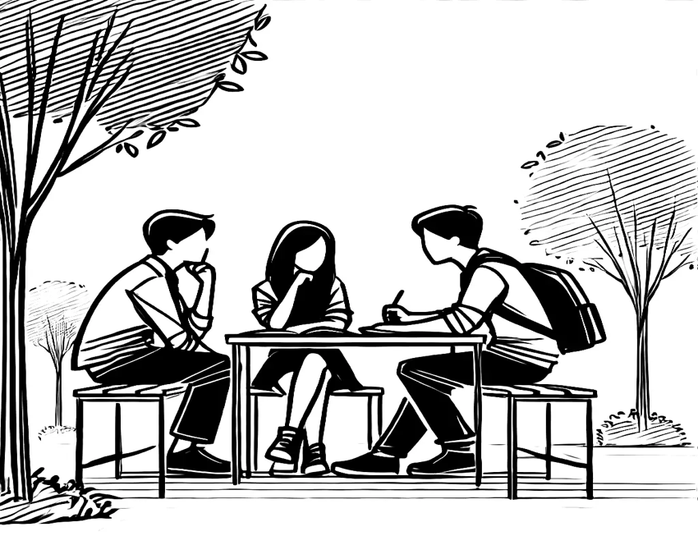

No, I’m not. I am from Germany. Where you from?

Are you from France?

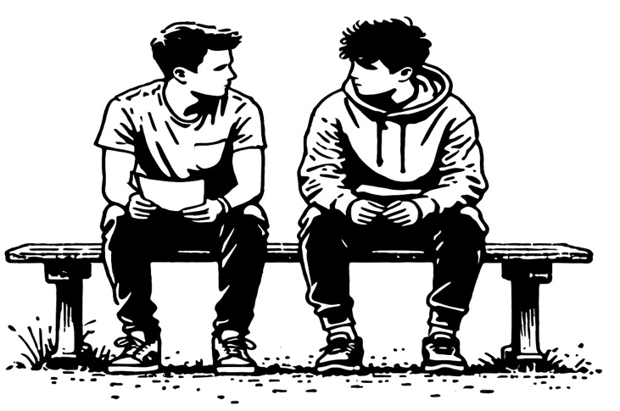

I’m sixteen years old. How about you, Susan?

I’m eighteen years old.

How old are you, Paul?

I’m from Spain.

Oliver

David

Paul

Susan

David

1.Where is Oliver from?

………………………………………He is from German ……………………………………………………………

2. Is David from France?

………………………………………No, he isn’t (He is from Spain ) ……………………………………………

3. How old is Susan?

………………………………………… She is eighteen years old ……………………………………………

4. How old is Paul?

.…………………………………………… He is sixteen years old. …………………………………………….

**2 Answer the questions according to Alice’s timetable given below ( 5X6=30p)** E5.1.R2. Students will be able to read their timetable for their lessons.

|  |  |  |  |  |
| --- | --- | --- | --- | --- |
| **Monday** | **Tuesday** | **Wednesday** | **Thursday** | **Friday** |
| Art | Music | History | Music | Art |
| Physical Education | English | History | Math | Geography |
| Math | English | Physical Education | Math | Geography |

1.When is Geography?

…………………………………………… It is on Friday ……………………………………………………………

2. Which classes does she have on Wednesday?

……………………………… She’s got History and Physical education ……………………………

3. How many classes does she have in a day?

……………………………… She’s got three classes a day …………………………………………..……

4. Which days does she have Music?

.………………………………………… Tuesday and Thursday. ……………………………………………….

5. When is History?

.………………………………………… It is on Wednesday ……………………………………………………

**3. Answer the questions according to the picture given below. (5x10=50p)** E5.2.R1. Students will be able to understand information about important places

**. (5x4=20p)**

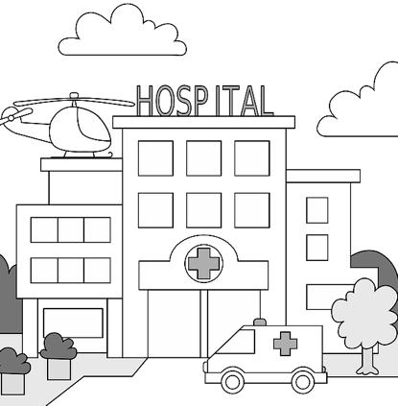

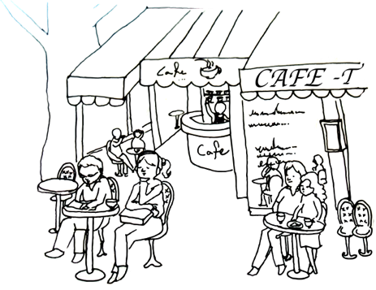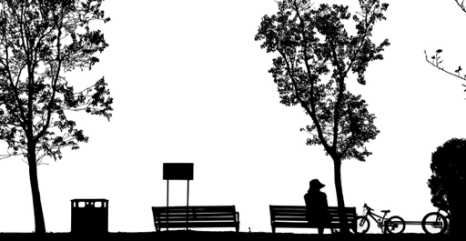

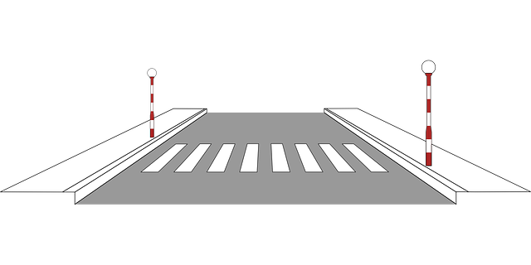



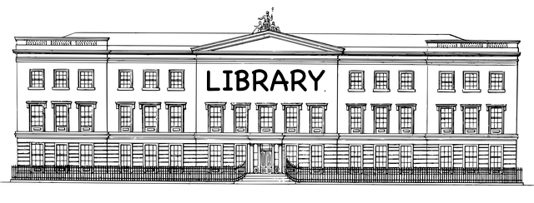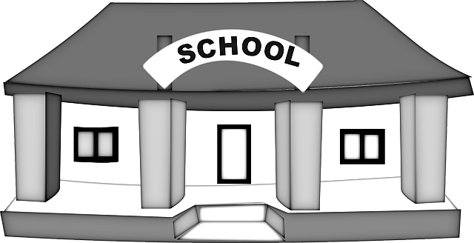

1.What is next to the school?

……………There is a library next to the school…………………………………………………………………… (4p)

2. Where is the hospital?

………………It is opposite the library / It is next to the park ………………………………………………(4p)

3. What is in front of the cinema?

……………………The cafe is in front of the cinema …………………………………………………………(4p)

4. Where is the library

.……………………It is between the school and cinema. ………………………………………………. (4p)

5. Where is the cafe?

.……………………………... It is opposite the hospital. …..…………………………………………………. (4p)

**Emma drinks tea with you in the cafe and she asks you the questions below;**

1.How can I get to the school?

……………Cross the road. Go past the library. It is on your left……………………………………………..……… (10p)

2. How can I get to the park?

…. Cross the sidewalk. Take the first right. Go past the hospital. It is on your right ………….………(10p)

3. How can I get to the library

…………………Cross the sidewalk Take the first right. It is in front of the hospital…………………. …… (10p)

**Students can use alternative directions since more answers available than one**

Mahir BARUT ………………………

İngilizce Öğretmeni Okul Müdürü