Writing & Reading Oturumu (%50) 100/ …………
Speaking (%25) 100/……….…
Listening (%25) 100/ …..….…

5th
Name/Surname: …………………………………….….
Circle your class x below Student No:……………..
No: ……..
A | B | C | D | E | F | G | H

1. Answer the questions about Tom according to the paragraph given below. ( 3X10=30P)


1.What’s wrong with Tom?
……………………….…………………….
2. What should Tom do?
……………………………………………..
3. How does Tom feel After Dentist?
……………………………………………….
Tom has a toothache. His tooth hurts a lot. He should see a dentist. The dentist can help him feel better. Tom is sad because of the pain. After the dentist, his tooth doesn’t hurt. He is happy again.

2- Write the name of the illness and one suggestion under the pictures according to the paragraph given below (3 x10= 30p). ( 5 x 3 illness =15p, 5x3 suggestions= 15p)


Hello, I am a doctor. I want to tell you about three people and their problems. First, Ava has a backache. She shouldn’t carry heavy things. She should rest and sit straight. Second, Luna has a toothache. She shouldn’t eat sweets. She should brush her teeth and see a dentist. Third, Kai has the flu. He shouldn’t go to crowded places. He should drink warm tea, take medicine, and rest a lot. This will help them feel better.

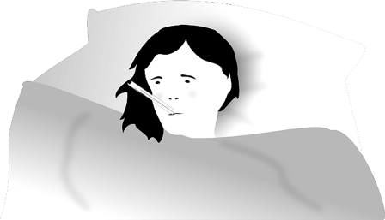
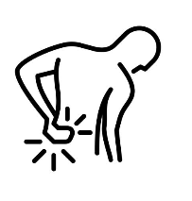
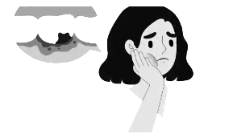

Illness: ………………….………...
Suggestion:……………….…….
………………………………...…..…
…………………………………...……

Illness: ………………….………...
Suggestion:……………….…….
………………………………...…..…
…………………………………...……

Illness: ………………….………...
Suggestion:……………….…….
………………………………...…..…
…………………………………...……

3- Answer the questions according to the poster given below (5 x4= 20p)

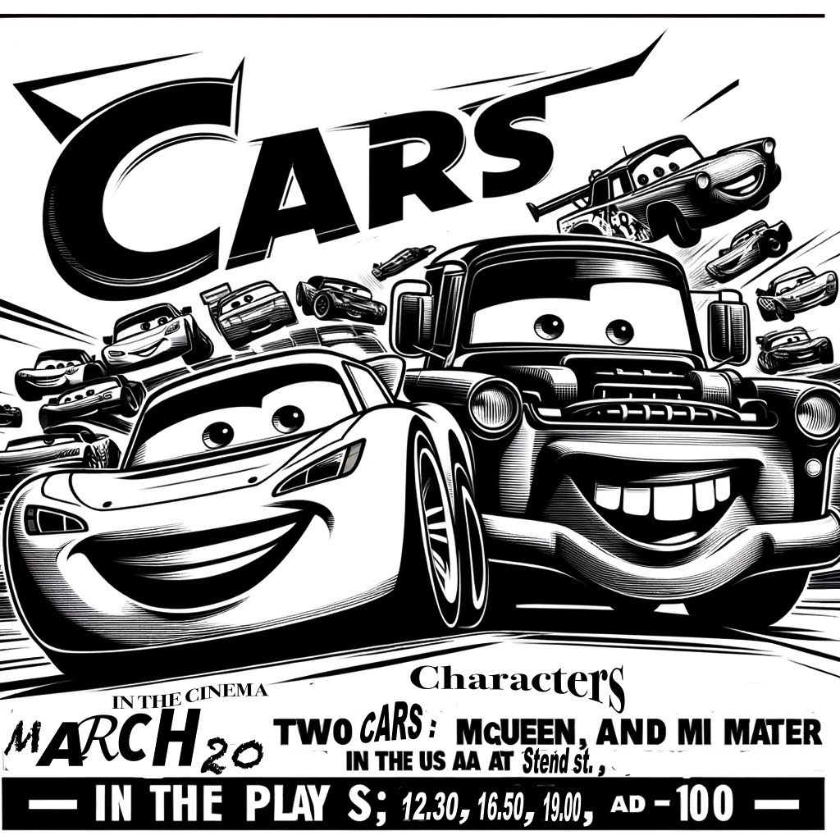
1.What is the name of the movie?
Anwer:………………………………………………………………………………………..

2. Who are the characters?
Answer: …………………………………
……………………………………………..

3. What kind of film is it?
Anwer: ………………………………….
………………………………………………

4. What is it about?
Answer: ……………………………….
…………………………………………….

5. When is the movie on?
Answer: ………………………………

4- Anser the questions according to movie advertisement below (4x5=20p)

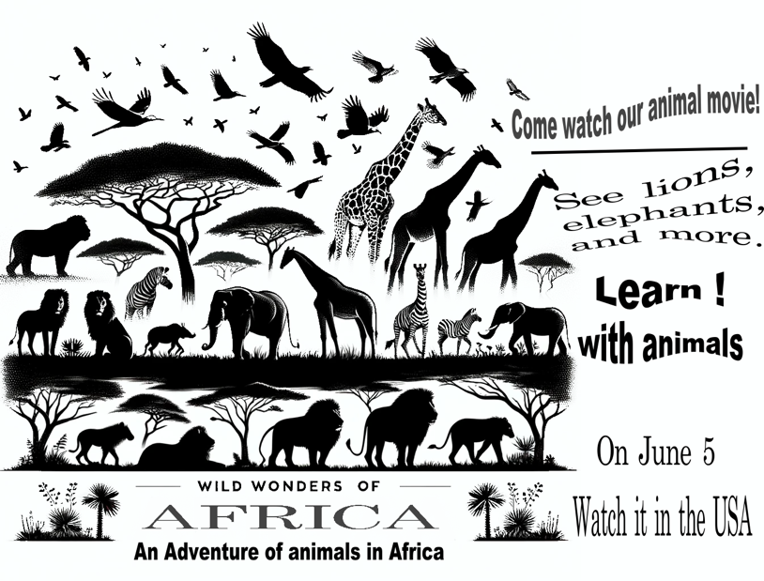

1.When can you watch the movie?
Anwer:…………………………………………………

2. What kind of movie is it?
Answer: ………………………………………………

3. Where can you watch this movie? (country)
Anwer: …………………………………………..….

4. What is it about?
Answer: …………………………………………….

Mahir BARUT ……………….. İngilizce Öğretmeni Okul Müdürü

