2025-2026 EĞİTİM ÖĞRETİM YILI
…………………………………………………………………ORTAOKULU
5th GRADE ENGLISH BEP EXAM
2nd Semester - 1st Exam by ingilizcepedia
Name / Surname: ________________________________ | Class: ______ Number: ______

Q1. Resimlere bakın ve kutudaki doğru vücut bölümünü yazın. (Look at the pictures and write the correct body part from the box.) (5x5=25 points)
hand / eyes / leg / arm / head

# | Picture | Body Part
1 |  | _______________
2 |  | _______________
3 |  | _______________
4 | 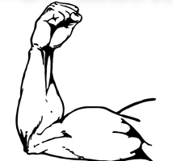 | _______________
5 | 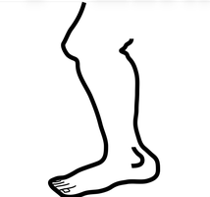 | _______________

Q2. Metni okuyun ve Doğru (T) veya Yanlış (F) yazın. (Read the text and write True (T) or False (F).) (5x5=25 points)
My Favourite Clothes
Hi! I’m Zeynep. I like wearing my blue coat in winter. I also wear my red scarf and black boots. In summer, I wear my favourite yellow T-shirt and jeans. I don’t like wearing a hat.

# | Sentence | T / F
1 | Zeynep likes wearing her blue coat in winter. | ( )
2 | She wears a green scarf. | ( )
3 | Zeynep wears black boots in winter. | ( )
4 | Her favourite T-shirt is yellow. | ( )
5 | Zeynep likes wearing a hat. | ( )

Q3. Boşlukları kutudaki doğru kelimelerle doldurun. (Fill in the blanks with the correct word from the box.) (5x5=25 points)
always / sometimes / never / brush / go

1. I ________________ my teeth every morning. (dişlerimi fırçalarım)
2. I ________________ go to school. I go every day. (her zaman)
3. My sister ________________ reads books. She reads 2-3 times a week. (bazen)
4. We ________________ shopping on Saturdays. (gideriz)
5. I ________________ eat fish. I don’t like it. (asla)

Q4. Doğru cevabı seçin. A, B veya C’yi daire içine alın. (Choose the correct answer. Circle A, B or C.) (5x5=25 points)
1. She has long and curly ________.
A) eyes
B) hair
C) nose
2. I ________ my teeth every morning.
A) brush
B) cook
C) read
3. It is very cold. I need my ________.
A) T-shirt
B) hat
C) coat
4. My father ________ fishing every weekend.
A) like
B) likes
C) liking
5. I ________ swim when I was 5 years old.
A) can
B) could
C) am

Mahir BARUT …………………………
İngilizce Öğretmeni Okul Müdürü

