**1. Answer the questions about Tom according to the paragraph given below. ( 3X10=30P)** E5.5.R1. Students will be able to understand short and simple texts about illnesses, needs and feelings.



Tom has a toothache. His tooth hurts a lot. He should see a dentist. The dentist can help him feel better. Tom is sad because of the pain. After the dentist, his tooth doesn’t hurt. He is happy again.

1.What’s wrong with Tom?

He has a toothache

2. What should Tom do?

He should see a dentist

3. How does Tom feel After Dentist?

He feels happy ( he is happy again.)

**2- Write the name of the illness and one suggestion under the pictures according to the paragraph given below (3x10=30p)**. E5.5.R1. Students will be able to understand short and simple texts about illnesses, needs and feelings



Hello, I am a doctor. I want to tell you about three patients and their problems. First, Kai has a backache. He shouldn’t carry heavy things. He should rest and sit straight. Second, Luna has a toothache. She shouldn’t eat sweets. She should brush her teeth and see a dentist. Third, Ava has the flu. She shouldn’t go to crowded places. She should drink warm tea, take medicine, and rest a lot. This will help them feel better.

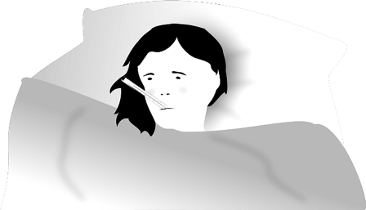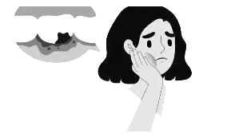



Illness: ………Flu…….……..

Suggestion:…………………….

She shouldn’t go to crowded places She should rest a lot

Illness: …Toothache……..

Suggestion:…………………….

She shouldn’t eat sweets

She should see a dentist.

Illness: ……Backache….……..

Suggestion:…………………….

He shouldn’t carry heavy things

He should rest and sit straight.

**3- Answer the questions according to the poster given below (5 x4= 20p) E5.6.R1**. Students will be able to understand phrases and simple sentences on posters and advertisements about movies and movie characters.

1.What is the name of the movie?

Anwer:……………Cars…………………………………………………………………

2. Who are the characters?

Answer: ……………McUEEN…and………………

……………MI MATER………………..

3. What kind of film is it?

Anwer: ……Cartoon……………….

………………………………………………

4. What is it about?

Answer: …………Two cars……..

…………………………………………….

5. When is the movie on?

Answer: ……on 20th March…….

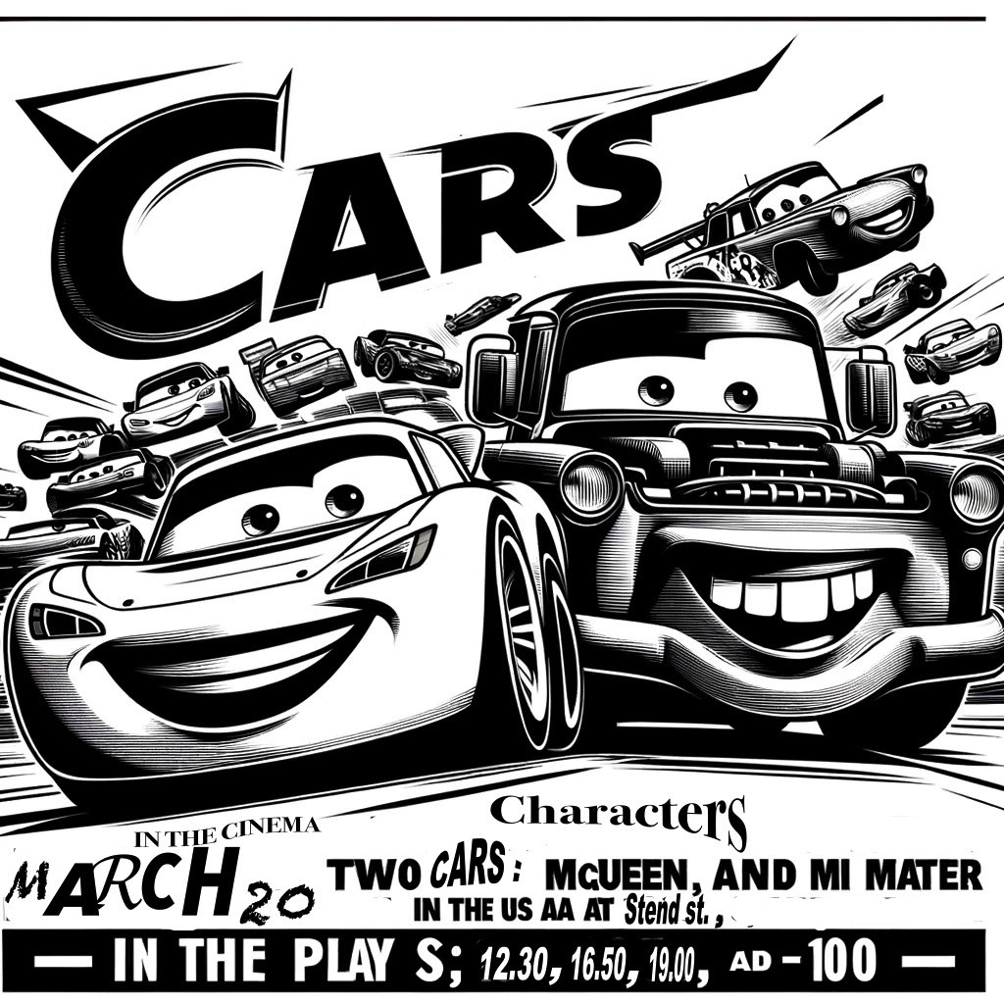

**4- Anser the questions according to movie advertisement below (4x5=20p) E5.6.R1**. Students will be able to understand phrases and simple sentences on posters and advertisements about movies and movie characters.



1.When can you watch the movie?

Anwer:……………On June 5…………………

2. What kind of movie is it=

Answer: …………Documentary……………

3. Where can you watch this movie? (country)

Anwer: ………………USA………………..….

4. What is it about?

Answer: ………It’s about animals………….

Mahir BARUT ………………

İngilizce Öğretmeni Okul Müdürü