Writing & Reading Oturumu (%50) 100/ …………

Speaking (%25) 100/……….…

Listening (%25) 100/ …..….…

5th

Name/Surname: …………………………………….….

Circle your class x below Student No:……………..

No: ……..

|  |  |  |  |  |  |  |  |
| --- | --- | --- | --- | --- | --- | --- | --- |
| **A** | B | C | D | E | F | G | H |

**1. Answer the questions about Tom according to the paragraph given below. ( 3X10=30P)**



1.What’s wrong with Tom?

……………………….…………………….

2. What should Tom do?

……………………………………………..

3. How does Tom feel After Dentist?

……………………………………………….

Tom has a toothache. His tooth hurts a lot. He should see a dentist. The dentist can help him feel better. Tom is sad because of the pain. After the dentist, his tooth doesn’t hurt. He is happy again.

**2- Write the name of the illness and one suggestion under the pictures according to the paragraph given below (3 x10= 30p)**. ( 5 x 3 illness =15p, 5x3 suggestions= 15p)



Hello, I am a doctor. I want to tell you about three people and their problems. First, Ava has a backache. She shouldn’t carry heavy things. She should rest and sit straight. Second, Luna has a toothache. She shouldn’t eat sweets. She should brush her teeth and see a dentist. Third, Kai has the flu. He shouldn’t go to crowded places. He should drink warm tea, take medicine, and rest a lot. This will help them feel better.

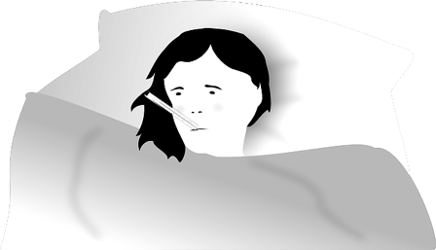

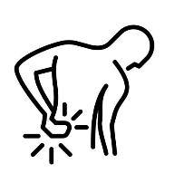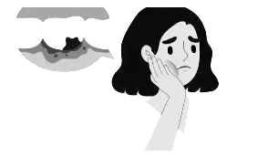

Illness: ………………….………...

Suggestion:……………….…….

………………………………...…..…

…………………………………...……

Illness: ………………….………...

Suggestion:……………….…….

………………………………...…..…

…………………………………...……

Illness: ………………….………...

Suggestion:……………….…….

………………………………...…..…

…………………………………...……

**3- Answer the questions according to the poster given below (5 x4= 20p)**

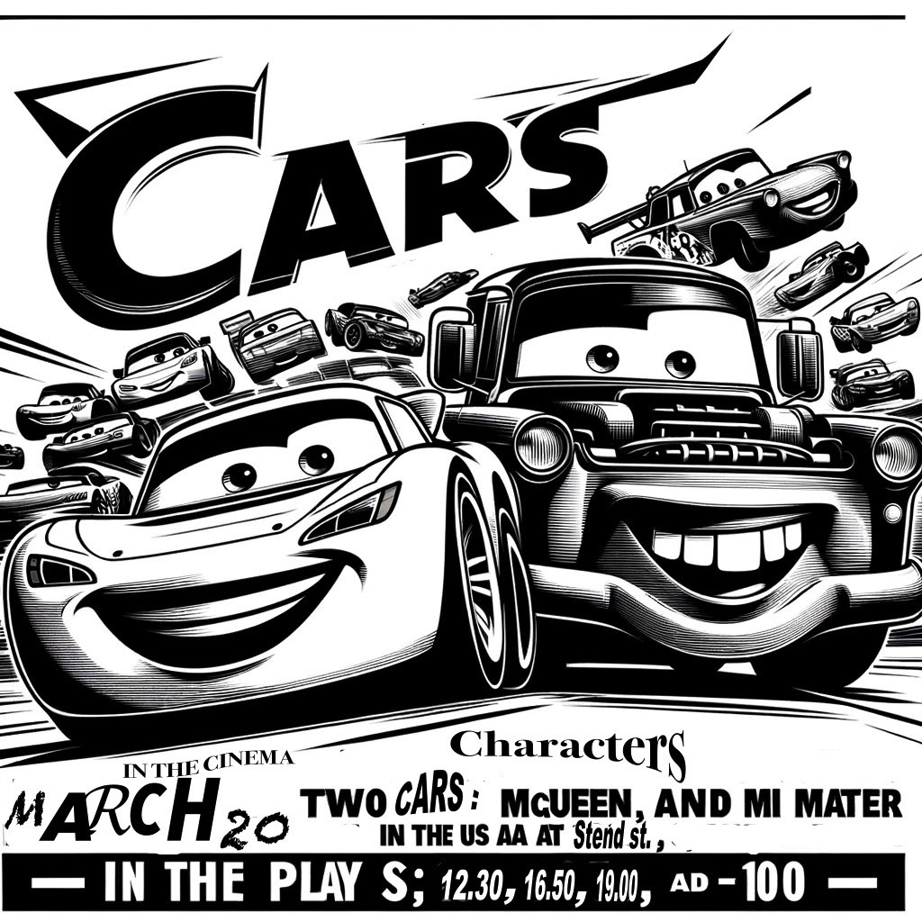

1.What is the name of the movie?

Anwer:………………………………………………………………………………………..

2. Who are the characters?

Answer: …………………………………

……………………………………………..

3. What kind of film is it?

Anwer: ………………………………….

………………………………………………

4. What is it about?

Answer: ……………………………….

…………………………………………….

5. When is the movie on?

Answer: ………………………………

**4- Anser the questions according to movie advertisement below (4x5=20p)**

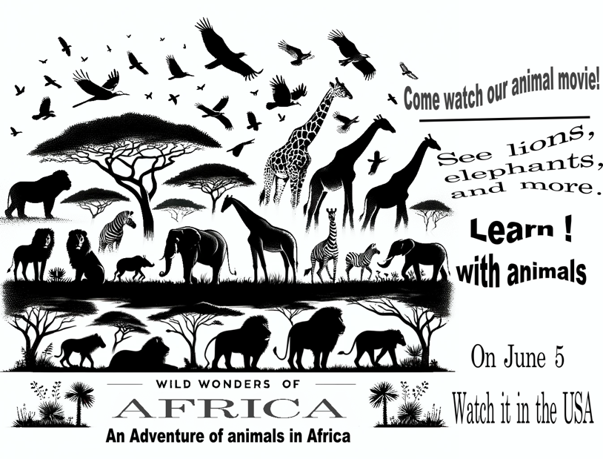

1.When can you watch the movie?

Anwer:…………………………………………………

2. What kind of movie is it=

Answer: ………………………………………………

3. Where can you watch this movie? (country)

Anwer: …………………………………………..….

4. What is it about?

Answer: …………………………………………….

Mahir BARUT ……………….. İngilizce Öğretmeni Okul Müdürü