2025-2026 ACADEMIC YEAR
………………………………………………………………………SECONDARY SCHOOL
5th GRADE 2nd Semester - 2nd BEP Exam by ingilizcepedia
Name / Surname: ____________________________ | Class: ______ Number: ______

Q1. Resimlere bakın ve kutudaki doğru hayvan adını yazın. (5x5=25 points)
(Look at the pictures and write the correct animal name from the box.)

lion / eagle / penguin / elephant / whale

1.   | 2.  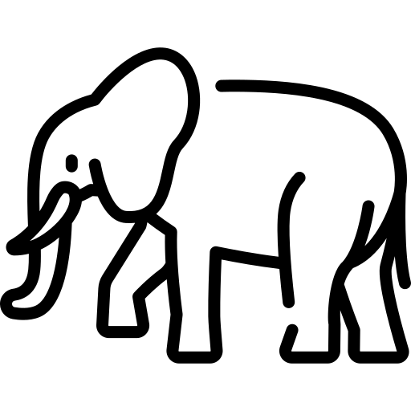 | 3.   | 4.   | 5.  
___________ | ___________ | ___________ | ___________ | ___________

Q2. Metni okuyun ve Doğru (T) veya Yanlış (F) yazın. (5x5=25 points)
(Read the text and write True (T) or False (F).)

My Favourite Food  Hi! My name is Emre. I love food! My mum has got bread and cheese at home. I can eat pasta every day! I must eat soup — it is healthy. I don't like meat. | 

# | Sentence | T / F
1 | Emre loves food. | ( )
2 | Emre's mum has got bread and eggs. | ( )
3 | Emre can eat pasta every day. | ( )
4 | Soup is healthy. | ( )
5 | Emre likes meat. | ( )

Q3. Boşlukları kutudaki doğru kelimelerle doldurun. (5x5=25 points)
(Fill in the blanks with the correct word from the box.)

Can / can / must / has got / bigger

# | Resim | Sentence
1 |  | ___________ I have some soup, please? (izin istemek / asking for permission)
2 |  | An elephant is ___________ than a penguin. (karşılaştırma / comparative)
3 |  | An eagle ___________ fly very fast. (yetenek / ability)
4 | 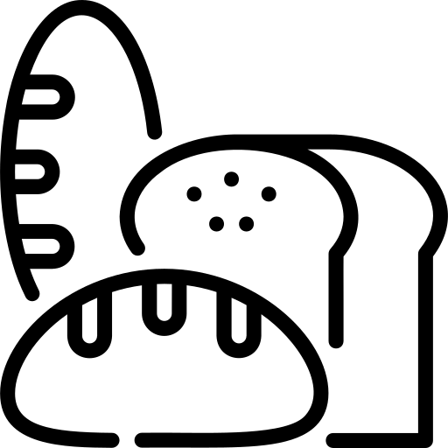 | She ___________ bread and cheese for lunch. (sahip olmak / possession)
5 |  | You ___________ eat vegetables. They are healthy! (zorunluluk / obligation)

Q4. Doğru cevabı seçin. A, B veya C'yi daire içine alın. (5x5=25 points)
(Choose the correct answer. Circle A, B or C.)
# | Resim | Question
1 |  | ______ I have some water, please?  A) Must B) Can C) Have got
2 |  | A lion is ______ than a cat.  A) small B) bigger C) biggest
3 |  | Penguins ______ swim very well.  A) must B) has got C) can
4 | 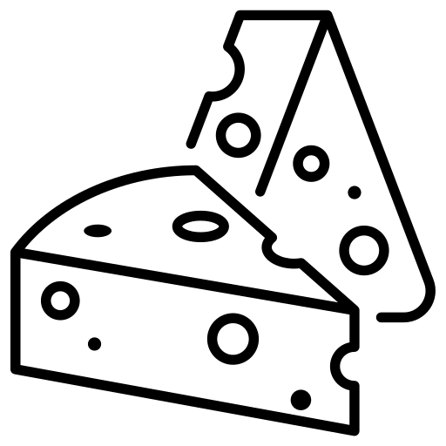 | She ______ a big sandwich for lunch.  A) have got B) has got C) can
5 |  | A whale is the ______ animal in the sea.  A) big B) bigger C) biggest
İngilizce Öğretmeni Okul Müdürü
Mahir BARUT ......................... ..........................

