**1. Look at the movie poster for "How to Train Your Dragon 4." And complete the table below with the correct information from the poster. (4x5=20p9 E5.6.R1. Students will be able to understand phrases and simple sentences on posters and advertisements about movies and movie characters.**

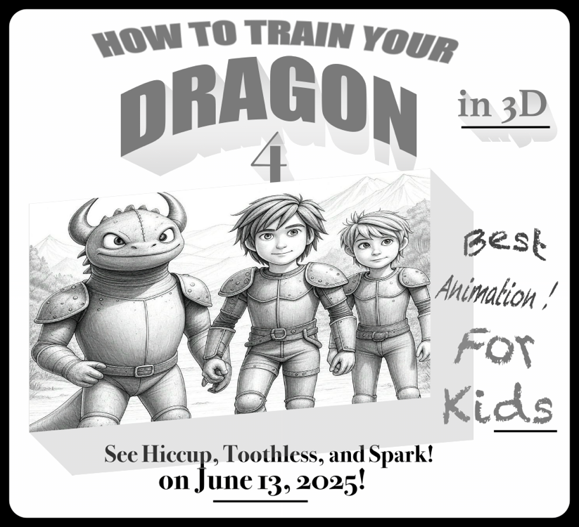



How to train your dragon 4

The name of the movie

Animation

Type of the movie

Hiccup, Toothless, and Spark

Characters

June 13, 2025

Date

**2. Read the invitation card and answer the questions. (4x5=20p) E5.7.R1. Students will be able to understand short texts with visual aids, such as cartoons, posters and birthday cards.**

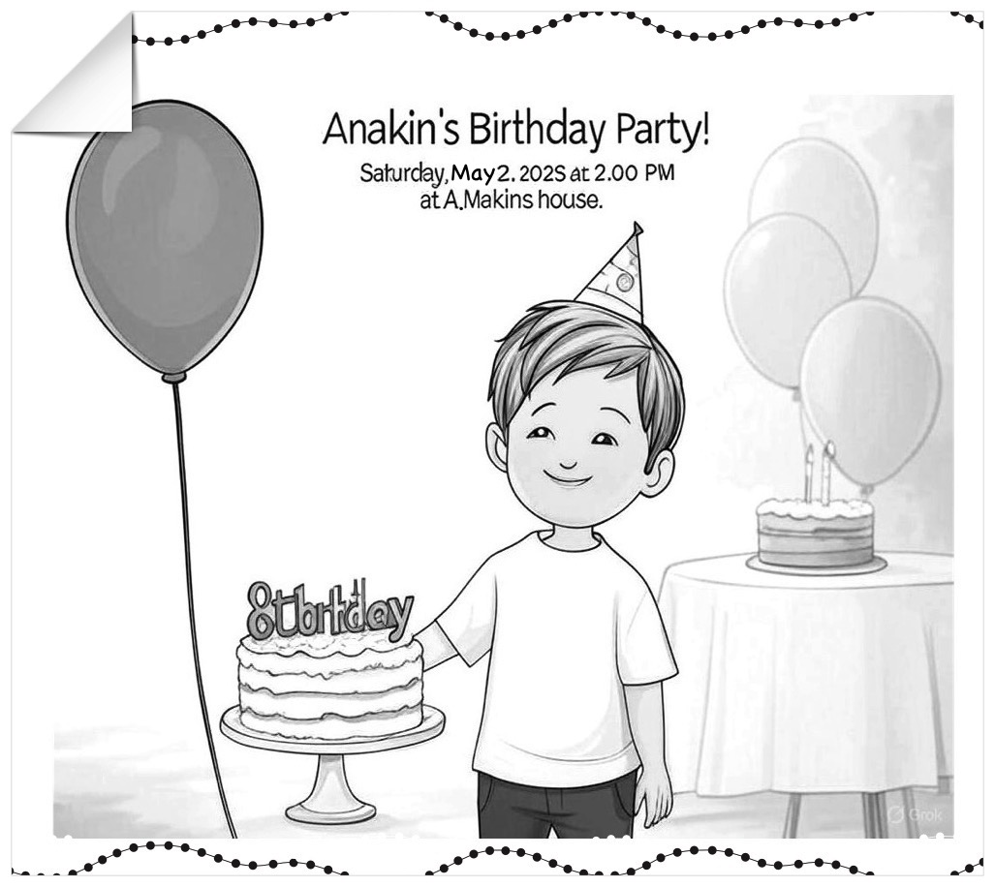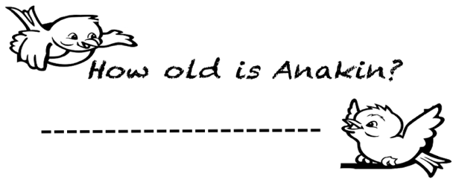

a)

He is 7/8 years old

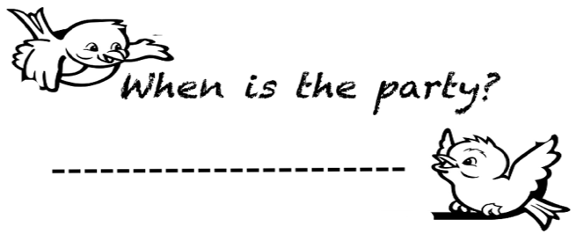

Saturday, May 2, 2025

b)

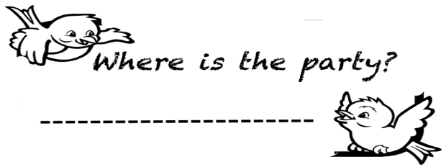

c)

At A.Makins house

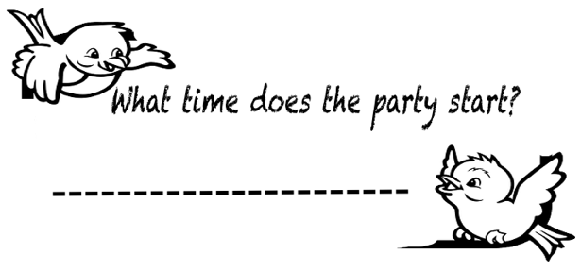

d)

At 2.00 pm

**3. Read the passage "A Fun Weekend with Friends." Answer the questions below in short sentences. (5x6=30p) E5.8.R1. Students will be able to understand simple texts about sports activities.**

Hi! I’m Oliver. My friends are Daisy, Leo, and Zara. We like outdoor activities. On Saturday, I want to go hiking. It is my favorite exercise. Leo doesn’t like hiking. Daisy wants to play tennis.

She is a good tennis player, but Zara can’t play tennis

and likes fishing. I like fishing too, so we fish together.

Leo wants to play basketball. He is good at it. I can’t play

basketball. Zara likes basketball, but Daisy doesn’t.

We are excited for our weekend!

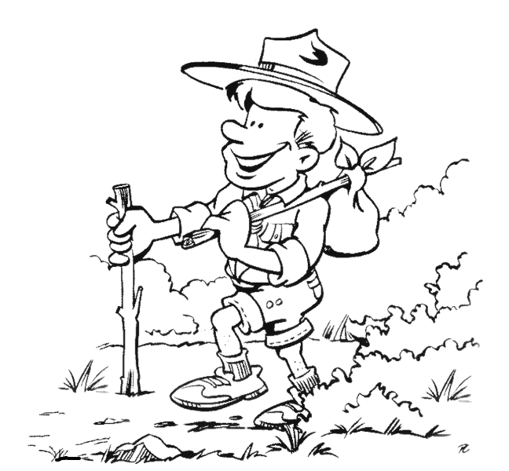

**1) Who likes fishing?**

**……Grace and Zara like fishing………………..**

**2) Who dislikes tennis?**

**……………Zara dislikes tenis………………………...**

**3) Can Daisy play tennis?**

**……Yes, she can play tennis……………………....**

**4) What^s Oliver’s favorite exercise?**

**……His favorite exercise is hiking………...**

**5) Who can play basketball?**

**………Leo can play basketball………………..…**

**4. Look at the pictures and answer the questions. Use the verbs “eat,sleep, play” and “present continuous tense” (3x10=30p) E5.9.R1. Students will be able to understand short and simple texts about what people/animals are doing at the moment.**

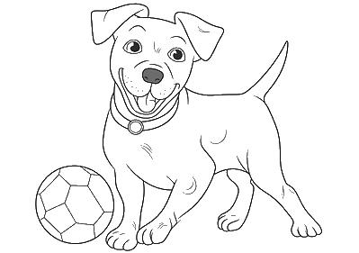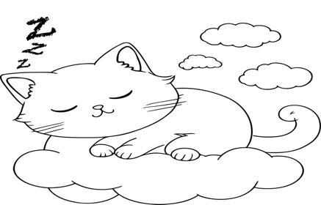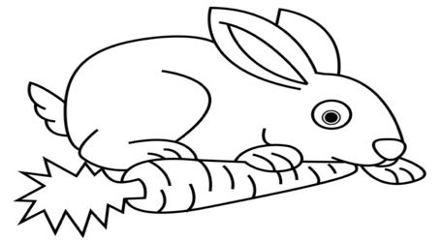

**What is the rabbit doing at the moment?**

**What is the dog doing at the moment?**

**What is it doing at the moment?**

The rabbit is eating a carrot

The dog is playing ball

It is sleeping

Mahir BARUT ………………

İngilizce Öğretmeni Okul Müdürü