1. Look at the movie poster for "How to Train Your Dragon 4." And complete the table below with the correct information from the poster. (4x5=20p9 E5.6.R1. Students will be able to understand phrases and simple sentences on posters and advertisements about movies and movie characters.

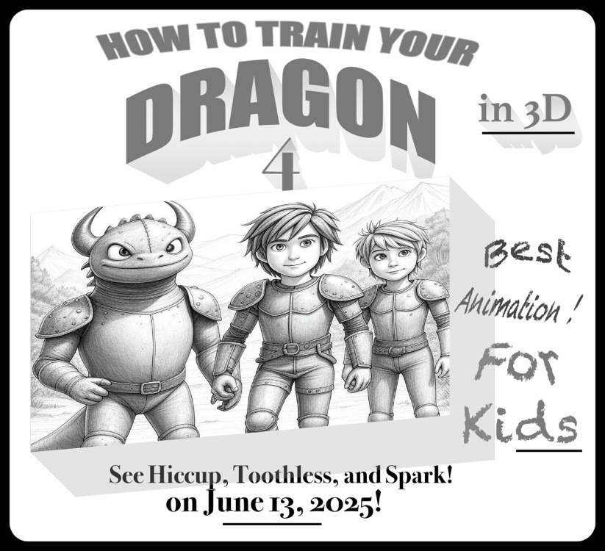


How to train your dragon 4
The name of the movie

Animation
Type of the movie

Hiccup, Toothless, and Spark
Characters

June 13, 2025
Date

2. Read the invitation card and answer the questions. (4x5=20p) E5.7.R1. Students will be able to understand short texts with visual aids, such as cartoons, posters and birthday cards.

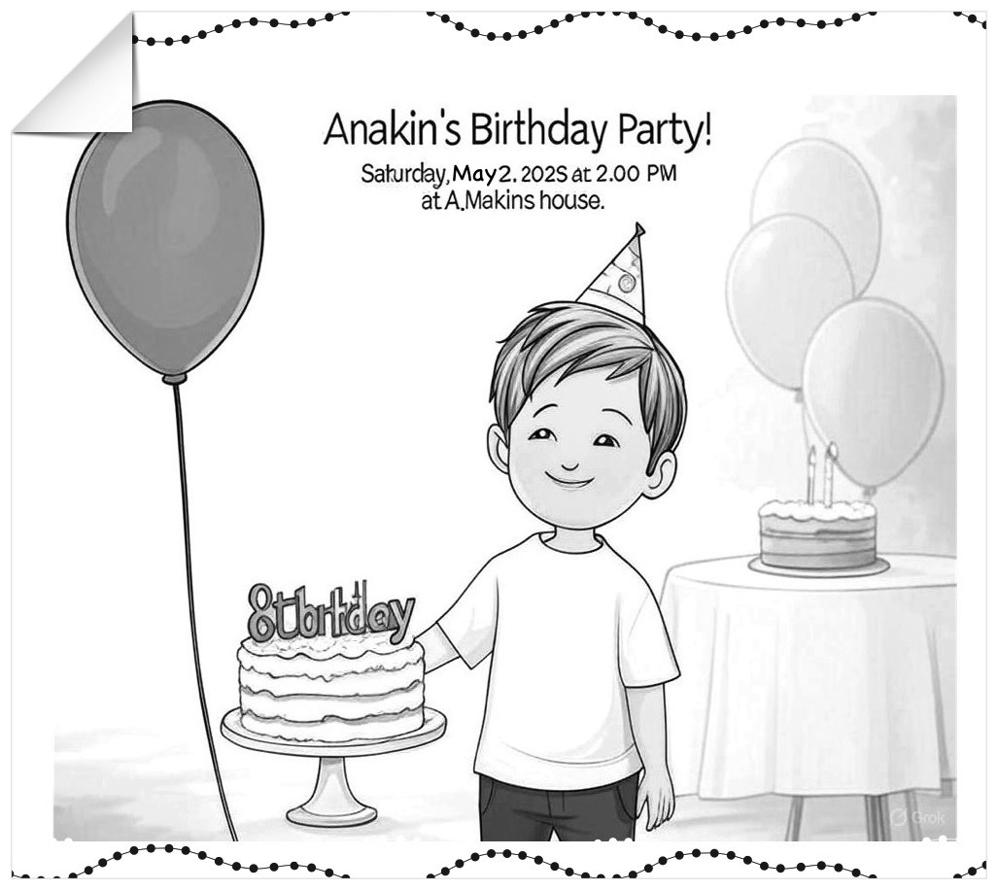
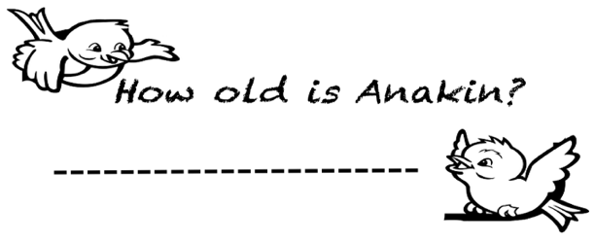
a)
He is 7/8 years old

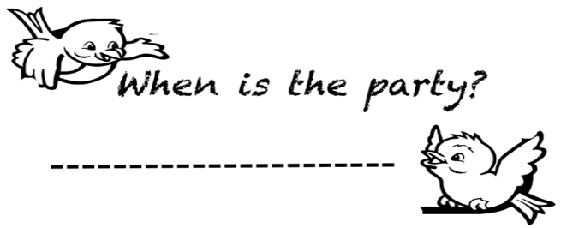

Saturday, May 2, 2025
b)

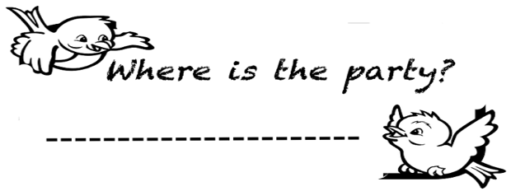

c)
At A.Makins house

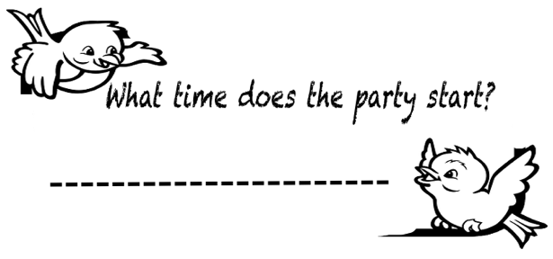

d)
At 2.00 pm

3. Read the passage "A Fun Weekend with Friends." Answer the questions below in short sentences. (5x6=30p) E5.8.R1. Students will be able to understand simple texts about sports activities.

Hi! I’m Oliver. My friends are Daisy, Leo, and Zara. We like outdoor activities. On Saturday, I want to go hiking. It is my favorite exercise. Leo doesn’t like hiking. Daisy wants to play tennis.
She is a good tennis player, but Zara can’t play tennis
and likes fishing. I like fishing too, so we fish together.
Leo wants to play basketball. He is good at it. I can’t play
basketball. Zara likes basketball, but Daisy doesn’t.
We are excited for our weekend!

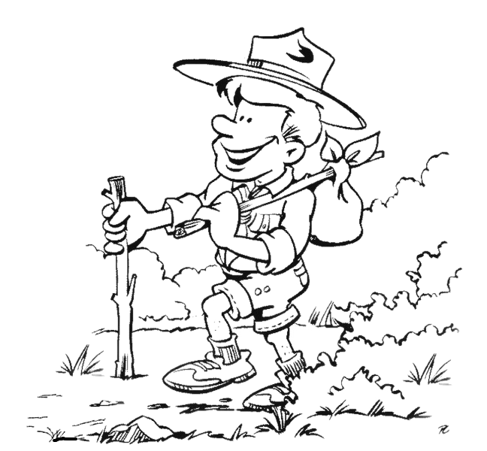

1) Who likes fishing?
……Grace and Zara like fishing………………..
2) Who dislikes tennis?
……………Zara dislikes tenis………………………...
3) Can Daisy play tennis?
……Yes, she can play tennis……………………....
4) What^s Oliver’s favorite exercise?
……His favorite exercise is hiking………...
5) Who can play basketball?
………Leo can play basketball………………..…

4. Look at the pictures and answer the questions. Use the verbs “eat,sleep, play” and “present continuous tense” (3x10=30p) E5.9.R1. Students will be able to understand short and simple texts about what people/animals are doing at the moment.

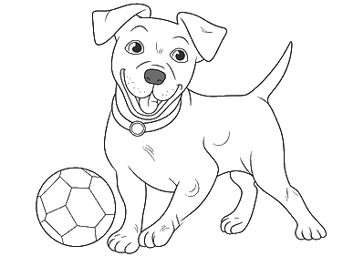
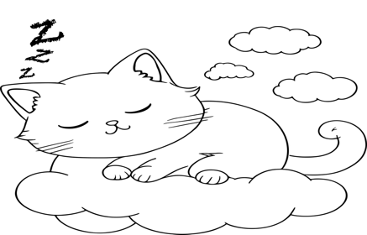
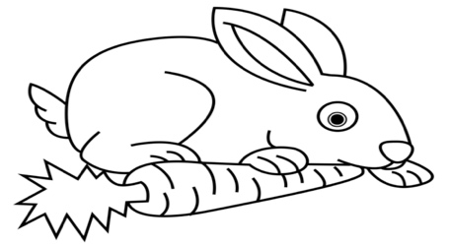

What is the rabbit doing at the moment?
What is the dog doing at the moment?
What is it doing at the moment?

The rabbit is eating a carrot
The dog is playing ball
It is sleeping

Mahir BARUT ………………
İngilizce Öğretmeni Okul Müdürü

