Writing & Reading Oturumu (%50) 100/ …………

Speaking (%25) 100/……….…

Listening (%25) 100/ …..….…

5th

Name/Surname: …………………………………….….

Circle your class x below Student No:……………..

No: ……..

|  |  |  |  |  |  |  |  |
| --- | --- | --- | --- | --- | --- | --- | --- |
| **A** | B | C | D | E | F | G | H |

**1. Look at the movie poster for "How to Train Your Dragon 4." And complete the table below with the correct information from the poster. (4x5=20p)**





The name of the movie

Type of the movie

Characters

Date

**2. Read the invitation card and answer the questions. (4x5=20p)**

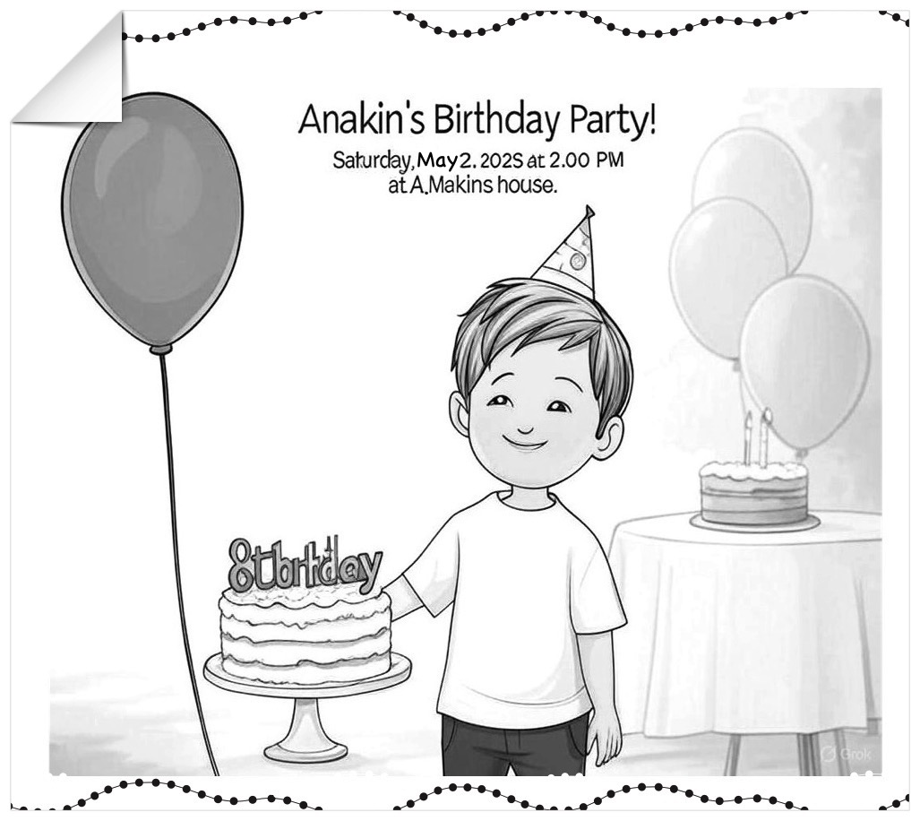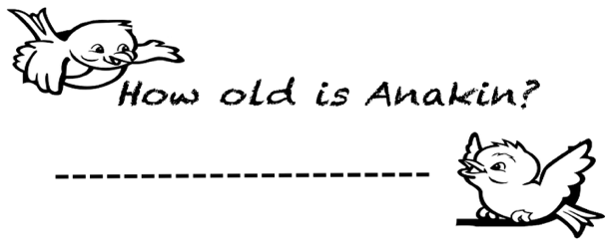

a)

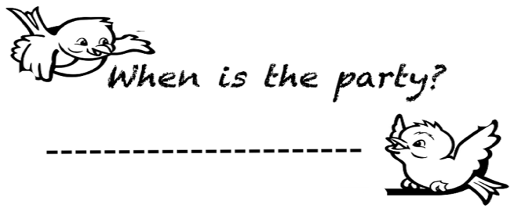

b)

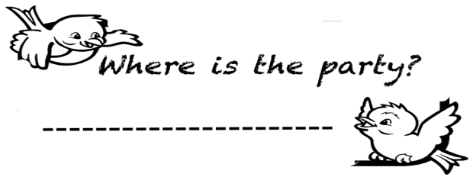

c)

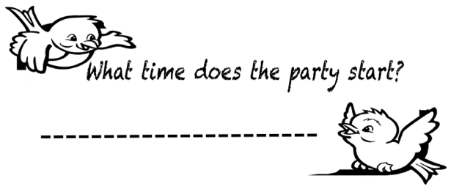

d)

**3. Read the passage "A Fun Weekend with Friends." Answer the questions below in short sentences. (5x6=30p)**

Hi! I’m Oliver. My friends are Daisy, Leo, and Zara. We like outdoor activities. On Saturday, I want to go hiking. It is my favorite exercise. Leo doesn’t like hiking. Daisy wants to play tennis.

She is a good tennis player, but Zara can’t play tennis

and likes fishing. I like fishing too, so we fish together.

Leo wants to play basketball. He is good at it. I can’t play

basketball. Zara likes basketball, but Daisy doesn’t.

We are excited for our weekend!

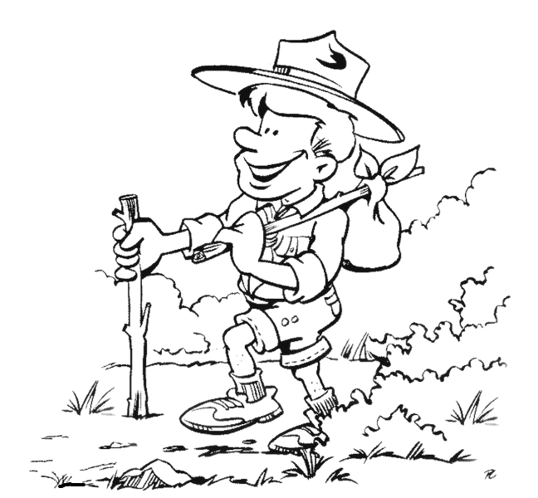

**1) Who likes fishing?**

**……………………………………………………………………..**

**2) Who dislikes tennis?**

**……………………………………………………………………..**

**3) Can Daisy play tennis?**

**……………………………………………………………………..**

**4) What^s Oliver’s favorite exercise?**

**…………………………………………………………………..**

**5) Who can play basketball?**

**……………………………………………………………………..**

**4. Look at the pictures and answer the questions. Use the verbs “eat,sleep, play” and “present continuous tense (3x10=30p)**

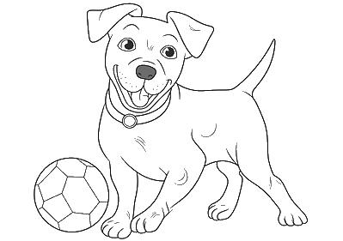

**What is the rabbit doing at the moment?**

**What is it doing at the moment?**

**What is the dog doing at the moment?**

………………………………………………/.

…………………………………………………/.

…………………………………………………/.

Mahir BARUT ……………….. İngilizce Öğretmeni Okul Müdürü