Writing & Reading Oturumu (%50) 100/ …………
Speaking (%25) 100/……….…
Listening (%25) 100/ …..….…

5th
Name/Surname: …………………………………….….
Circle your class x below Student No:……………..
No: ……..
A | B | C | D | E | F | G | H

1. Look at the movie poster for "How to Train Your Dragon 4." And complete the table below with the correct information from the poster. (4x5=20p)




The name of the movie

Type of the movie

Characters

Date

2. Read the invitation card and answer the questions. (4x5=20p)

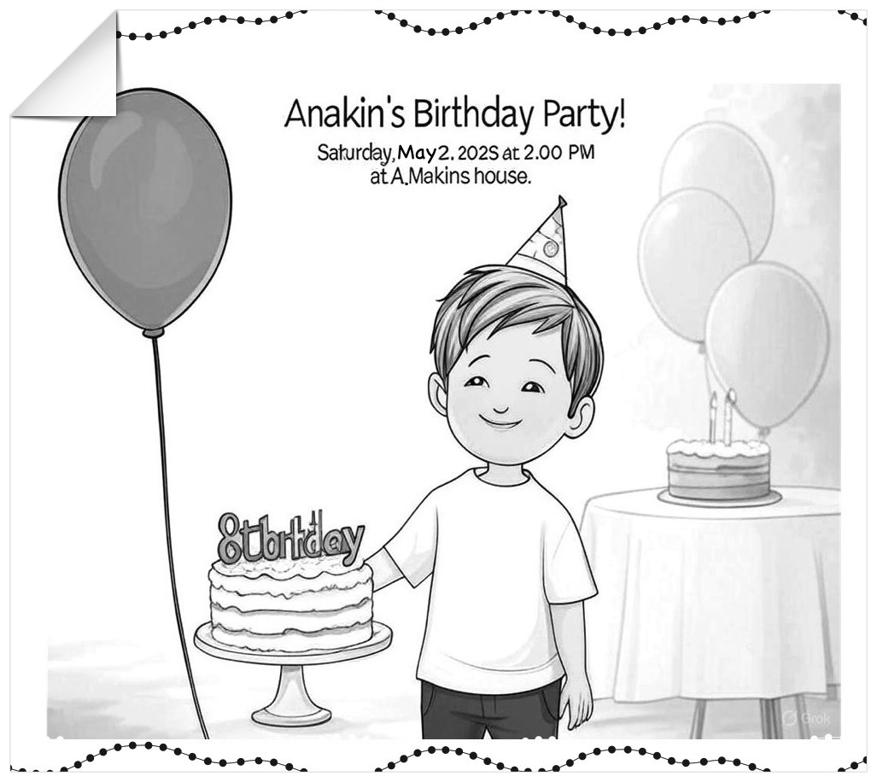
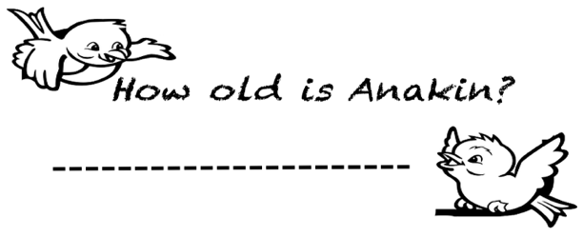
a)

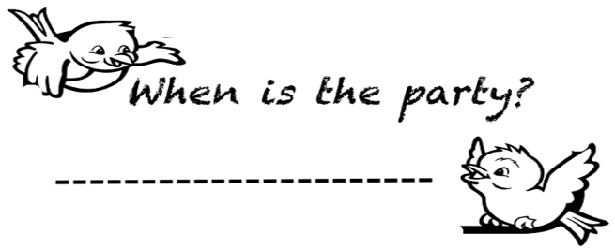

b)

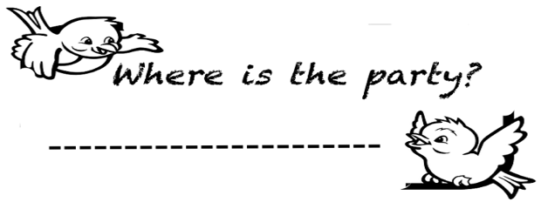
c)

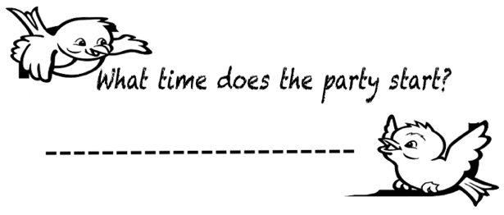

d)

3. Read the passage "A Fun Weekend with Friends." Answer the questions below in short sentences. (5x6=30p)

Hi! I’m Oliver. My friends are Daisy, Leo, and Zara. We like outdoor activities. On Saturday, I want to go hiking. It is my favorite exercise. Leo doesn’t like hiking. Daisy wants to play tennis.
She is a good tennis player, but Zara can’t play tennis
and likes fishing. I like fishing too, so we fish together.
Leo wants to play basketball. He is good at it. I can’t play
basketball. Zara likes basketball, but Daisy doesn’t.
We are excited for our weekend!

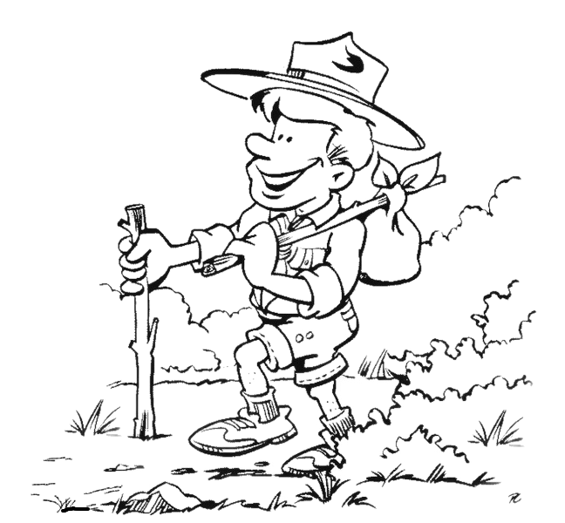

1) Who likes fishing?
……………………………………………………………………..
2) Who dislikes tennis?
……………………………………………………………………..
3) Can Daisy play tennis?
……………………………………………………………………..
4) What^s Oliver’s favorite exercise?
…………………………………………………………………..
5) Who can play basketball?
……………………………………………………………………..

4. Look at the pictures and answer the questions. Use the verbs “eat,sleep, play” and “present continuous tense (3x10=30p)

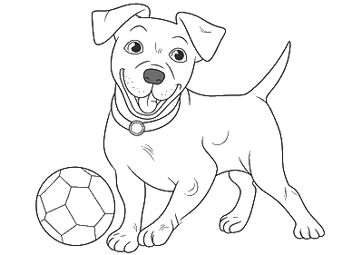



What is the rabbit doing at the moment?
What is it doing at the moment?
What is the dog doing at the moment?

………………………………………………/.
…………………………………………………/.
…………………………………………………/.

Mahir BARUT ……………….. İngilizce Öğretmeni Okul Müdürü

