CEVAP ANAHTARI

6th

**1- Write Mia’s diary according to the paragraph given below. (4x5= 20p)** E6.1.R1. Students will be able to understand short and simple texts, such as personal narratives about repeated actions.

**(5x5=25)**

Hello! My name is Mia. Every week, I have different activities. On Mondays, I go to the library to read new books. On Tuesdays and Thursdays, I take ballet classes after school. Wednesdays are for my art lessons where I paint and draw. On Fridays, I like to play tennis with my friends. I also have piano lessons on Saturdays. Every evening, I spend time doing my homework and then watch a little TV before bed. Sundays are special because I go to the park with my family.



|  |  |  |  |  |  |  |
| --- | --- | --- | --- | --- | --- | --- |
| **Monday** | **Tuesday** | **Wednesday** | **Thursday** | **Friday** | **Saturday** | **Sunday** |
| Going to the library | Taking Ballet classes | Art lessons | Taking Ballet classes | Playing tennis with friends | Having piano lesson | Doing homework and watching Tv |

**2 Answer the questions according to the paragraph given below ( 5X6=30p)** E6.2.R1. Students will be able to understand short and simple texts about food and preferences.

. Hello! My name is Lisa. For breakfast, I like pancakes with syrup and apple juice. My brother Tom prefers cereal and a banana. At lunch, I enjoy a cheese sandwich and carrots. My mom loves her chicken salad. For dinner, my favorite is spaghetti with tomato sauce. Sometimes, I have chocolate cake for dessert. My dad's favorite is meatballs, especially on Sundays. On weekends, we all enjoy eating pizza together, and we drink soda with it. Emily loves the pizza the most.

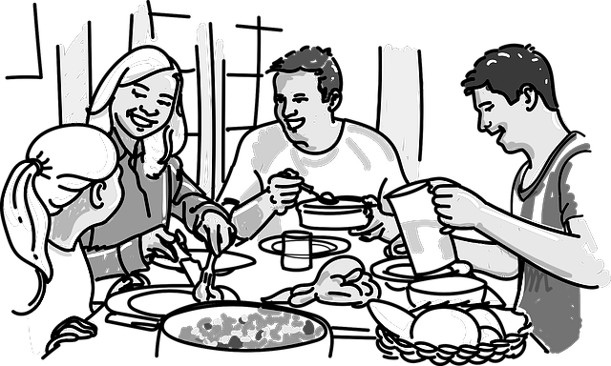

1. What is Tom's favorite breakfast?

Tom's favorite breakfast is cereal and a banana…………………………….

2. What does Lisa's mom love to eat for lunch?

Lisa's mom loves to eat chicken salad for lunch……………………..……….

3. What is Lisa's favorite dinner?

Lisa's favorite dinner is spaghetti with tomato sauce…………………..….

4. What food does Dad especially enjoy on Sundays?

Dad especially enjoys meatballs on Sundays……………………………………

5. What does Lisa like to eat for breakfast?

Lisa likes pancakes with syrup and apple juice for breakfast……………

**3. Write the names of the foods and drinks mentioned in the conversation at the café (10x5=50p)** E6.2.R2. Students will be able to understand the label of food products.

**. (5x4=20p)**

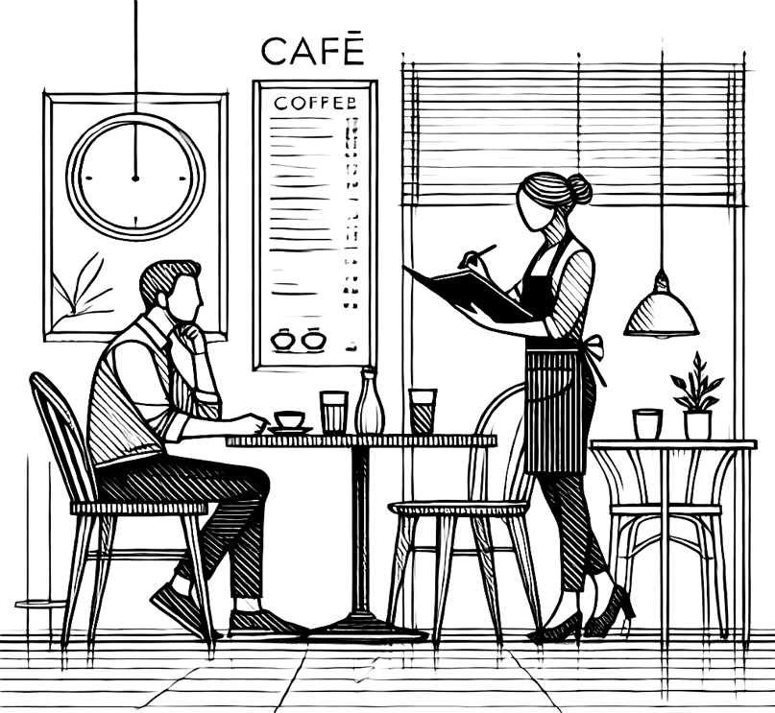

**Waitress:** Good morning! Welcome to Sunny Side Café!

**Mr. Thompson:** Good morning. I'd like something for breakfast. What do you recommend?

**Waitress:** We have a special breakfast combo today. It includes pancakes, toast, and a side of bacon. Would you like to try that?

**Mr. Thompson:** That sounds good, but I don't eat bacon. Do you have any vegetarian options?

**Waitress:** Of course! We have a veggie omelette with mushrooms, spinach, and tomatoes. It's very popular.

**Mr. Thompson:** Great, I'll have the veggie omelette. Could I also get a glass of milk with that?

**Waitress:** Sure, would you like anything else to drink? We have coffee, tea, orange juice, and water.

**Mr. Thompson:** I’ll start with coffee, please. And could you add a slice of avocado toast to my order?

**Waitress:** Absolutely. Just to let you know, we also offer freshly squeezed apple juice. It’s quite refreshing!

**Mr. Thompson:** That sounds lovely, but I’ll stick with coffee and milk for now.

**Waitress:** No problem. Your order will be right up. Enjoy your breakfast!

**Mr. Thompson:** Thank you very much!

|  |  |  |
| --- | --- | --- |
|  | **FOOD** | **DRINK** |
| 1 | TOST | MILK |
| 2 | BACON | COFFEE |
| 3 | OMELETTE | TEA |
| 4 | PANCAKE | ORANGE JUİCE |
| 6 | AVACADO (TOST) | WATER |

Mahir BARUT ………………………

İngilizce Öğretmeni Okul Müdürü