Değerlendirme:

Writing & Reading Oturumu 50/100: …………

Speaking & Listening Oturumu:50 /100 …..….…

Sınav notu 100/100 …………. ……..….

Name/Surname: …………………………………….….

Circle your class x below Student No:……………..

No: ……..

6th

|  |  |  |  |  |  |  |  |
| --- | --- | --- | --- | --- | --- | --- | --- |
| **A** | B | C | D | E | F | G | H |

**1- Write Mia’s diary according to the paragraph given below. (4x5= 20p)**

**(5x5=25)**

Hello! My name is Mia. Every week, I have different activities. On Mondays, I go to the library to read new books. On Tuesdays and Thursdays, I take ballet classes after school. Wednesdays are for my art lessons where I paint and draw. On Fridays, I like to play tennis with my friends. I also have piano lessons on Saturdays. Every evening, I spend time doing my homework and then watch a little TV before bed. Sundays are special because I go to the park with my family.



|  |  |  |  |  |  |  |
| --- | --- | --- | --- | --- | --- | --- |
| **Monday** | **Tuesday** | **Wednesday** | **Thursday** | **Friday** | **Saturday** | **Sunday** |
| Going to the library |  |  |  |  | Having piano lesson |  |

**2 Answer the questions according to the paragraph given below ( 5X6=30p)**

. Hello! My name is Lisa. For breakfast, I like pancakes with syrup and apple juice. My brother Tom prefers cereal and a banana. At lunch, I enjoy a cheese sandwich and carrots. My mom loves her chicken salad. For dinner, my favorite is spaghetti with tomato sauce. Sometimes, I have chocolate cake for dessert. My dad's favorite is meatballs, especially on Sundays. On weekends, we all enjoy eating pizza together, and we drink soda with it. Emily loves the pizza the most.

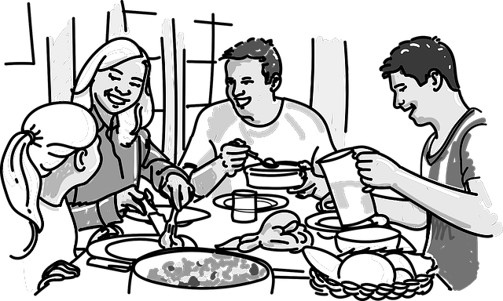

1. What is Tom's favorite breakfast?

…………………………………………………………………………………………………………………………………………………………………….

2. What does Lisa's mom love to eat for lunch?

…………………………………………………………………………………………………………………………………………………………………….

3. What is Lisa's favorite dinner?

…………………………………………………………………………………………………………………………………………………………………….

4. What food does Dad especially enjoy on Sundays?

…………………………………………………………………………………………………………………………………………………………………….

5. What does Lisa like to eat for breakfast?

…………………………………………………………………………………………………………………………………………………………………….

**3. Write the names of the foods and drinks mentioned in the conversation at the café (10x5=50p)**

**. (5x4=20p)**

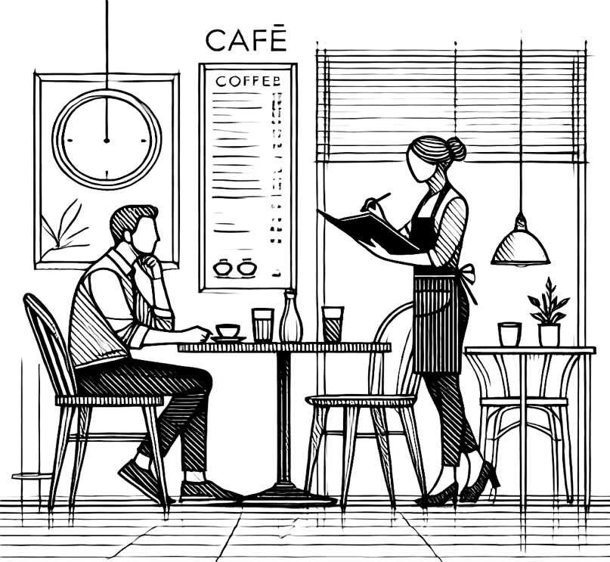

**Waitress:** Good morning! Welcome to Sunny Side Café!

**Mr. Thompson:** Good morning. I'd like something for breakfast. What do you recommend?

**Waitress:** We have a special breakfast combo today. It includes pancakes, toast, and a side of bacon. Would you like to try that?

**Mr. Thompson:** That sounds good, but I don't eat bacon. Do you have any vegetarian options?

**Waitress:** Of course! We have a veggie omelette with mushrooms, spinach, and tomatoes. It's very popular.

**Mr. Thompson:** Great, I'll have the veggie omelette. Could I also get a glass of milk with that?

**Waitress:** Sure, would you like anything else to drink? We have coffee, tea, orange juice, and water.

**Mr. Thompson:** I’ll start with coffee, please. And could you add a slice of avocado toast to my order?

**Waitress:** Absolutely. Just to let you know, we also offer freshly squeezed apple juice. It’s quite refreshing!

**Mr. Thompson:** That sounds lovely, but I’ll stick with coffee and milk for now.

**Waitress:** No problem. Your order will be right up. Enjoy your breakfast!

**Mr. Thompson:** Thank you very much!

|  |  |  |
| --- | --- | --- |
|  | **FOOD** | **DRINK** |
| 1 |  |  |
| 2 |  |  |
| 3 |  |  |
| 4 |  |  |
| 6 |  |  |

Mahir BARUT ………………………

İngilizce Öğretmeni Okul Müdürü