**1- Answer the questions according to the dialogue (5x6=30p) E7.3.R1.**. **E6.3.L2.** Students will be able to pick up the expressions in a dialogue comparing things

**Tom:** I think our school is bigger than the library.

**Sue**: Yes, it is. But the library is quieter than our school.

**Tom:** That's true. And the library has more books than our school.

**Sue:** Our school is newer than the museum. It has bigger windows.

**Tom:** The museum is older, but it is more interesting.

**Sue:** I agree. And the park is greener than the schoolyard.

**Tom:** Yes, the park is the best place to play. It is nicer than the gym.

**Sue:** But our gym is bigger than the one in the park.

**Tom:** You're right. It's great for sports. It's also cleaner than

the park



1. **Question:** Which is bigger, the school or the library? **Answer:** The school.
2. **Question:** Where are there more books, in the school or the library? **Answer:** The library.
3. **Question:** What is newer, the school or the museum? **Answer:** The school.
4. **Question:** Which place is greener, the park or the schoolyard? **Answer:** The park.
5. **Question:** Where is it nicer to play, in the park or the gym? **Answer:** In the park.

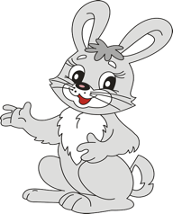

**2- Ask and answer the questions about the pictures as in the picture. (3x5=15p) E6.3.SI2.** Students will be able to ask people to comapre things.



**Question:** Which is more dangerous?

A crocodile or a rabbit?

**Answer:** A crocodile is more dangerous than a rabbit.

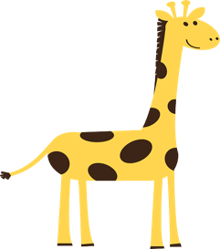

**dangerous**

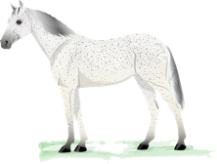

Question: Which is taller? A giraffe or a horse?

Answer: Giraffe is taller than horse

**tall**

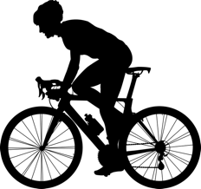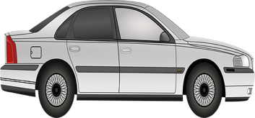

Question: Which is more expensive? A car or a bicycle?

Answer: A car is more expensive than a bicycle.

**Expensive**

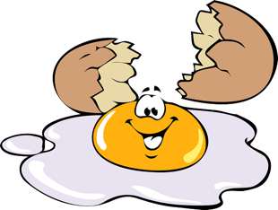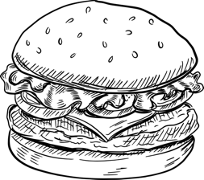

Question: Which is healtier? An egg or a hamburger?

Answer: An egg is healtier than a hamburger

**Healty**

**3- Look at the pictures and answer the questions. (20p) E6.3.SP1.** Students will be able to describe people doing different actions

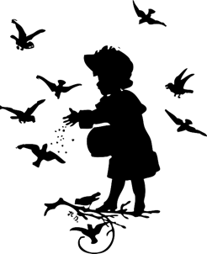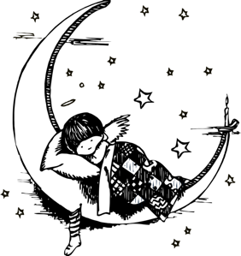

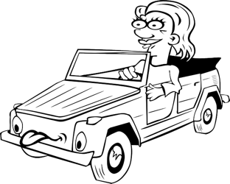

What is Clara doing?

Answer: She is reading a book.

What is Clara doing?

Answer: She is sleeping

What is she doing now?

Answer: She is feeding the birds.

What is Cate doing at the moment?

Answer: She is driving.

**4- Look at the pictures and asnwer the questions (20p) E6.4.L1.** Students will be able to pick up specific information from short oral texts about weather conditions and emotions.

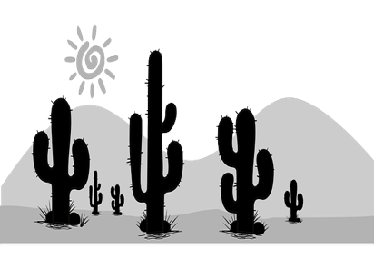

What is the wheather like in Canada?

Answer: **It’s 43 degrees Celsius**

What is the temperature in Egypt?

Anwer: It is snowing or It’s snowy

43 °C

Egypt

Canada

**5- Choose your emotion in the pictures according to the paragraph (3x5=15p) E6.4.R1** Students will be able to understand short and simple texts about the weather, weather conditions and emotios.

Weather can change how we feel. When it is sunny, we often feel happy. The sun is warm and bright. When it is raining, we might feel sad. Rain can make the day dark. Sometimes, when it is cloudy, we feel sleepy. Clouds hide the sun, and everything is grey. But when it snows, we can feel excited. Snow is white and pretty. It covers everything like a blanket. We can play in the snow. So, weather can make us feel different emotions. It is interesting how the sky can change our feelings.

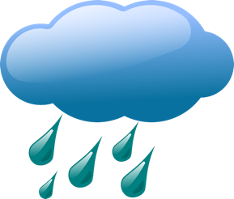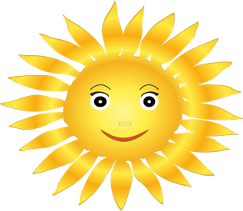



How do you feel?

I feel happy

How do you feel?

I feel sad

How do you feel?

I feel sleepy

Mahir BARUT ……………….. İngilizce Öğretmeni Okul Müdürü