Değerlendirme:

Writing & Reading Oturumu 50/100: …………

Speaking & Listening Oturumu:50 /100 …..….…

Sınav notu 100/100 …………. ……..….

Name/Surname: …………………………………….….

Circle your class x below Student No:……………..

No: ……..

|  |  |  |  |  |  |  |  |
| --- | --- | --- | --- | --- | --- | --- | --- |
| **A** | B | C | D | E | F | G | H |

**1- Answer the questions according to the dialogue (5x6=30p)**

**Tom:** I think our school is bigger than the library.

**Sue**: Yes, it is. But the library is quieter than our school.

**Tom:** That's true. And the library has more books than our school.

**Sue:** Our school is newer than the museum. It has bigger windows.

**Tom:** The museum is older, but it is more interesting.

**Sue:** I agree. And the park is greener than the schoolyard.

**Tom:** Yes, the park is the best place to play. It is nicer than the gym.

**Sue:** But our gym is bigger than the one in the park.

**Tom:** You're right. It's great for sports. It's also cleaner than

the park

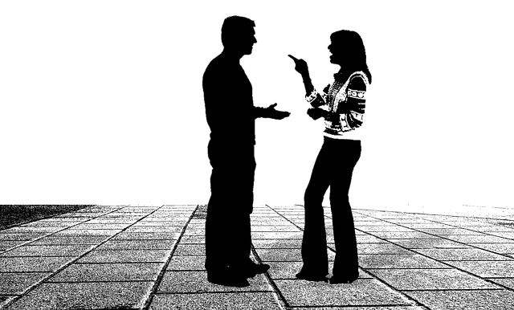

1. Which is bigger, the school or the library? **Answer:** ……………………………
2. Where are there more books, in the school or the library? **Answer:** ……………………………
3. What is newer, the school or the museum? **Answer:** ……………………………
4. Which place is greener, the park or the schoolyard? **Answer:** ……………………………
5. Where is it nicer to play, in the park or the gym? **Answer:** ……………………………

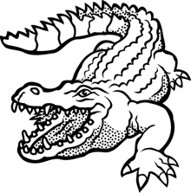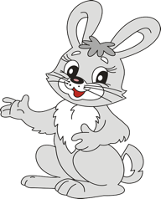

**2- Ask and answer the questions about the pictures as in the picture. (3x5=15p) E6.3.SI2.** Students will be able to ask people to comapre things.

**Question:** Which is more dangerous?

A crocodile or a rabbit?

**Answer:** A crocodile is more dangerous than a rabbit.

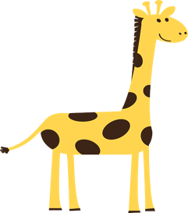

**dangerous**

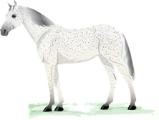

Question: ………………………………………………………….….……………….…..…..

Answer: ………………………………………………………………….……………………....

**long**

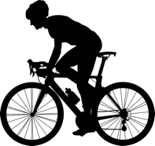

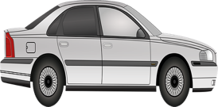

Question: ………………………………………………………….….……………….…..…..

Answer: ………………………………………………………………….……………………....

**Expensive**

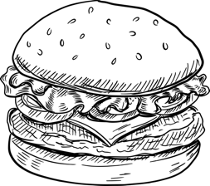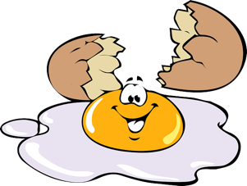

Question: ………………………………………………………….….……………….…..…..

Answer: ………………………………………………………………….……………………....

**Healty**

**3- Look at the pictures and answer the questions. (20p) E6.3.SP1.** Students will be able to describe people doing different actions

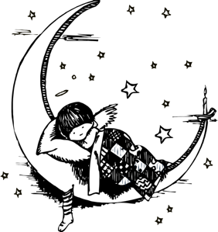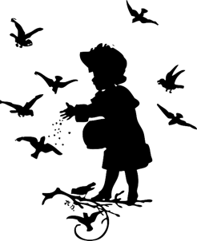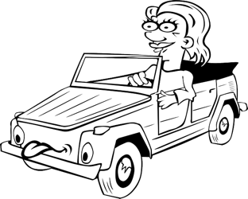

What is Clara doing?

Answer:

What is Clara doing?

Answer:

What is she doing now?

Answer:

What is Cate doing at the moment?

Answer:

**4- Look at the pictures and asnwer the questions (2x10=20p)**

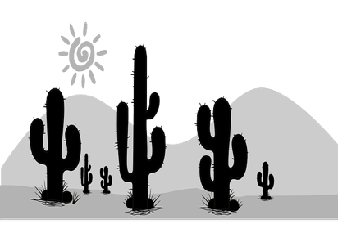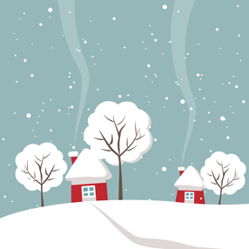

What is the wheather like in Canada?

Answer:………………………………………….

What is the temperature in Egypt?

Anwer:………………………………………….

43 °C

Egypt

Canada

**5- Choose your emotion in the pictures according to the paragraph (3x5=15p)**

Weather can change how we feel. When it is sunny, we often feel happy. The sun is warm and bright. When it is raining, we might feel sad. Rain can make the day dark. Sometimes, when it is cloudy, we feel sleepy. Clouds hide the sun, and everything is grey. But when it snows, we can feel excited. Snow is white and pretty. It covers everything like a blanket. We can play in the snow. So, weather can make us feel different emotions. It is interesting how the sky can change our feelings.

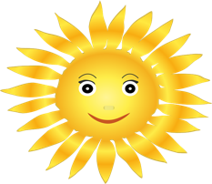

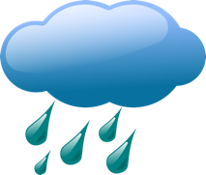

How do you feel?

How do you feel?

How do you feel?

Mahir BARUT ……………….. İngilizce Öğretmeni Okul Müdürü