2025-2026 EĞİTİM ÖĞRETİM YILI
…………………………………………………………………ORTAOKULU
6. SINIF İNGİLİZCE BEP 2. DÖNEM 1. SINAV
CEVAP ANAHTARI by ingilizcepedia
1- Resimlere bakın ve kutudaki doğru lunapark oyuncağını yazın. (5x5=25p) (25p)
BEP: Students will be able to identify fair rides with visual support.
1  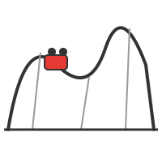  roller coaster | 2  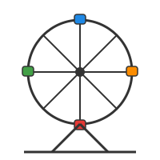  ferris wheel | 3    bumper car
4    carousel | 5  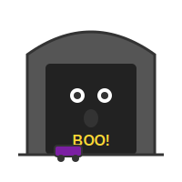  ghost train

2- Resimlere bakın ve meslekleri doğru işyerleriyle eşleştirin. (5x5=25p) (25p)
BEP: Students will be able to match occupations to workplaces with visual support.
1    doctor  (c) hospital | 2    nurse  (e) hospital | 3  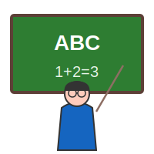  teacher  (a) school
4    cook  (d) restaurant | 5    farmer  (b) farm

2025-2026 EĞİTİM ÖĞRETİM YILI
…………………………………………………………………ORTAOKULU
6. SINIF İNGİLİZCE BEP 2. DÖNEM 1. SINAV
CEVAP ANAHTARI by ingilizcepedia
3- Metni okuyun ve Doğru (T) veya Yanlış (F) yazın. (5x5=25p) (25p)
BEP: Students will be able to understand simple texts about fairs and express feelings.
A Day at the Fair
Last weekend, Cem and his family went to the fair. Cem went on the roller coaster. It was very exciting! His sister Elif rode the carousel. She thinks carousels are fun. Their father tried the ghost train, but he thinks it was frightening. They all loved the ferris wheel because the view was amazing. Cem says: “I think fairs are great!”

1 | Cem went on the ferris wheel first. | FALSE
2 | The roller coaster was exciting. | TRUE
3 | Elif rode the carousel. | TRUE
4 | Their father thinks the ghost train was fun. | FALSE
5 | Cem thinks fairs are great. | TRUE

4- Doğru cevabı seçin. A, B veya C’yi daire içine alın. (5x5=25p) (25p)
BEP: Students will be able to recognize occupations, workplaces, feelings and dates.
1. B) hospital
2. B) exciting
3. A) teacher
4. C) on
5. A) frightening

Mahir BARUT ………………………………………
İngilizce Öğretmeni Okul Müdürü

