2025-2026 ACADEMIC YEAR
………………………………………………………………………SECONDARY SCHOOL
6th GRADE 2nd Semester - 2nd BEP Exam by ingilizcepedia
Name / Surname: ______________________________ Class: _______ Number: _______

Q1. Resimlere bakın ve kutudaki doğru kelimeyi yazın. (5x5=25 points)
(Look at the pictures and write the correct word from the box.)
forest / lake / mountain / beach / snowman

1.  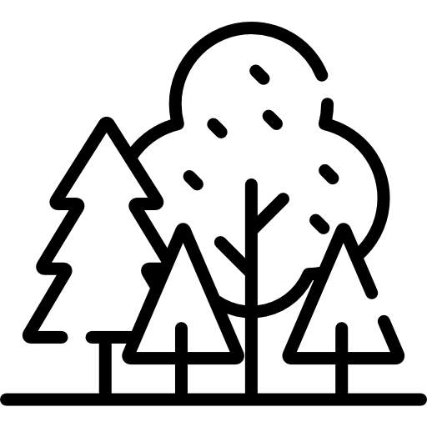 | 2.  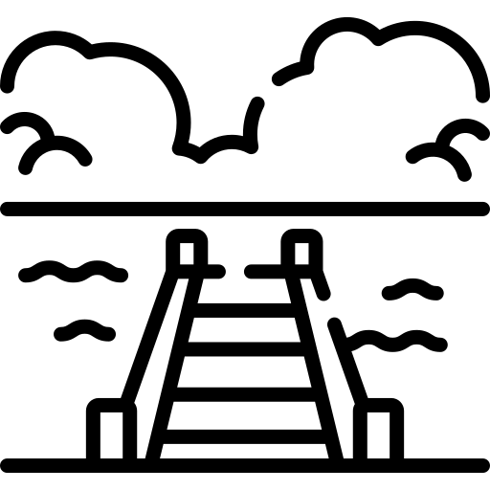 | 3.   | 4.  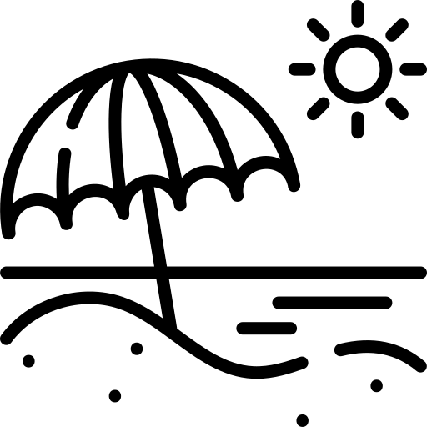 | 5.  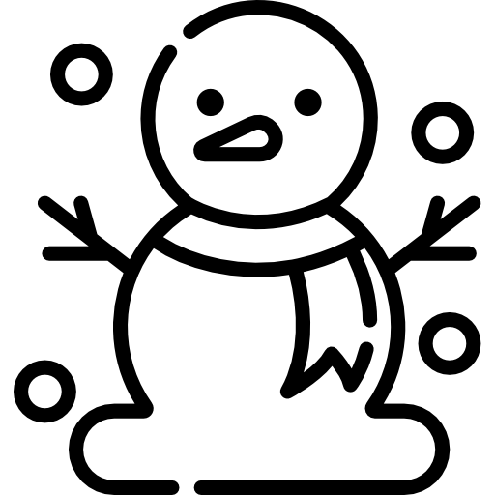
___________ | ___________ | ___________ | ___________ | ___________

Q2. Metni okuyun ve Doğru (T) veya Yanlış (F) yazın. (5x5=25 points)
(Read the text and write True (T) or False (F).)
My Holiday
Last week, I went to the seaside with my family. We walked on the beach and climbed the mountains. My sister picked flowers in the forest. We played near the lake. We enjoyed it very much!

# | Sentence | T / F
1 | The family went to the seaside. | ( )
2 | They climbed the mountains. | ( )
3 | The sister picked fruit. | ( )
4 | They played near the river. | ( )
5 | They enjoyed the holiday. | ( )

Q3. Boşlukları kutudaki doğru kelimeyle doldurun. (5x5=25 points)
(Fill in the blanks with the correct word from the box.)
next to / behind / between / under / in front of

# | Resim | Sentence
1 | 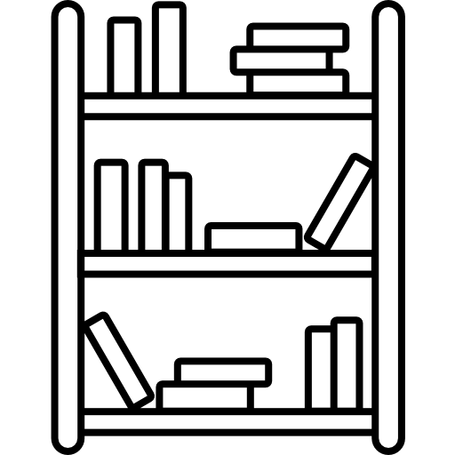 | The dictionary is ___________ the novels on the shelf. (yanında / next to)
2 |  | The bag is ___________ the door. (arkasında / behind)
3 |  | The lake is ___________ the forest and the mountain. (arasında / between)
4 |  | The cat is ___________ the table. (altında / under)
5 |  | The school is ___________ the library. (önünde / in front of)

Q4. Doğru cevabı seçin. A, B veya C'yi daire içine alın. (5x5=25 points)
(Choose the correct answer. Circle A, B or C.)
# | Resim | Question
1 |  | She _______ a great novel last night.  A) reads B) read C) reading
2 |  | He _______ his dictionary under the bed.  A) finds B) found C) finding
3 |  | I _______ for my book everywhere.  A) looked B) look C) looking
4 |  | We _______ in the forest last summer.  A) walks B) walk C) walked
5 |  | They _______ near the seaside last holiday.  A) play B) played C) playing

İngilizce Öğretmeni Okul Müdürü
Mahir BARUT .........................

