**1- Anwer the questions under the pictures according to the dialogue. (4x5=20p) E6.5.R1. Students will be able to understand general meaning in simple texts related to the feelings and personal opinions about places and things.**

**Liam:** "Hey Maya, let’s ride the Ferris wheel!"  
**Maya:** "No, Liam! I think Ferris wheels are dull. I love the roller coaster—it’s amazing!"  
**Liam:** "Roller coasters are terrifying! The bumper cars are better. They’re so funny!"  
**Maya:** "Hmm, I think bumper cars are boring. But the carousel is fantastic!"  
**Liam:** Carousels are too slow. I don’t like it. But I still think this fun park is exciting!

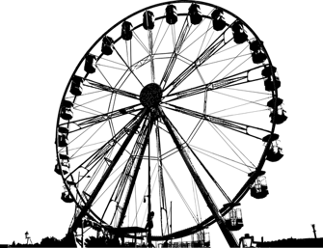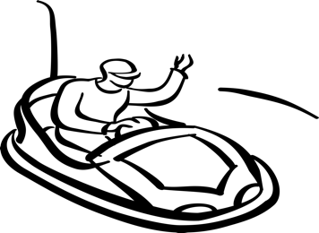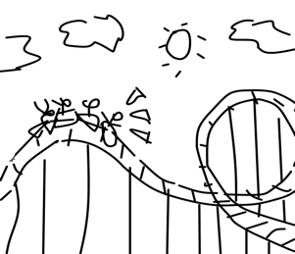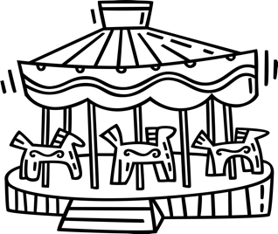

**1.** What does **Maya** think about **the Ferris Wheel?**  
__She thinks Ferris wheels are dull_______________

**3.** Does **Maya** like **roller coasters**?  
___Yes, she loves roller coasters_____________

**4.** Does **Liam** like **the carousel?**___No, she doesn’t like the carouse__________

**2.** What does **Liam** think about the **bumper cars**?  
____She thinks bumber cars so funny________

**2- Answer the questions according to the dialogue (5x6=30p) E6.7.R1. Students will be able to understand short, simple sentences and expressions related to past activities.**

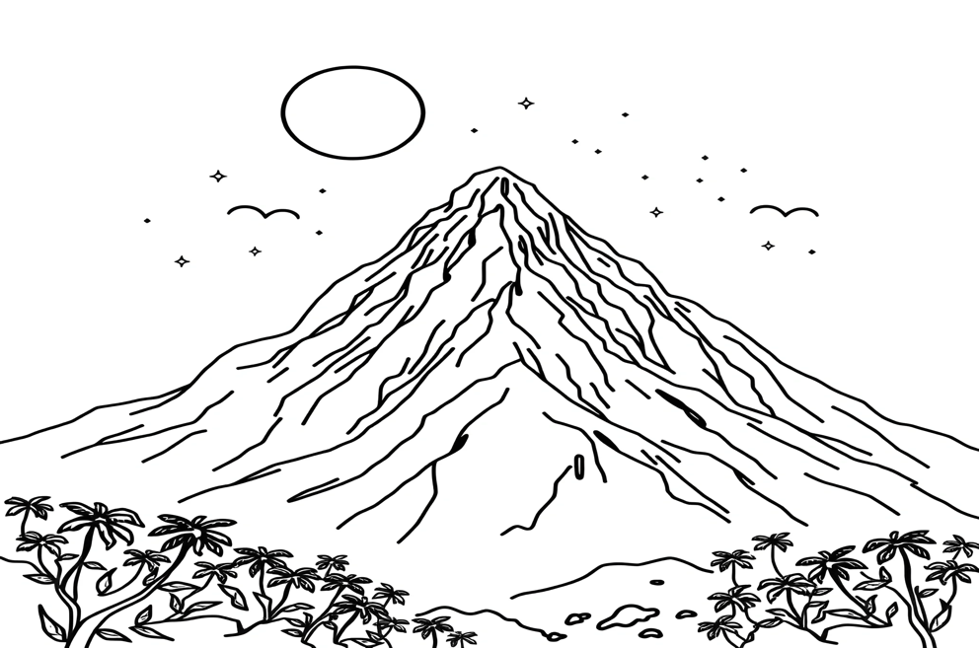

My friends Joe, Mia, and I, Anakin, went on a trip to Mount Everest in 2020. It was summer, but the weather was very cold. We slept in a tent. My friends climbed Everest, but I didn’t. I waited for my friends at the campsite. I learned to climb in Antalya two years ago. Finally, I climbed a mountain named “Olympos” in Kemer last year.

It was a fantastic adventure.

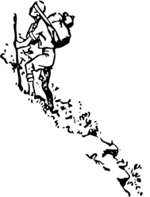

1. When did Anakin learn to climb? ___He learned to climb two years ago________

2. When did they go to Mount Everest? ____They went to Mount Everest in 2020_____

3. Did Anakin climb Mount Everest? ____No, he didn’t _______________________

4. Did Mia climb Mount Everest? ____Yes, she did ________________________

5. Where did Anakin climb a mountain? ____He climbed Olympos in Kemer ___________

**3- Look at these cute cats and answer their questions according to the pictures. (4x5=20p) E6.8.W2. Students will be able to write about the locations of people and things.**

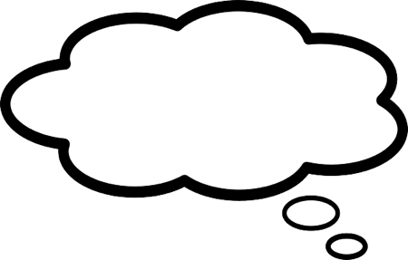



Pur!

Where am I?

Meow!

Where am I?

Where am I?

Mew! Mew!

Where am I?

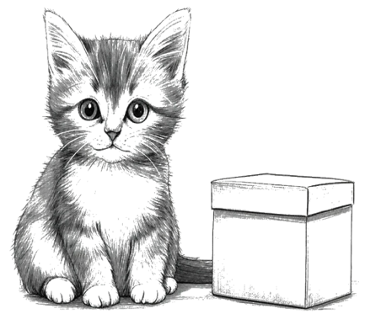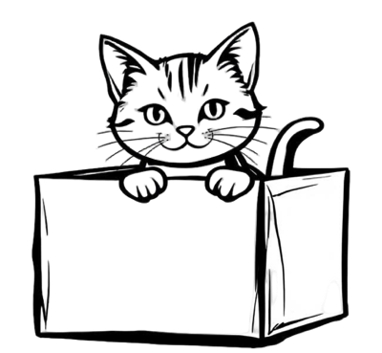

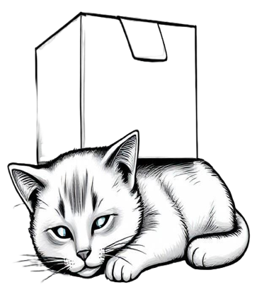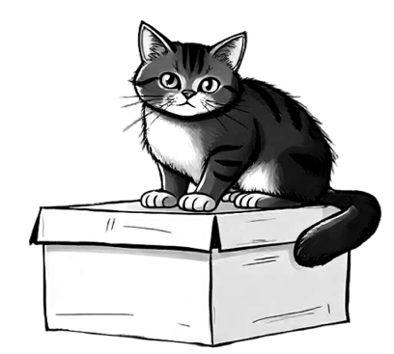

You are near/next to/ beside the box….

You are under the box….

You are on the box……..

You are in the box…..

**4- Answer the questions according to the paragraph given below. (5x6=30p) E6.9.R1. Students will be able to understand the texts about the protection of the environment.**



***Protecting Our***

***Environment***

Rubbish in parks and streets can harm animals and pollute nature. We should keep public places clean and separate garbage for recycling. Last weekend, my sister Carol and I helped protect the environment. First, we picked up litter in our neighborhood. Next, we separated paper and plastic into recycling bins. We also planted a small tree in our garden to help the forest. At home, we turned off the lights to save energy. Finally, we learned about the importance of clean water. Boats can pollute the sea. My sister said,

“Never throw trash into the water!”

1. What did they do to help the forest?

..They planted a small tree in their garden….

2. How did they save energy at home?

.. They turned off the lights………………….

3. What did Carol say about clean water?

.. She said, “Never throw trash into the water!”

4. What should we do to recycle garbage?

.. We should separate garbage for recycling….

5. What did they do to clean their neigborhood?

..They picked up litter in their neighborhood…

Mahir BARUT ……………….

İngilizce Öğretmeni Okul Müdürü