Writing & Reading Oturumu (%50) 100/ …………

Speaking (%25) 100/……….…

Listening (%25) 100/ …..….…

6th

Name/Surname: …………………………………….….

Circle your class x below Student No:……………..

No: ……..

|  |  |  |  |  |  |  |  |
| --- | --- | --- | --- | --- | --- | --- | --- |
| **A** | B | C | D | E | F | G | H |

**1- Anwer the questions under the pictures according to the dialogue. (4x5=20p)**

**Liam:** "Hey Maya, let’s ride the Ferris wheel!"  
**Maya:** "No, Liam! I think Ferris wheels are dull. I love the roller coaster—it’s amazing!"  
**Liam:** "Roller coasters are terrifying! The bumper cars are better. They’re so funny!"  
**Maya:** "Hmm, I think bumper cars are boring. But the carousel is fantastic!"  
**Liam:** Carousels are too slow. But I still think this fun park is exciting! There are many fun rides.

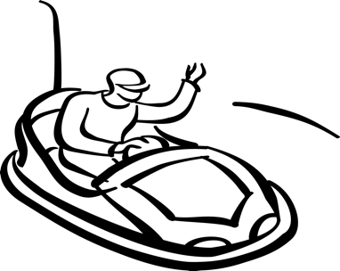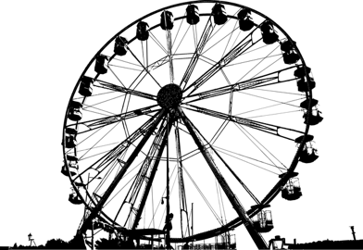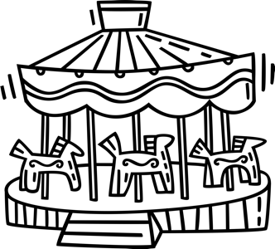

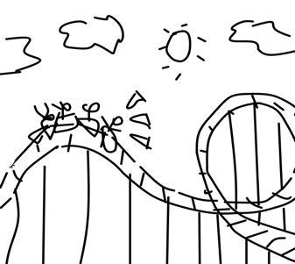

**2.** What does **Liam** think about the **bumper cars**?  
____________________________________________

**4.** Does **Liam** like **the carousel?**______________________________________________

**3.** Does **Maya** like **roller coasters**?  
____________________________________________

**1.** What does **Maya** think about **the Ferris Wheel?**  
__________________________________________

**2- Answer the questions according to the dialogue (5x6=30p)**

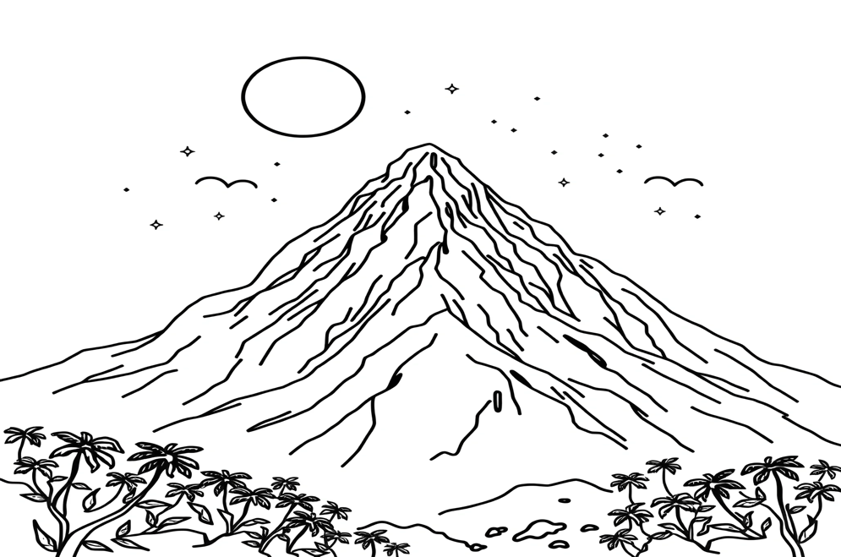

My friends Joe, Mia, and I, Anakin, went on a trip to Mount Everest in 2020. It was summer, but the weather was very cold. We slept in a tent. My friends climbed Everest, but I didn’t. I waited for my friends at the campsite. I learned to climb in Antalya two years ago. Finally, I climbed a mountain named “Olympos” in Kemer last year.

It was a fantastic adventure.

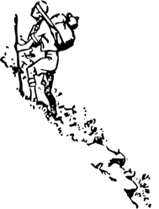

1. When did Anakin learn to climb? ________________________________________

2. When did they go to Mount Everest? ________________________________________

3. Did Anakin climb Mount Everest? ________________________________________

4. Did Mia climb Mount Everest? ________________________________________

5. Where did Anakin climb Olympos? ________________________________________

**3- Look at these cute cats and answer their questions according to the pictures. (4x5=20p)**





Meow!

Where am I?

Where am I?

Mew! Mew!

Where am I?

Pur!

Where am I?

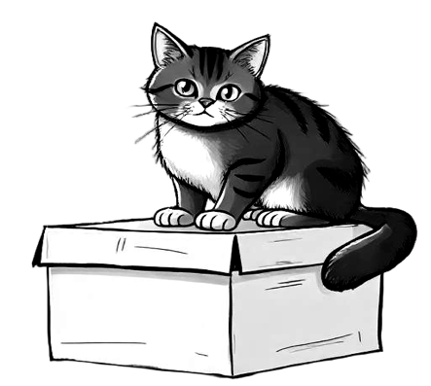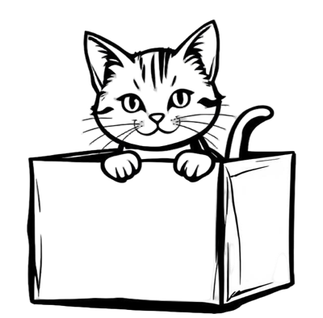

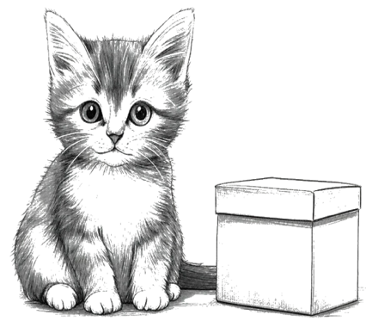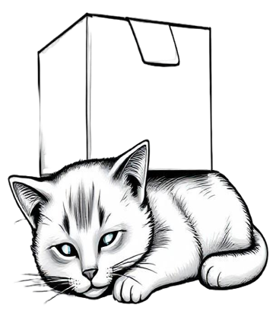

You are …………………………..

You are …………………………..

You are …………………………..

You are …………………………..

**4- Answer the questions according to the paragraph given below. (5x6=30p)**



***Protecting Our***

***Environment***

Rubbish in parks and streets can harm animals and pollute nature. We should keep public places clean and separate garbage for recycling. Last weekend, my sister Carol and I helped protect the environment. First, we picked up litter in our neighborhood. Next, we separated paper and plastic into recycling bins. We also planted a small tree in our garden to help the forest. At home, we turned off the lights to save energy. Finally, we learned about the importance of clean water. Boats can pollute the sea. My sister said,

“Never throw trash into the water!”

1. What did they do to help the forest?

……………………………………………………………………..

2. How did they save energy at home?

……………………………………………………………………..

3. What did Carol say about clean water?

……………………………………………………………………..

4. What should we do to recycle garbage?

…………………………………………………………………….

5. What did they do to clean their neigborhood?

…………………………………………………………………….

Mahir BARUT ……………….. İngilizce Öğretmeni Okul Müdürü