**1- Fill in the chart according to the paragraph given below. (20p) E7.3.R1.** Students will be able to spot specific information about names and dates in past events in the written texts.

Two famous scientists are Albert Einstein and Marie Curie. Albert Einstein was born in Germany in 1879. He went to school there. He was very smart in physics and math. Einstein made a famous idea called the Theory of Relativity. It changed how we think about time and space. Marie Curie was born in Poland in 1867. She studied in Paris. Curie was very good in chemistry. She found two elements, radium and polonium. She won two Nobel Prizes. Einstein and Curie helped us understand the world better. Their work is very important.

|  |  |  |
| --- | --- | --- |
| Name | Albert Einstein | Marie Curie |
| Place of birth | Germany | Poland |
| Date of birth | 1879 | 1867 |
| Education | Physics and Math | Chemistry |
| Achievements | the Theory of Relativity | radium and polonium and two Nobel Prizes |

**2- Write a short bio by using the clues given in the box. (20p) E7.3.W1.** Students will be able to write a short and simple report about past events.

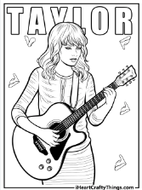

Taylor Swift/singer/born in1989/USA

Later/solo singer

First sang in a band/ called “the factory”

All over/big star

Taylor Swift/singer/born in1989/USA

Songs about love and life

Not married

Anwer: Taylor Swift is a famous singer. She was born in the USA in 1989. Taylor first sang in a band called "The Factory" when she was young. Later, she became a solo singer. Her best album is "1989." It has many popular songs. Taylor is not married. She writes songs about love and life. People all over the world like her music. Taylor Swift is a big star**. Or**

**STUDENTS’ OWN ANSWERS….**

**3- Write what happened in 2023 and try to guess why they are important and using the clues in the table 20p) E7.3.SP1.** Students will be able to describe past events and experiences.

"Exciting Scientific Advances Mark a Remarkable Year in 2023"

Discovery / Invention / development

Planet” Exo-Earth” / HeartHeal / RoboHelper

A new Home. / Medicine / Robot

Astronomers discovered a new planet named "Exo-Earth 2023." This planet was special because it looked like Earth.

Doctors: developed a new medicine called "HeartHeal." It is important because It can help people with heart problems

Developers: developed s new robot named "RoboHelper" RoboHelper can do many things in homes.

**4- Read the text and write four suggestions about protecting wildlife. (4x5=20p) E7.4.SP1.** Students will be able to make simple suggestions.

To protect wildlife, we have many easy ways. First, do not buy things made from wild animals. This means things like ivory from elephants or fur coats. Buying these things can hurt animals. Second, plant trees and flowers. Trees and flowers give animals places to live and food to eat. Third, always throw your trash in the bin. Trash in forests or rivers is bad for animals. It can make them sick. Fourth, save water at home. When we use less water, there is more clean water for animals. Fifth, learn about animals. Go to the library and read books about them. Knowing more about animals can help us protect them better. Lastly, tell your friends and family how to help. When many people work together, it is better for wildlife. These steps are simple but very important. By doing these, we help animals and our planet.

1. **Avoid Buying Wildlife Products:** Don't purchase items made from wild animals, like ivory or fur.
2. **Plant Trees and Flowers:** Create natural habitats for wildlife by planting trees and flowers in your area.
3. **Dispose of Trash Properly:** Always throw your garbage in bins to prevent pollution in natural habitats.
4. **Conserve Water:** Use less water at home to ensure there's enough clean water for wildlife in their habitats. **Or STUDENTS’ OWN ANSWERS**

**5- Find the animals in the text and put them in the correct box below.(20p)**

**E7.4.R2.** Students will be able to spot the names of wild animals in simple texts.

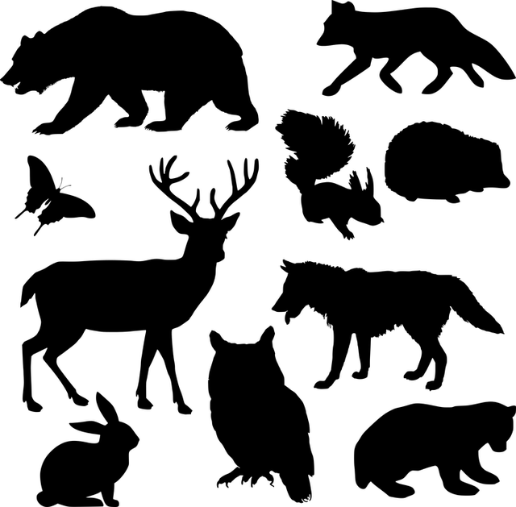

Animals are interesting. Elephants are big and have long trunks. They are very strong. Falcons can fly very fast. They can see well. Crocodiles live in water and have big mouths with sharp teeth. Horses run fast and are very friendly. Eagles have strong wings. They fly high in the sky. Snakes are long and have no legs. They move on the ground. Whales are very big animals that live in the sea. They swim and jump in the water. Owls can see at night. They fly quietly. Lizards are small and have four legs. They like to sit in the sun. These animals are different and have their own special things. Animals are amazing.

|  |  |  |
| --- | --- | --- |
| BIRDS | MAMALS | REPTILES |
| Falcons (2p) | Elephants (2p) | Crocodiles (2p) |
| Eagles (2p) | Horses (2p) | Snakes (2p) |
| Owls (2p) | Whales (2p) | Lizards (4p) |

Mahir BARUT ……………….. İngilizce Öğretmeni Okul Müdürü