2025-2026 ACADEMIC YEAR
………………………………………………………………………SECONDARY SCHOOL
7th GRADE 2nd Semester - 2nd BEP Exam by ingilizcepedia
Name / Surname: ______________________________ Class: _______ Number: _______

Q1. Resimlere bakın ve kutudaki doğru kelimeyi yazın. (5x5=25 points)
(Look at the pictures and write the correct word from the box.)

amusement park / art gallery / chemist's / fire station / movie theater

1.   | 2.   | 3.   | 4.  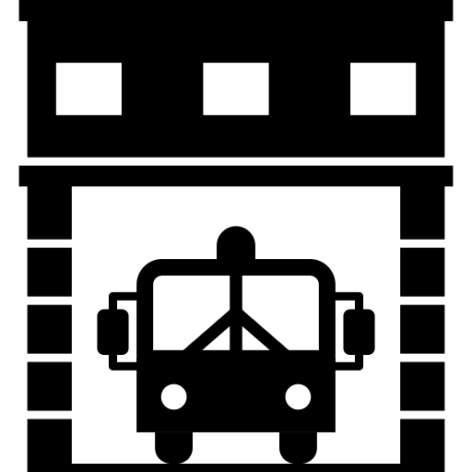 | 5.  
___________ | ___________ | ___________ | ___________ | ___________

Q2. Metni okuyun ve Doğru (T) veya Yanlış (F) yazın. (5x5=25 points)
(Read the text and write True (T) or False (F).)

My Dreams  My name is Ali. I have big dreams for the future. I will study hard at university. I may become a doctor. I will travel to many countries. I may not live in a small city. The world will be a more peaceful place. I hope so! | 

# | Sentence | T / F
1 | Ali will study hard at university. | ( )
2 | Ali will definitely become a doctor. | ( )
3 | Ali will not travel to other countries. | ( )
4 | Ali may live in a small city. | ( )
5 | Ali hopes the world will be peaceful. | ( )

Q3. Boşlukları kutudaki doğru kelime grubuyla doldurun. (5x5=25 points)
(Fill in the blanks with the correct phrase from the box.)
to watch / to buy / to report / to see / to have fun

# | Resim | Sentence
1 |  | She went to the movie theater ___________ a film. (izlemek için / to watch)
2 |  | He went to the chemist’s ___________ some medicine. (almak için / to buy)
3 |  | They went to the fire station ___________ the fire. (bildirmek için / to report)
4 |  | She went to the art gallery ___________ the paintings. (görmek için / to see)
5 |  | We went to the amusement park ___________ fun. (eğlenmek için / to have fun)

Q4. Doğru cevabı seçin. A, B veya C'yi daire içine alın. (5x5=25 points)
(Choose the correct answer. Circle A, B or C.)
# | Resim | Question
1 |  | I want to watch a film. I should go to the _______.  A) bakery B) movie theater C) fire station
2 |  | I am sick. I _______ go to the chemist's for medicine.  A) should B) may not C) went
3 |  | The world _______ be a more peaceful place in the future.  A) was B) will C) went
4 |  | He went to the fire station _______ the fire.  A) to report B) report C) reporting
5 |  | I _______ travel to many countries next year.  A) went B) will C) goes
İngilizce Öğretmeni Okul Müdürü
Mahir BARUT ......................... ..........................

