**1- Read the chat messages between friends. Then answer the questions about the invitation. Write the names (4x6=24p). E7.6.R1. Students will be able to understand texts about celebrations.**



1. Who makes an invitation?  
....Thomas....

**Thomas:**  
Hey guys! Let’s organize a surprise birthday party for Sarah on Saturday!

2. Who accepts the invitation?  
..........Julia.......

**Lisa:**  
Wow, that sounds fun! What

time will it start?



4. Who asks for more information?  
.........Lisa......

3. Who refuses the invitation?  
.......Edward.......



**Edward:**  
I wish I could come, but I’m visiting my

grandma that day.

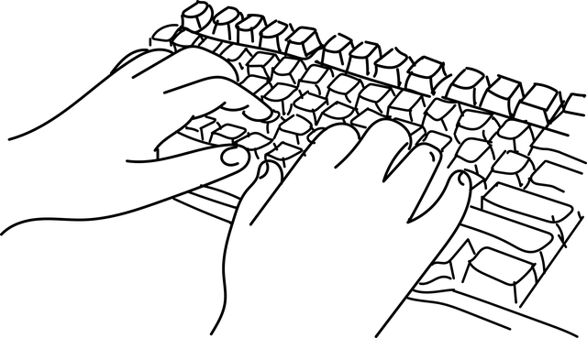



**Julie:**  
 Great idea! Count me in!

**2- Write one prediction for Jason, Bruce, and Steven according to the dialogue. (3x5=15p) E7.7.R1. Students will be able to understand short and simple texts about predictions.**

**Steven**: Do you think robots will be a part of our daily life in the future?

**Jason**: Yes, I do. I think robots will help us at home. They will cook meals, clean the house, and maybe even help with homework. People will have more free time.

**Bruce**: That’s a good idea, but I think robots may also take our jobs. Many people may lose their work. I’m a bit worried about that.

**Steven**: I think robots will work at dangerous places like space or deep under the sea. They will make life easier and safer.

Steven: I think robots will work at dangerous places………………………………………………………………………

Jason: I think robots will help us at home……..

………………………………………………………………………………….

Bruce: I think robots may also take our jobs..

………………………………………………………………………………..

**3- Answer the question using these reasons ( to see a doctor, to read a book, to watch a movie, and to mail a letter) according to the places given below. (4x4=16p) E7.8.R1. Students will be able to understand simple expressions and recognize familiar words about explanations with reasons.**

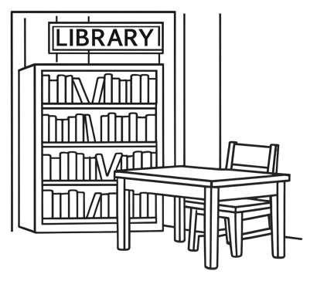

**Why do people go to these places?**



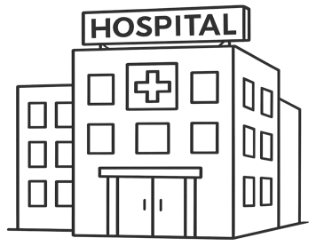

People go to the cinema to watch a movie

People go to the hospital to see a doctor

People go to the post offfice to mail a letter

People go to the library to read a book

**4- Answer the questions according to the paragrapg given below. (5x6=30p) E7.9.R1. Students will be able to identify specific information in various texts about environment**



1. What does the Earth have?

… Clean air, water, and trees………………

2. What do people throw in the rivers?

……Trash…….……………………………………..

3. Why is cutting trees a problem?

……Trees gives us clean air………………..

4. What makes the air dirty?

……Smoke from car…………………………..

5. Who make the Earth dirty?

….. People………………………………………..

The Earth is our home. It has clean air, water, and trees. But people make the Earth dirty. They throw trash in the rivers.

This makes the water bad for fish. People also cut trees. Trees give us clean air, so this is a problem. Cars make smoke. The smoke makes the air dirty. We can help the Earth! We can walk or ride a bike. We can pick up trash. We can plant new trees.

**5- Welcome to the Green Earth Club! Look at the pictures on our club board. Write a short message, motto, or slogan under each picture to help save the environment. Use simple words. (3x5=15p) E7.9.W1. Students will be able to write short, simple messages about environment.**

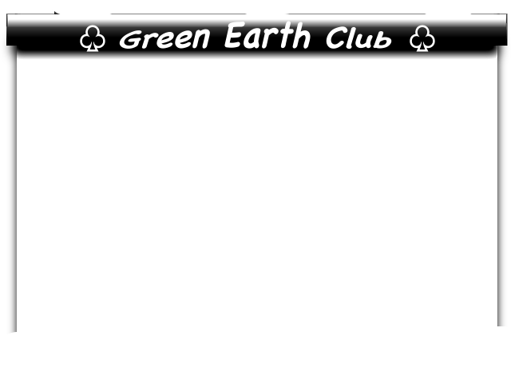

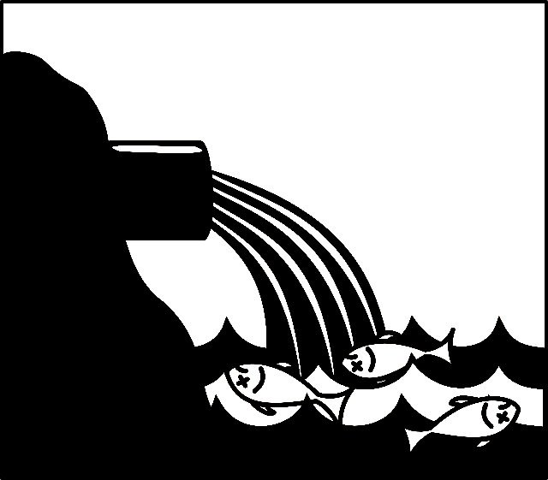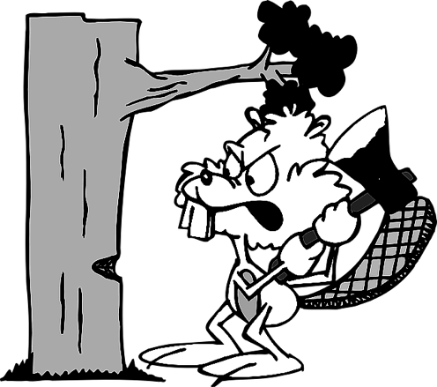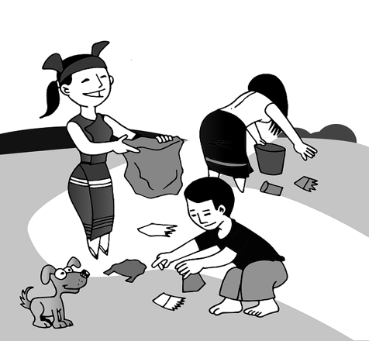



STUDENTS’ OWN ANSWERS such as

“Pick up trash

in the park!”

STUDENTS’ OWN ANSWERS

STUDENTS’ OWN ANSWERS

Mahir BARUT ……………….. İngilizce Öğretmeni Okul Müdürü