Writing & Reading Oturumu (%50) 100/ …………

Speaking (%25) 100/……….…

Listening (%25) 100/ …..….…

7th

Name/Surname: …………………………………….….

Circle your class x below Student No:……………..

No: ……..

|  |  |  |  |  |  |  |  |
| --- | --- | --- | --- | --- | --- | --- | --- |
| **A** | B | C | D | E | F | G | H |

**1- Read the chat messages between friends. Then answer the questions about the invitation. Write the names. (4x6=24p)**



2. Who accepts the invitation?  
..........................

1. Who makes an invitation?  
............................

**Thomas:**  
Hey guys! Let’s organize a surprise birthday party for Sarah on Saturday!

**Lisa:**  
Wow, that sounds fun! What

time will it start?

3. Who refuses the invitation?  
.......................



4. Who asks for more information?  
........................

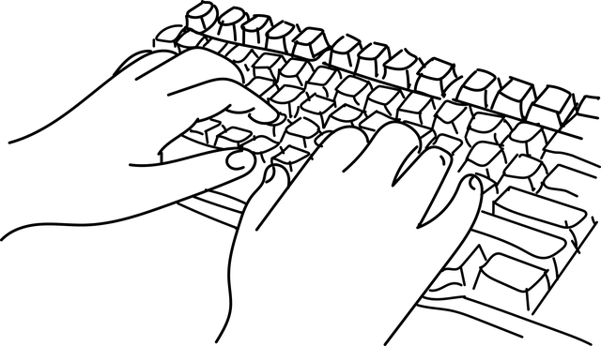

**Edward:**  
I wish I could come, but I’m visiting my

grandma that day.



**Julie:**  
 Great idea! Count me in!

**2- Write one prediction for Jason, Bruce, and Steven according to the dialogue. (3x5=15p)**

**Steven**: Do you think robots will be a part of our daily life in the future?

**Jason**: Yes, I do. I think robots will help us at home. They will cook meals, clean the house, and maybe even help with homework. People will have more free time.

**Bruce**: That’s a good idea, but I think robots may also take our jobs. Many people may lose their work. I’m a bit worried about that.

**Steven**: I think robots will work at dangerous places like space or deep under the sea. They will make life easier and safer.

Steven: ………………………………………………………….

………………………………………………………………………

Jason: ………………………………………………………….

………………………………………………………………………

Bruce: ………………………………………………………….

………………………………………………………………………

**3- Answer the question using these reasons ( to see a doctor, to read a book, to watch a movie, and to mail a letter) according to the places given below. (4x4=16p)**

**Why do people go to these places?**

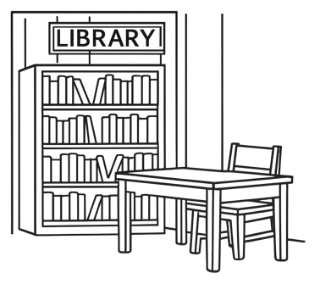



………………………………………….

………………………………………….

………………………………………….

………………………………………….

………………………………………….

………………………………………….

………………………………………….

………………………………………….

**4- Answer the questions according to the paragrapg given below. (5x6=30p)**



1. What does the Earth have?

………………………………………………………..

2. What do people throw in the rivers?

………………………………………………………..

3. Why is cutting trees a problem?

………………………………………………………..

4. What makes the air dirty?

………………………………………………………..

5. Who makes the Earht dirty?

……………………………………………………….

The Earth is our home. It has clean air, water, and trees. But people make the Earth dirty. They throw trash in the rivers.

This makes the water bad for fish. People also cut trees. Trees give us clean air, so this is a problem. Cars make smoke. The smoke makes the air dirty. We can help the Earth! We can walk or ride a bike. We can pick up trash. We can plant new trees.

**5- Welcome to the Green Earth Club! Look at the pictures on our club board. Write a short message, motto, or slogan under each picture to help save the environment. Use simple words. (3x5=15p)**



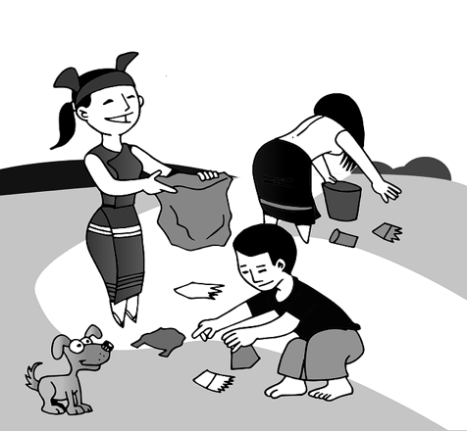

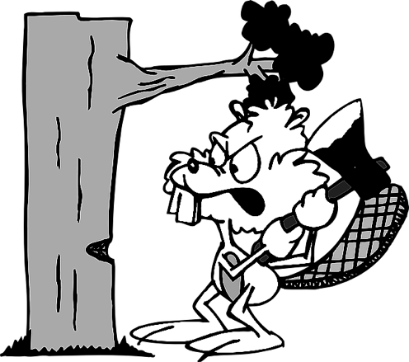





Mahir BARUT ……………….. İngilizce Öğretmeni Okul Müdürü