2025-2026 ACADEMIC YEAR
7th
……………………………………………………SECONDARY SCHOOL
7th GRADE 2nd Semester - 2nd Exam (Scenario 1) by ingilizcepedia
Name / Surname: ________________________________ | Class: ______ Number: ______
Q1. Read the text and answer the questions. (20 points)
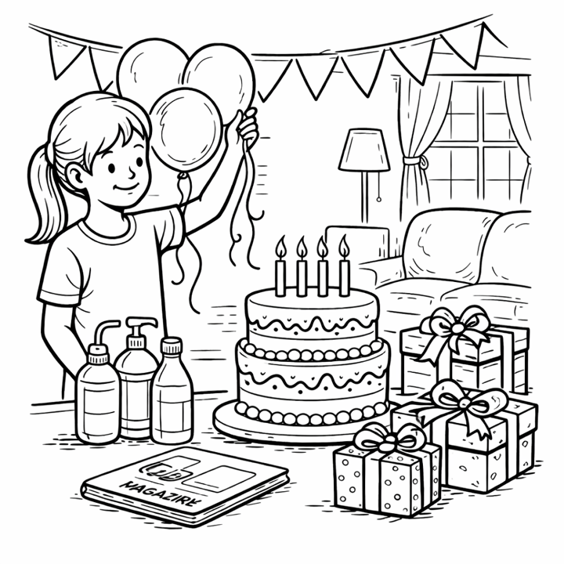

Danny's Birthday Party
Danny is organising a birthday party next Saturday. She is going to invite a lot of guests. First, she will decorate the living room with balloons. Then, she will wrap the gifts for a small game. Finally, she will arrange some beverages and a fancy cake. She sent an invitation card to her friends last week. Tom refused the invitation because he has to attend a family dinner, but Emma accepted it. Danny's mum will host the party and help with the food.

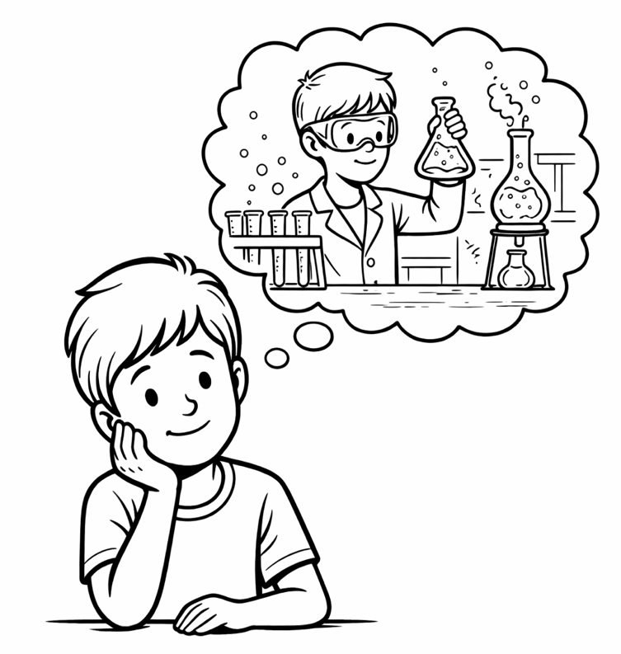
a) What does Chris dream of becoming?
_____________________________________________________________
b) Where does he imagine he will work?
_____________________________________________________________
c) What does Chris predict about scientists?
_____________________________________________________________
d) Why does his teacher think he will be successful?
_____________________________________________________________
e) What does Chris say about a peaceful world?
_____________________________________________________________
a) When is Danny's birthday party?
__________________________________________________________________
b) What will Danny do first?
__________________________________________________________________
c) Why did Tom refuse the invitation?
__________________________________________________________________
d) Who accepted the invitation?
__________________________________________________________________
e) Who will host the party?
__________________________________________________________________
Chris's Dream Career
Chris believes he will have an excellent career in the future. He dreams of becoming a scientist. He imagines he will probably work in a big laboratory. He predicts that scientists will receive more support from governments. "I guess I will make important discoveries," he says. He may travel to many countries for his research. His teacher thinks he will be successful because he is hardworking. Chris says, "I hope so! A peaceful world needs more science."

Q2. Read the text and answer the questions. (20 points)
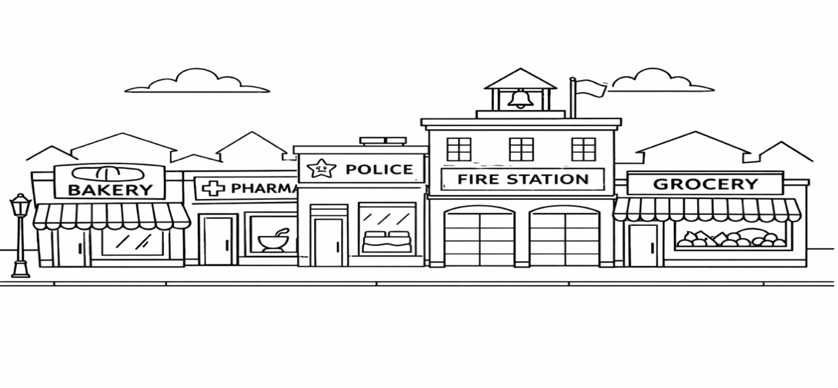
Q3. Read the text and answer the questions. (20 points)
Our Town Centre
There are many public buildings in our town centre. People go to the bakery to buy fresh bread every morning. You should go to the chemist's to get medicine when you are ill. The fire station is next to the police station. Students can visit the art gallery to see beautiful paintings. My mum goes to the grocery to buy fruit and vegetables.

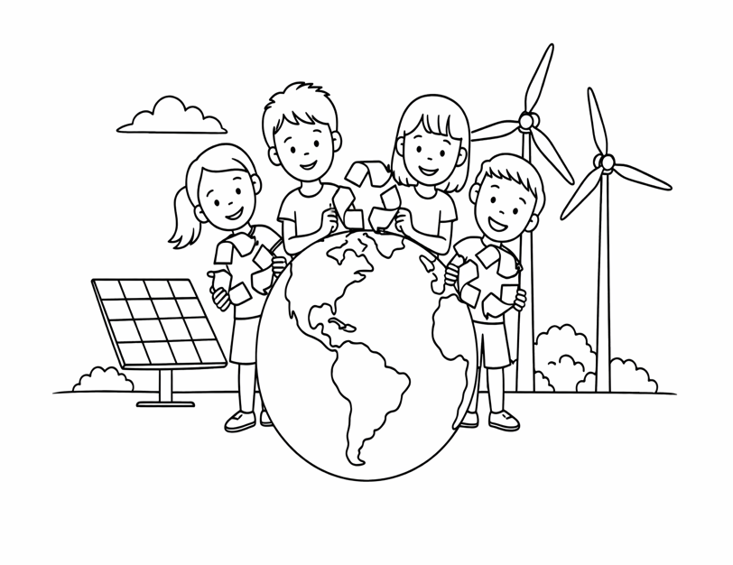
İngilizce Öğretmeni Okul Müdürü
Mahir BARUT ..........................
Q4. Look at the information card and write a paragraph about Emily's neighbourhood. Write at least 5 sentences. (20 points)
a) Why do people go to the bakery?
_____________________________________________________________
b) Where should you go to get medicine?
_____________________________________________________________
c) What is next to the police station?
_____________________________________________________________
d) Why can students visit the art gallery?
_____________________________________________________________
e) What does the writer's mum buy at the grocery?
_____________________________________________________________
NEIGHBOURHOOD INFO CARD
Name | Emily
City | Ankara
Favourite Place | coffee shop (quiet and peaceful)
Goes to bakery | to buy fresh bread
Goes to shopping centre | to buy new clothes
Weekend Activity | goes to the movie theater with friends

Protect Our Planet
Global warming is a big problem for our planet. The temperature is increasing because of pollution. We must take action to protect nature. First, we should recycle paper, plastic and glass. Then, we have to use renewable energy like solar energy and wind energy. We shouldn't waste water or electricity. If we are responsible and eco-friendly, we can keep the balance of nature. Everyone must do something because the climate is changing fast.
Q5. Read the text and answer the questions. (20 points)
a) What is a big problem for our planet?
___________________________________________________________________________
b) Why is the temperature increasing?
___________________________________________________________________________
c) What should we recycle?
___________________________________________________________________________
d) What are two examples of renewable energy?
___________________________________________________________________________
e) What must everyone do?
___________________________________________________________________________
Use 'to + verb' for reasons. Write at least 5 sentences.
___________________________________________________________________________
___________________________________________________________________________
___________________________________________________________________________
___________________________________________________________________________
___________________________________________________________________________

