**CEVAP ANAHTARI**

8th

**1- Answer the questions about Emma and her three close friends: Leo, Sara, and Tom. (4x5= 20p)** E8.1.R1. Students will be able to understand short and simple texts about friendship.

Hello! My name is Emma. I have three close buddies: Leo, Sara, and Tom. We all get along well. Leo is very reliable, and I can always count on him when I need help. He is also very honest and keeps all my secrets. Sara is supportive, always backing me up in tough situations. She is also very kind and listens to me whenever I have problems. Tom is the funniest among us; he makes everyone laugh with his jokes. He's also quite creative and often comes up with new games for us to play. We enjoy doing things together like playing games and watching movies because we share the same interests. Having good friends like them makes me very happy. Good friendships are based on trust, support, and having fun together. My friends show all these qualities, which makes our bond strong.

1. Who is honest according to the paragraph?

…………………… Leo is honest. ……………………………………………………………………………………………..……….

2. what qualities does Sara have as a friend?

………………She is supportive and kind………………………………………………………….………………..…….………….

3. What activities do Emma and her friends enjoy doing together?

……………… They enjoy playing games and watching movies together. …………………………………….

4. What makes Emma's friendships strong?

……Trust, support, and having fun together make her friendships strong……………………………….…..……

**2 Imagine your friend Mia has invited you to her birthday party next Saturday. Unfortunately, you cannot attend because you have a family gathering that same day. Write a short letter to Mia apologizing for missing her party and explain why you can't come. (30p)** E8.1.W1. Students will be able to write a short and simple letter apologizing and giving reasons for not attending a party in response to an invitation.

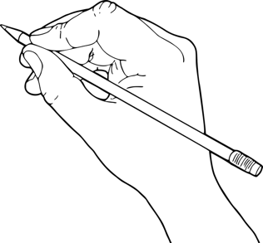

STUDENTS’ OWN ANSWERS

**3. Answer the questions reading the paragraph about Tom, a teenager and his everyday activities. (5x4=20)** E8.2.R1. Students will be able to understand short and simple texts about regular activities of teenagers.

**. (5x4=20p)**

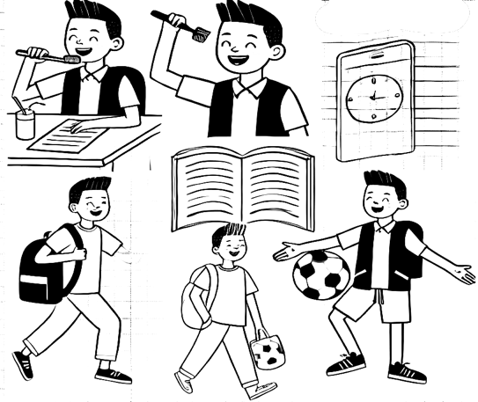

Meet Tom, a teenager with a regular day. He wakes up early every morning. First, he takes a shower and brushes his teeth. Then, he has breakfast and likes to check social media. He walks to school before 8:30 a.m. Tom eats lunch at school at 12:30 p.m. and always chooses healthy food. After school, he plays soccer with friends at 4 p.m. He has dinner at home around 7:00 p.m. In the evening, Tom enjoys playing video games or watching movies. He doesn’t like reading books. On weekends, he loves hanging out at the park with his friends. Tom goes to bed at 10 p.m. Tom believes staying active and having fun keeps him happy.

1. What time does Tom wake up in the morning?

………… Tom wakes up early every morning.………………………………………………………………..…….

2. What does Tom like to check during breakfast?

…………… Tom likes to check social media during breakfast.………………………………………….…….

3. What sport does Tom play after school?

………………… Tom plays soccer with friends after school.……………………………………………………….

4. What does Tom enjoy doing in the evening?

.…In the evening, Tom enjoys playing video games or watching movies.………………………………

5. What does Tom do on weekends?

.…… On weekends, Tom loves hanging out at the park with his friends.………………………….……

**4. Write about your typical day in the life as a teenager. Think about the daily activities you or a friend usually do from morning until night. Think about what time you wake up, what you eat, how you go to school, what sports or hobbies you enjoy, and how you spend your evenings. (30p)** E8.2.W1. Students will be able to write a short and simple paragraph about regular activities of teenagers.

**. (5x4=20p)**

STUDENTS’ OWN ANSWERS



Mahir BARUT ………………………

İngilizce Öğretmeni Okul Müdürü