2025-2026 EĞİTİM ÖĞRETİM YILI
……………………………………………………ORTAOKULU
8th GRADE ENGLISH EXAM
2nd Semester - 1st Exam (Scenario 2) by ingilizcepedia
Name / Surname: ________________________________ | Class: ______ Number: ______
Q1. Read the text and answer the questions. (20 points)

An Exciting Weekend
Last weekend, Mert and his friends went to Antalya for an adventure camp. Mert tried bungee-jumping for the first time. He found it extremely exciting but also challenging. His friend Selin preferred canoeing because she thought it was more entertaining than bungee-jumping. Selin would rather go canoeing than take risks with extreme sports. Mert disagreed — he said extreme sports are more fascinating than regular activities. At the end of the camp, they both agreed that the weekend was amusing and unforgettable.

a) Where did Mert and his friends go last weekend?
___________________________________________________________________________
b) What did Mert try for the first time?
___________________________________________________________________________
c) Why did Selin prefer canoeing?
___________________________________________________________________________
d) What does Mert think about extreme sports?
___________________________________________________________________________
e) How did they describe the weekend at the end?
___________________________________________________________________________

Q2. Read the text and fill in the table. (20 points)

Adventure Club Survey
Deniz joined an adventure club last month. She tried kayaking and found it exciting. She prefers kayaking to skateboarding because kayaking is more challenging. Her friend Arda likes paragliding. He thinks paragliding is less disappointing than motor racing. Arda would rather go hang-gliding than try rafting. Both Deniz and Arda agree that taking risks makes life more fascinating.

Question | Answer
Deniz's favourite activity | ________________
How Deniz feels about kayaking | ________________
Arda's favourite activity | ________________
Arda would rather do (instead of rafting) | ________________
What both friends agree on | ________________

Q3. Read the questions, look at the pictures and write your answers under the correct picture. (20 points)
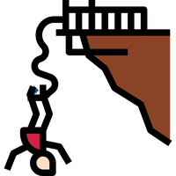  1. b________ | 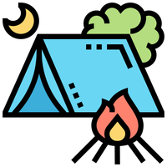  2. c________ | 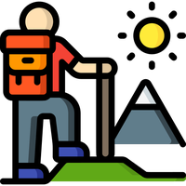  3. h________ | 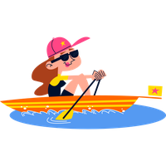  4. k________ |   5. r________
Questions:
• What do you call going down a fast river on a rubber boat?
• What do you call sleeping in a tent in nature?
• What do you call walking a long way in nature for fun?
• What do you call jumping from a high place with an elastic rope?
• What do you call paddling a small boat on water?

Q4. Read the text and answer the questions. (20 points)

A Trip to Cappadocia
Last summer, the Yilmaz family visited Cappadocia, one of the most fascinating destinations in Turkey. They stayed at a bed and breakfast in a rural area. The ancient architecture of the region was incredible. They explored historic sites and walked around the old square in the town centre. Mrs Yilmaz said she would rather visit cultural attractions than stay at an all-inclusive resort. The countryside was peaceful and the landscape was unlike any urban place they had seen before.

a) When did the Yilmaz family visit Cappadocia?
___________________________________________________________________________
b) Where did they stay?
___________________________________________________________________________
c) What was incredible about the region?
___________________________________________________________________________
d) What would Mrs Yilmaz rather do?
___________________________________________________________________________
e) What was the countryside like?
___________________________________________________________________________

Q5. Write a postcard to your friend about a place you visited. (20 points)

You are on holiday in Ephesus (an ancient city in Izmir). Write a postcard to your friend Jack.
• Where are you now?
• What historic sites did you visit?
• What is the architecture like?
• What is your favourite attraction? Why?
• Would you recommend this destination?
_________________________________________________________________________
___________________________________________________________________________
___________________________________________________________________________
___________________________________________________________________________
___________________________________________________________________________
___________________________________________________________________________
___________________________________________________________________________
___________________________________________________________________________

Mahir BARUT ……………………… İngilizce Öğretmeni Okul Müdürü

