8th

Name/Surname: …………………………………….….

Circle your class x below Student No:……………..

No: ……..

Writing & Reading Oturumu (%50) 100/ …………

Speaking (%25) 100/……….…

Listening (%25) 100/ …..….…

|  |  |  |  |  |  |  |  |
| --- | --- | --- | --- | --- | --- | --- | --- |
| **A** | B | C | D | E | F | G | H |

**1- Read the text messages between Elia and Tom. Then write the meanings of the acronyms. (4x5=20p)**



**Ella**: ***OMG!*** I forgot we have a

science quiz today!  
**Tom**: Me too! Let’s study together***ASAP.***  
**Ella**: Good idea! ***CU*** in the library.

**Tom**: ***THX,*** Ella! You’re the best. ☺







**2- Read the paragraph and answer the questions about Niagara Falls. (5x6=30p)**



*Niagara Falls is one of the most*

*famous natural wonders in the*

*world. The best time to visit*

*is between May and September.*

*Visitors can enjoy boat tours close to the falls, walk through beautiful parks, and explore interesting museums. If you want to stay overnight, there are many hotels and guesthouses near the falls. Local dishes include maple syrup pancakes and poutine,*

*a popular Canadian snack. As souvenirs, tourists often buy mini waterfall snow globes, keychains, or postcards to remember their trip.*

**1. What’s the best time to visit there?  
...........................................................**

**2. What are some tourist attractions?  
...........................................................**

**3. Where can visitors stay?  
...........................................................**

**4. What are the traditional dishes?  
...........................................................**

**5. What can we buy as a present?  
...........................................................**

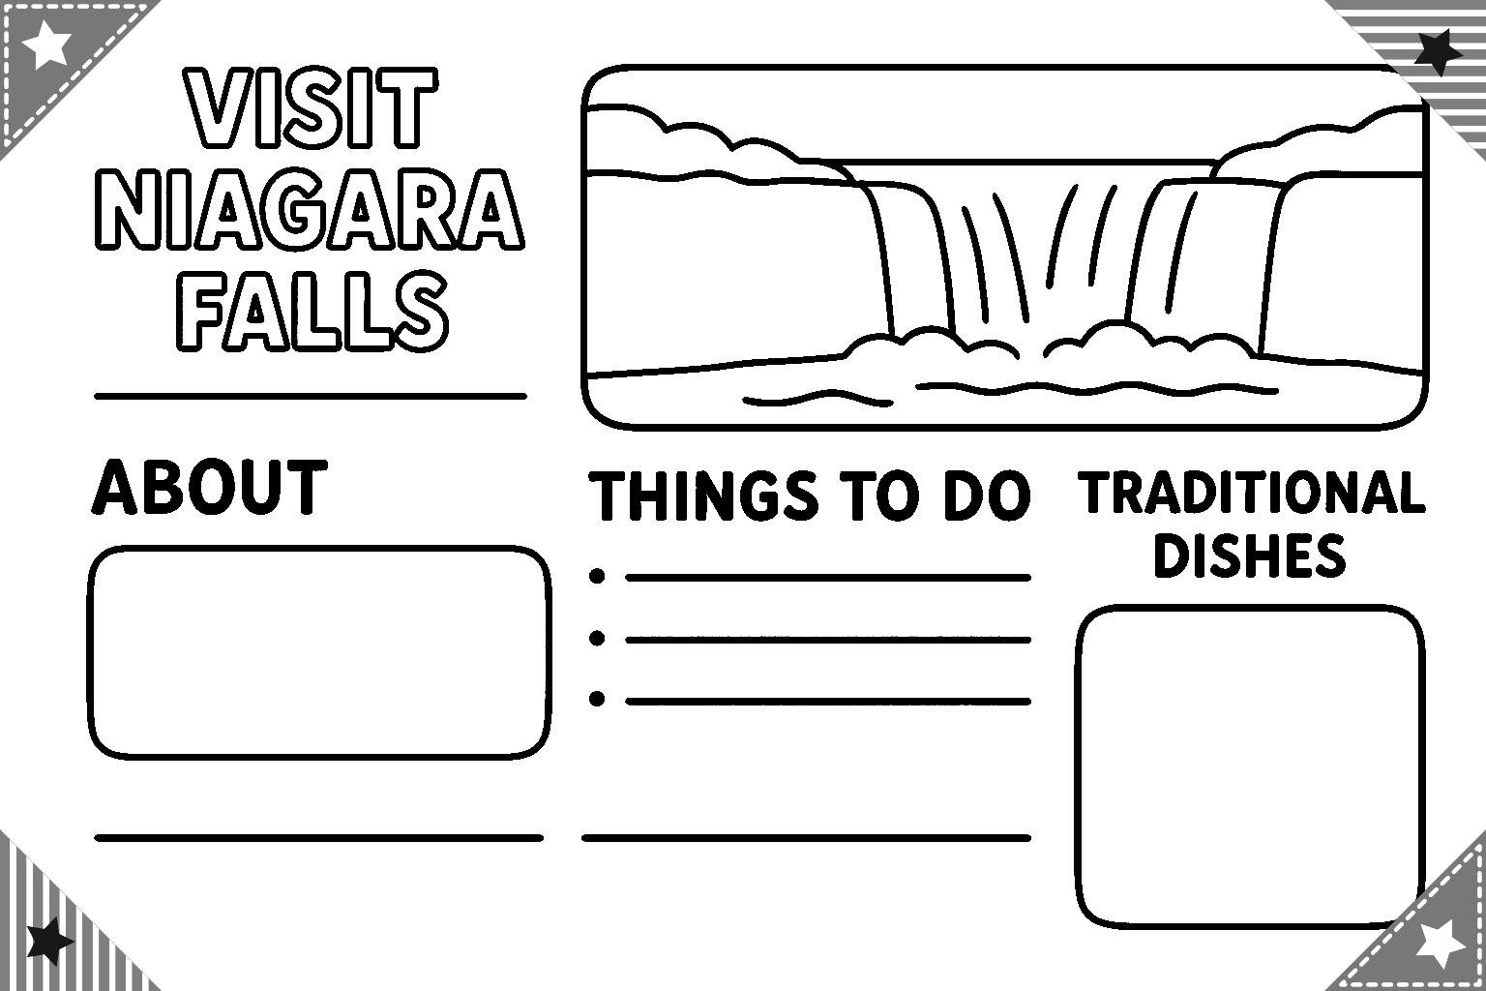

**3- Read the paragraph again about Niagara Falls given above and complete the brochure about it. (15p)**

**\* About (5p)**

**\* Things to do (5p)**

**\* Dishes (5p)**

**4- Read the paragraph carefully. Then, look at the pictures and write the name of the family member who is responsible for each chore shown in the images. ( 5x4=20p)**

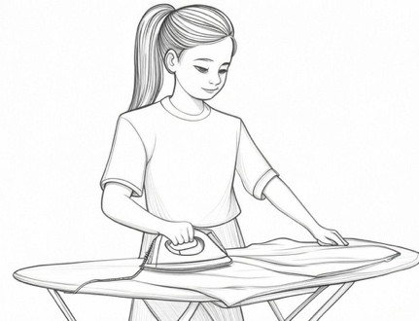

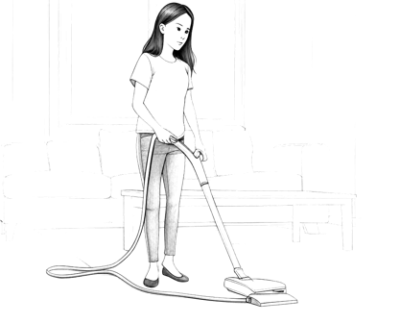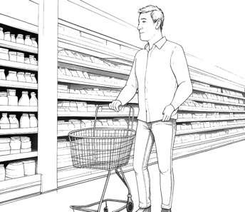

*Hi, I’m Lucas, and I’d like to tell you about how my family shares the chores at home. My mother, Susan, prepares breakfast every morning. My sister, Sara, irons the clothes. My other sister, Theresa, usually vacuums the house because she enjoys using the vacuum cleaner. My father, Scott, does the shopping every Saturday. As for me, I’m responsible for taking the garbage out…*

……………………….

……………………….

……………………….

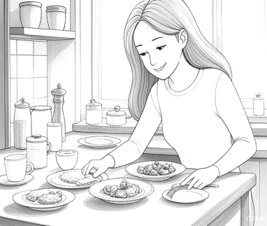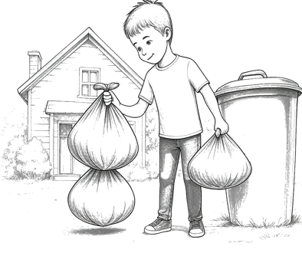

……………………….

……………………….

**5- Read the paragraph below carefully. It tells you about a scientist named Anne L’Huillier. It describes what she is doing now and what she did before. Then, answer the questions that follow. (5x3=15p)**

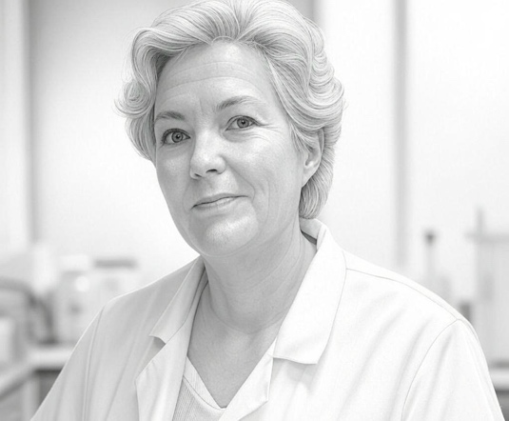

*1. Where does Anne L’Huillier live now?*

*……………………………………………………….*

*2. What did Anne win in 2023?*

*………………………………………………………..*

*3. When did Anne work on laser experiments?*

*………………………………………………………..*

*4. Where does Anne work today?*

*………………………………………………………..*

*5. What did Anne discover in her work?*

*………………………………………………………..*

*Anne L’Huillier is a famous french scientist. She lives in Sweden now. She studies physics. In 2023, she won the Nobel Prize. She discovered attosecond pulses of light..*

*In 1985, she worked on laser experiments with her team. Today, Anne works at Lund University. She is talking to young students at a school.*

Mahir BARUT ……………….. İngilizce Öğretmeni Okul Müdürü