2025-2026 ACADEMIC YEAR
8th
……………………………………………………SECONDARY SCHOOL
8th GRADE 2nd Semester - 2nd Exam (Scenario 1) by ingilizcepedia
Name / Surname: ________________________________ | Class: ______ Number: ______
Q1. Read the text and answer the questions. (20 points)

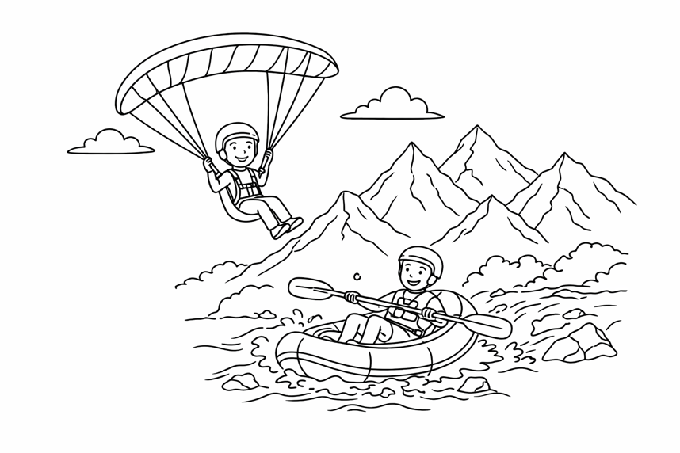
An Adventurous Weekend
Last weekend, Dave and his friends went to Antalya for extreme sports. Dave tried paragliding for the first time. He said it was more exciting than canoeing. His friend Mike preferred rafting because it was more challenging than kayaking. They also watched a motor racing event in the afternoon. Dave would rather go paragliding than do bungee-jumping because he finds bungee-jumping disappointing. Mike thinks rafting is more fascinating than skateboarding. They both agreed it was an entertaining weekend.

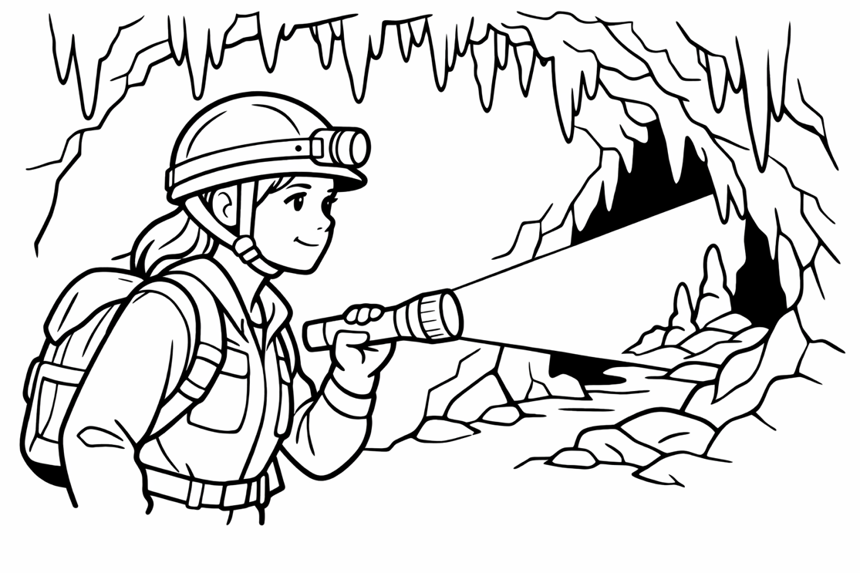
Q2. Read the text and fill in the blanks with the words from the box. (20 points)
a) Where did Dave and his friends go last weekend?
___________________________________________________________________________
b) What did Dave try for the first time?
___________________________________________________________________________
c) Why did Mike prefer rafting?
___________________________________________________________________________
d) Why would Dave rather go paragliding than do bungee-jumping?
___________________________________________________________________________
e) What did they watch in the afternoon?
___________________________________________________________________________
caving / amusing / extreme sports / hang-gliding / take risks / challenging / entertaining
Emma loves adventure. She prefers (1)_________ to other activities because she likes to (2)___________. Last summer, she tried (3)__________ in a deep cave in Cappadocia. It was very dark but really (4)__________. Her brother prefers (5)____________ because flying in the sky is more exciting than walking underground. They both find adventure sports very amusing.
Q3. Look at the table and compare rafting and paragliding. Write at least 5 sentences using comparative adjectives. (20 points)

Compare rafting and paragliding. Use comparative adjectives. Write at least 5 sentences.
___________________________________________________________________________
___________________________________________________________________________
___________________________________________________________________________
___________________________________________________________________________
___________________________________________________________________________
Feature | Rafting | Paragliding
Difficulty | challenging | more challenging
Speed | fast | faster
Place | rivers | mountains
Fun Level | exciting | more exciting
Risk Level | less risky | riskier

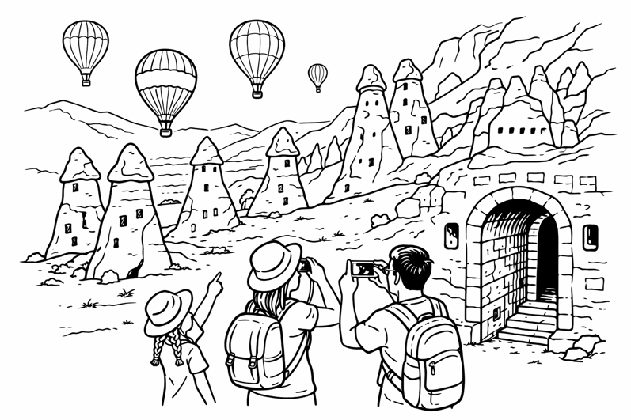
İngilizce Öğretmeni Okul Müdürü
Mahir BARUT ..........................
You are on holiday in a fascinating destination. Write a postcard to your friend Alex. Use the clues below.

• Where are you? (destination, country)
• What is the place like? (ancient, cultural, incredible...)
• What did you visit? (historic site, square, attraction...)
• Where are you staying? (resort, bed and breakfast...)
• How do you feel about the holiday?
___________________________________________________________________________
___________________________________________________________________________
___________________________________________________________________________
___________________________________________________________________________
___________________________________________________________________________
___________________________________________________________________________
___________________________________________________________________________
___________________________________________________________________________
Q5. Imagine you are on holiday. Write a postcard to your friend about a tourist destination. Use the clues below. (20 points)
a) Where did Chris and his family go last summer?
___________________________________________________________________________
b) Where did they stay in Cappadocia?
___________________________________________________________________________
c) What did Chris visit there?
___________________________________________________________________________
d) Why did his mother prefer the countryside?
___________________________________________________________________________
e) What would Chris rather do than go to a resort?
___________________________________________________________________________
Q4. Read the text and answer the questions. (20 points)
A Holiday in Cappadocia
Last summer, Chris and his family visited Cappadocia. It is a fascinating destination in central Turkey. They stayed at a bed and breakfast in a rural area near the town. Chris visited the ancient underground cities and saw incredible architecture. His mother preferred the countryside because it was more peaceful than the urban areas. Chris would rather visit historic sites than go to a resort. The square in the town centre had many cultural attractions. It was an unforgettable holiday.

