**1- Answer the questions according to the text given below (5x4=20p)** E9.5.R1. Students will be able to scan a text for specific information.



Elon Musk is a brilliant inventor from South Africa. He was born on June 28, 1971, in a sunny city called Pretoria. Elon is famous for his creative ideas and works hard to build amazing things.

1.Where is Elon Musk from?

…He is from South Africa……

2. When was Elon born?

…He was born on June 28, 1971….

3. What kind of ideas does Elon have?

…Creative ideas………………..

4.What company did Elon start in 2004?

…He started Tesla in 2004…..

5. What does SpaceX make?

…SpaceX makes powerful rockets…

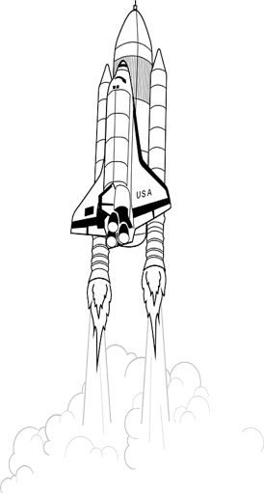

In 2004, he started Tesla, a popular electric car company. He is also the clever leader of SpaceX, a big company that makes powerful rockets. Elon has a curious mind and loves solving difficult problems. His exciting plans include living on Mars one day. He inspires many people with his bold dreams and fearless spirit.

**2- Read the traveler’s opinion and answer the questions given below (5x5=25)** E9.6.R1.Students will able to scan short texts describing some famous cities in the world for specific information.

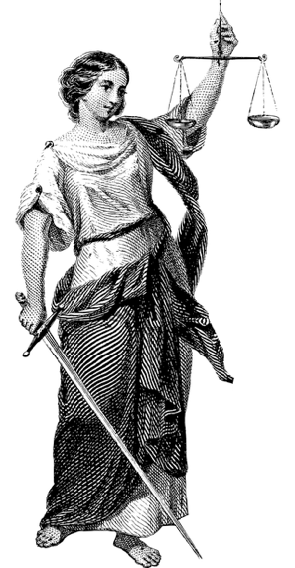

I really like Rome, the capital of Italy. It's a great city with lots of history. Right now it's April, so the weather is getting warm and it's nice to walk around. The city has many old buildings and you can see places like the Colosseum where gladiators used to fight. Lots of people come to visit Rome, but it's still a fun place with no stress. I'm staying close to a busy street with many shops called Via del Corso. It's perfect for buying gifts and trying Italian ice cream called gelato. I also see people making pizza and pasta, which are famous in Italy. And Rome is known for starting the Roman Empire a long time ago. **Lucas Rossi, April 20th**

1.What is the capital of Italy?

Rome is the capital of Italy.

2.What is the weather like in Rome in April?

It is getting warm.

3.What famous ancient building can you visit in Rome?

You can visit the Colosseum

4.Where is a good place to buy gifts in Rome?

Via del Corso

5.What food is Rome famous for?

Rome is famous for its pizza and pasta.

**3- Answer the questions according to the paragraph (4x5=20)** E9.6.R2. Students will be able to get the main points of the informative texts related to intercultural differences.



In our language school, I, Maria, meet new friends from all around the world. A friend from Japan showed me how to bow when we say hello. This is different from shaking hands, which we do in my country. At lunch, my friend from Italy shared her pasta with me. I shared my rice with her. I eat rice a lot at home. On our school board, everyone puts up pictures of their favorite holidays. I saw pictures of Diwali. He is from India. It has lots of lights and colors. An American friend showed pictures of Fourth of July parades. I like learning about these different customs. It shows me how special and interesting every culture is

1.Where does Maria meet her international friends?

… At the language school.

2. How does Maria's friend from Japan greet people?

… Maria's friend from Japan greets people by bowing,

3. What did Maria's friend from Italy share with her for lunch?

… Maria's friend from Italy shared pasta with her for lunch.

4. What festival did Maria learn about from her Indian friend?

.. Maria learned about the festival of Diwali from her Indian friend.

**4- You are in a holiday with your family. Your friend got a movie ticket for you. You have to write a message to your family before leaving the Hotel. This is the image of your ticket below. Now, write a message at the reception desk for your family. Let them know why you left the hotel and where you will be. (15p)** E9.6.W1. Students will be able to leave a short written message for their parents at the reception desk.



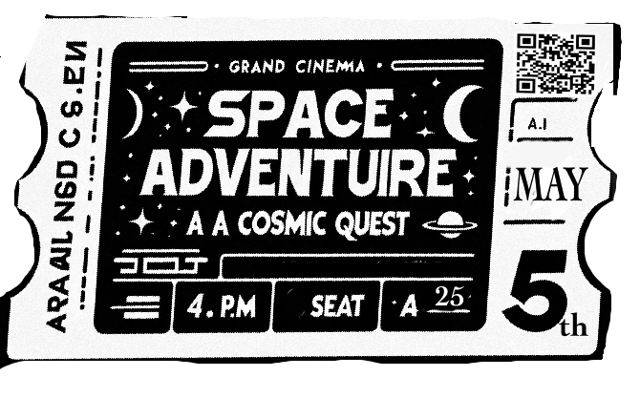

*Hi Mom and Dad,*

*I’m going to the 4 p.m. showing of 'Space Adventure' at the Grand Cinema. I'll make sure to head back right after it finishes. My phone is with me, so just call or text if you need to. Don’t worry, I’ll be safe.*

*See you after the movie!*

*Tom*

**THIS IS JUST AN EXAMPLE: STUNDENTS’ OWN ANSWERS NEEDED**

**5- Answer the questions according to the paragraph (4x5=20)** E9.7.R1.Students will be able to ask and answer the questions about a text related to the world heritage

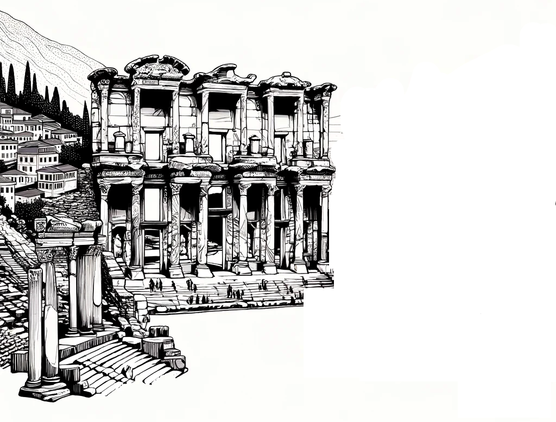

Hi, I'm John from the USA. Last summer, I visited Ephesus in Turkey and it was amazing. First, I saw the Library of Celsus. It's a big, beautiful building. It was a library a long time ago. Then, I went to the Great Theatre. It's huge! It could hold 25,000 people in the past. After that, I saw the Temple of Artemis. It's mostly ruins now, but it was interesting. I also walked through the Terrace Houses. They have pretty mosaics and paintings. I saw the Hadrian Temple too. It's a small temple for an old Roman emperor. Lastly, I visited the Ephesus Museum. There were many old statues and coins.

1.Where is John from?

He is from the USA.

2.What did John see in the Terrace Houses? He saw pretty mosaics and paintings.

3.What was the first place John visited in Ephesus?

It was the Library of Celsus.

4. Which museum did John visit at the end of his trip?

the Ephesus Museum.

Mahir BARUT …………………. İngilizce Öğretmeni . Okul Müdürü