2025-2026 ACADEMIC YEAR
………………………………………………………………………HIGH SCHOOL
9th GRADE 2nd Semester - 2nd BEP Exam by ingilizcepedia
Name / Surname: ______________________________ Class: _______ Number: _______

Q1. Resimlere bakın ve kutudaki doğru kelimeyi yazın. (5x5=25 points)
(Look at the pictures and write the correct word from the box.)

bungalow / kitchen / sofa / fridge / garden

1.   | 2.  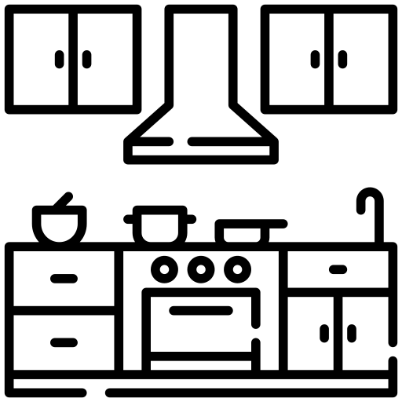 | 3.   | 4.  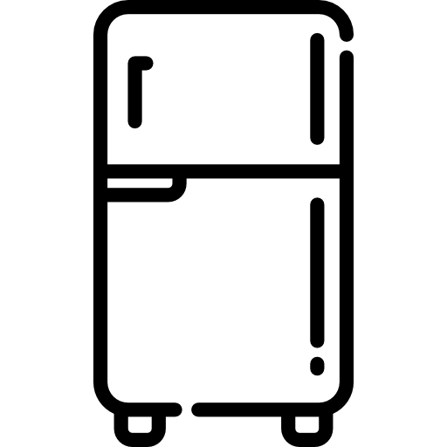 | 5.  
___________ | ___________ | ___________ | ___________ | ___________

Q2. Metni okuyun ve Doğru (T) veya Yanlış (F) yazın. (5x5=25 points)
(Read the text and write True (T) or False (F).)

My House
Hi, I'm Ayşe. I live in a detached house with a beautiful garden. My house has four rooms: two bedrooms, a kitchen, and a living room. I usually cook dinner in the kitchen. Right now, I am watching TV in the living room. My mother is cooking in the kitchen.

# | Sentence | T / F
1 | Ayşe lives in a flat. | ( )
2 | Her house has a garden. | ( )
3 | There are four rooms in her house. | ( )
4 | Ayşe is cooking dinner now. | ( )
5 | Her mother is in the kitchen. | ( )

Q3. Boşlukları kutudaki doğru kelimeyle doldurun. (5x5=25 points)
(Fill in the blanks with the correct word from the box.)

am / is / are / lives / cooks

# | Sentence
1 | She ___________ in a small cottage. (yaşıyor / lives)
2 | I ___________ watching TV now. (şu anda / am)
3 | My parents ___________ in the kitchen right now. (şu anda / are)
4 | He ___________ dinner every day. (her gün / cooks)
5 | My mother ___________ reading a book in her bedroom. (şu anda / is)

Q4. Doğru cevabı seçin. A, B veya C'yi daire içine alın. (5x5=25 points)
(Choose the correct answer. Circle A, B or C.)

# | Question
1 | Where _______ you live?  A) do B) is C) are
2 | My brother _______ playing computer games right now.  A) are B) is C) do
3 | The sofa is _______ the window.  A) in B) on C) next to
4 | _______ is the Orange Festival held? — In Türkiye.  A) Where B) What C) How
5 | I like _______ food because it is hot and has pepper.  A) sweet B) spicy C) cold
İngilizce Öğretmeni Okul Müdürü
Mahir BARUT .........................

