Değerlendirme:

Writing & Reading Oturumu 50/100: …………

Speaking & Listening Oturumu:50 /100 …..….…

Sınav notu 100/100 …………. ……..….

Name/Surname: …………………………………….….

Circle your class x below Student No:……………..

No: ……..

|  |  |  |  |  |  |  |  |
| --- | --- | --- | --- | --- | --- | --- | --- |
| **A** | B | C | D | E | F | G | H |

**1- Read the text and create a time line with dates and events.. (5x5=25) E10.3.R1. Students will be able to scan a short story to fill in the timelines with events and dates.**

Mustafa Kemal Atatürk, the visionary leader and first President of the Republic of Turkey, orchestrated a series of transformative reforms that left an indelible mark on the nation's history. Following the end of World War I, Atatürk led Turkey through a challenging period of change. In 1923, he founded the Republic of Turkey, officially proclaimed on October 29th, and became its first President. Over the next decade, Atatürk implemented a range of progressive reforms. In 1930, he established the Central Bank of the Republic of Turkey, solidifying the foundation for a stable and modern economic system. In 1924. He introduced a new European-inspired legal code. In 1928, he initiated the adoption of the Latin alphabet, replacing the Arabic script, to enhance literacy and communication. Atatürk granted women the right to vote and run for office in 1934, making Turkey one of the first countries in the world to grant full suffrage to women. His tireless efforts to modernize Turkey's political, social, and economic structures have left an enduring legacy, and his passing in 1938 marked the end of an era, with Atatürk's vision continuing to shape the nation's identity to this day.

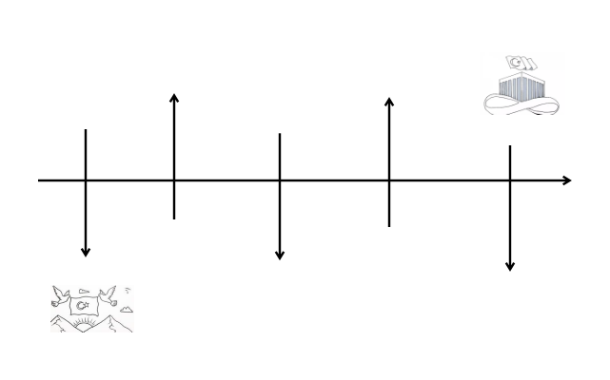

women the right to vote

the Latin alphabet

1930

1023

1938

1934

the Republic of Turkey

1928

Atatürk passed away,

the Central Bank of the Republic of Turkey

**2 Make two sentences about luck and unlucky moments using “when” or “while. (5x2=10) E10.3.S2. Students will be able to retell a story by describing characters and places.**

My lcuky moment: Students’own answer

My unlucky moment: Students’ own answer

**3. Read the unfinished story below and write an ending for it. Consider the forest in the picture and remember that Jadav Payeng, the hero of the story, has a fame as a legendary forest man in India. The verbs in box may be of help. (15p) E10.3.W1. Students will be able to write the end of a given unfinished story.**

(save, make, challange, look after, begin, live, bring back, come back, generations )

Once upon a time in a little village, there was a farmer named Jake. One day, he got a mysterious map that pointed to the Crystal Cave in the Whispering Woods. Feeling brave, Jake decided to go on an adventure.

With his wooden sword, Jake traveled through forests, crossed rivers, and climbed mountains. He met magical creatures and solved tricky riddles. The map helped him overcome challenges, and he learned that being clever and brave was important.

After a few days, Jake reached the entrance of the Crystal Cave. Inside, he found a cool place with glowing crystals guarded by a big dragon. Jake fought the dragon and won! The people inside the cave were happy.

Jake came out with a bag of special crystals, each with its own magic. When he went back to his village, everyone thought he was a hero. The crystals brought good luck, and the village became better.

So, the farmer Jake turned into a famous hero. People in the village always remembered his bravery and the cool crystals he brought back. And they all lived happily ever after.

Students’own answer………… a One day, as Jake was enjoying the peaceful life in the village, a messenger arrived with urgent news. The Whispering Woods were in trouble, and the magical balance that Jake had restored was under threat. Without hesitation, Jake grabbed his trusty sword and the remaining enchanted crystals. He knew that the Crystal Cave held the key to preserving the harmony of the woods.Returning to the familiar path, Jake faced new challenges along the way. The creatures he once befriended now sought his help……..etc

**4. Write 5 habits you used to do when you were a child. (5x3=15p)** E10.4.S2. E10.4.W2. Students will be able to write the things they used to do when they were children.

**. (5x4=20p)**

1. … Students own answers
2. …
3. …
4. ..
5. …

**5. Read the comparison paragraph on Indonesian and Malaysian traditions and answer the following questions. (15p)** E10.4.R1. Students will be able to answer the questions about short texts on social, educational, and technological lives of people in the past around the world**.**

1 - What is the topic sentence? Greece and Turkey, neighboring countries with rich histories, share diverse yet distinctive clothing and food traditions

2 – Write four signal words: Often, Also, Both, like

3- What are the similarities? Both nations boast Mediterranean-inspired cuisines with Greek dishes like moussaka and Turkish delights from Turkey

Greece and Turkey, neighboring countries with rich histories, share diverse yet distinctive clothing and food traditions. In Greece, traditional attire often includes toga-like garments during cultural events, reflecting ancient influences. Similarly, Turkish clothing, influenced by the Ottoman era, embraces a variety of styles with vibrant colors and intricate patterns. Both nations boast Mediterranean-inspired cuisines with Greek dishes like moussaka and Turkish delights from Turkey, each featuring unique spices and flavors. The cultural richness in clothing and food highlights the distinct charm of these neighboring nations.

**6. Read the texts below and answer questions. (5x4=20p)** E10.4.R2. Students will be able to identify the differences between the lifestyles and customs of people in the past and the ones in the 21st century in a written text**.**

1. How did people in the past in Alaska connect with nature, and what were some of their traditional activities?
2. How does life in the 21st century in Alaska differ from the past, considering the blend of traditional practices and modern technologies?
3. How has technology impacted communication and transportation in Alaska in the present day?
4. What challenges do people in Alaska face in the 21st century, particularly concerning changes in the weather and the environment?

1. in Alaska connected with nature by engaging in activities like hunting, fishing, and communal gatherings, adapting to the challenges of the cold environment.

2. Life in the 21st century in Alaska is a mix of old traditions and new technologies. While some still rely on traditional ways of living off the land, others use modern tools and gadgets.

3.Technology has made communication and travel easier in present-day Alaska, influencing the way people connect with each other and access resources.

4. People in Alaska face challenges in the 21st century, including dealing with changes in the weather and the environment. The impact of climate change is one of the new challenges that the community must address.

Mahir BARUT ………………………

İngilizce Öğretmeni Okul Müdürü