10th

ANSWER KEY

**1- Read Look at the percentage lines in the diagram given below and write what they stand for according to the text. (4x5=20p)**

**(5x5=25)**

**Healthy Habits for Students**

Many students have habits. Some habits are good and some are not. Reading books helps many students relax. According to our survey, 82% of students say that reading is an effective way to manage stress. Eating a healthy breakfast is also important. Starting the day with breakfast helps you think better and learn more. 70% of students say that having breakfast helps them perform better in school. Getting enough sleep is crucial for health and doing well in school. 95% of students agree that sleeping well makes them more effective during the day. However, being social is important too, but 56% of students find it hard to find time to spend with friends because they are so busy. These habits can help you feel better and do better in school.

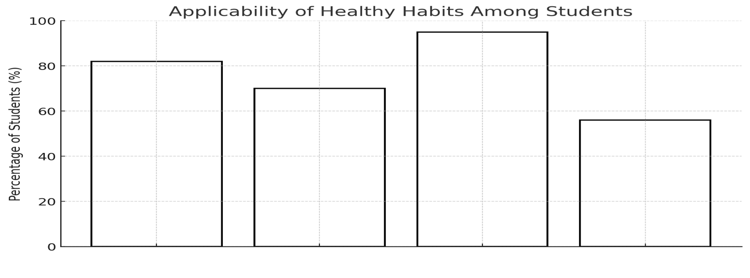

……BEING SOCIAL..

……SLEEPİNG……………..

……BREAKFAST……..

……READING……..

**2 Describe yourself ( including family and habits) in a short descriptive paragraph with the help of the guiding questions given below. (30p)**

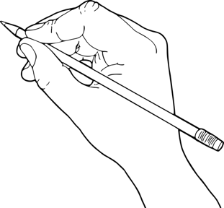

* What do you usually do in a day? Tell us about your typical day from morning to night.
* Who are the people in your family? What do they do, and what do you like to do together?
* What are three words that describe you well? Why do you choose these words?

STUDENTS’ OWN ANSWERS

**3. Answers the questions according to the paragraph about Anakin Skywalker given below. (5x5=25p)**

**. (5x4=20p)**

Anakin Skywalker is an ambitious student with a clear vision for his future. He loves the thrill of flying and is going to become a pilot. After he graduates from school next year, he is going to travel extensively to explore different cultures around the world. He plans to start his travels with a trip to Europe, where he hopes to visit historical sites and learn new languages.

In addition to traveling, Anakin is studying hard to pass all his exams with excellent grades, as he knows this is crucial for his career in aviation. He is also working part-time at a local bookstore, saving every penny to fund his travels. Anakin is excited about his future and is determined to make his dreams a reality.

1. What career is Anakin planning to pursue?

…A Anakin is going to become a pilot.

2. What does Anakin plan to do after graduating from school?

… After graduating, Anakin is going to travel extensively to explore different cultures around the world.

3. Where does Anakin plan to start his international travels?

… He plans to start his travels with a trip to Europe.

4.Why is Anakin working part-time at a local bookstore?

…. Anakin is working part-time to save money to fund his travels.

**4. Write an opinion paragraph about your plans after high school. (30p)**



Mahir BARUT ………………………

İngilizce Öğretmeni Okul Müdürü