**1- Write under the pictures what Lila feels or thinks (5x7=35p)** E6.5.R1. Students will be able to understand general meaning in simple texts related to the feelings and personal opinions about places and things.

This weekend, Lila goes to a carnival with her friends. She thinks the carnival is amazing! Lila loves the roller coaster—it’s exciting and fun. The Ferris wheel is fantastic; she feels happy up high. But the ghost trains are boring for Lila. She thinks they’re not scary, just dull. She doesn’t like the clowns—they look scary! The bumper cars are funny, and Lila laughs a lot. She thinks the carnival is a great place.

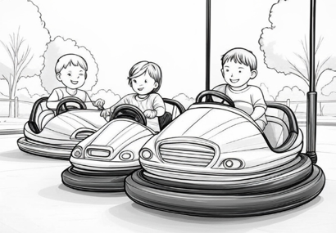

….They look scary….

…They are funny…

…They are boring…

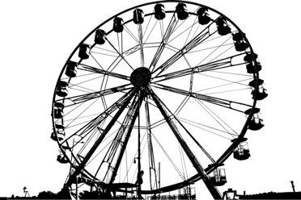

…..It is fantastic…..

…it’s exciting and fun…

**2- Answer the questions according to the dialogue (3x5=15p) E6.6.R1.** Students will be able to understand familiar words and simple sentences about occupations and the dates.

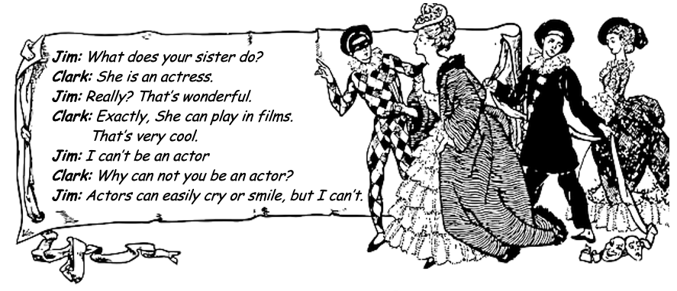

1.What can an actress do? ………She can play in films….…….

2.What does Clerk’s sister do? ………She is an actress.……………

3. Can Jim be an actor? …………He can’t……………………………

**3- Write the missing information about David, Tom and Sarah according to the paragraph given below. (5x6=30p) E6.6.R1.** Students will be able to understand familiar words and simple sentences about occupations and the dates.

Hello. I'm David. I was born on 15th of March, 1985. I'm a teacher. I was at the school yesterday, but I'm not at work today. This is my brother, Tom. He was born in London in 1992. He is a waiter. This is my sister, Sarah. She was born on 8th September, 1998. She is an engineer. She was in Paris in July, but she is in London now.



Name: …David..

Birth Date: 15th of March 1985

Occupation: Teacher

Name: ..Tom..

Birth Date: …1992…

Occupation: …Waiter

Name: …Sarah….

Birth Date: 8th September, 1998

Occupation: ..Engineer…

**4- Answer the questions according to the paragraph about Jack (5x4=20p) E6.6.W1.** Students will be able to produce a piece of writing about occupations and the dates.

I’m Jack. I was born on 15th May, 1992. I’m a mechanic. I like my job. I work five days a week at a car care service. My work begins at 9 o’clock in the morning and finishes at 7 o’clock in the evening. I can repair your car and machines.

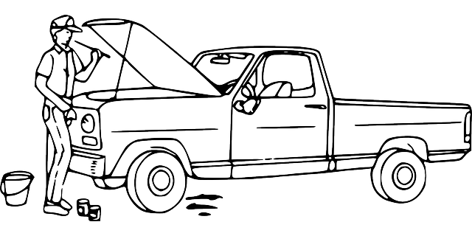

1.When was he born? ……15th May, 1992…………….

2.How many days does he work a week? ………five days.……

3.How many hours does he work a day? …………10 hours…

4. What can he do? ……………He can repair your cars…….

Mahir BARUT ……………….

İngilizce Öğretmeni Okul Müdürü