6th

Writing & Reading Oturumu (%50) 100/ …………

Speaking (%25) 100/……….…

Listening (%25) 100/ …..….…

Name/Surname: …………………………………….….

Circle your class x below Student No:……………..

No: ……..

|  |  |  |  |  |  |  |  |
| --- | --- | --- | --- | --- | --- | --- | --- |
| **A** | B | C | D | E | F | G | H |

**1- Write under the pictures what Lila feels or thinks (5x7=35p)**

This weekend, Lila goes to a carnival with her friends. She thinks the carnival is amazing! Lila loves the roller coaster—it’s exciting and fun. The Ferris wheel is fantastic; she feels happy up high. But the ghost trains are boring for Lila. She thinks they’re not scary, just dull. She doesn’t like the clowns—they look scary! The bumper cars are funny, and Lila laughs a lot. She thinks the carnival is a great place.



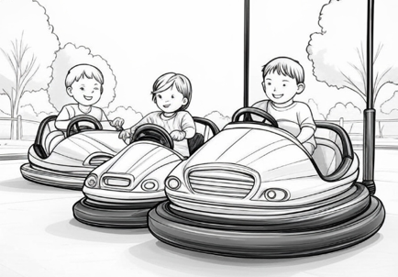

…………………………….

…………………………….

…………………………….

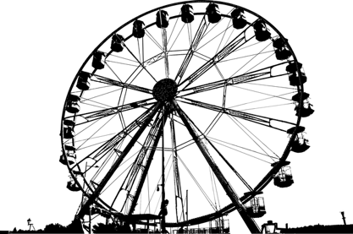

…………………………….

…………………………….

**2- Answer the questions according to the dialogue (3x5=15p)**

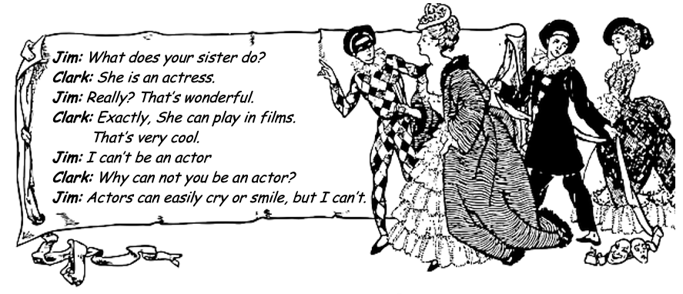

1.What can an actress do? ……………………………………………………….

2.What does Clerk’s sister do? ………………………………………………………

3. Can Jim be an actor? ………………………………………………………

**3- Write the missing information about David, Tom and Sarah according to the paragraph given below. (5x6=30p)**



Hello. I'm David. I was born on 15th of March, 1985. I'm a teacher. I was at the school yesterday, but I'm not at work today. This is my brother, Tom. He was born in London in 1992. He is a waiter. This is my sister, Sarah. She was born on 8th September, 1998. She is an engineer. She was in Paris in July, but she is in London now.

Name: Sarah

Birth Date: ……..…………

Occupation: ………….……..

Name: Tom

Birth Date: ……..…………

Occupation: ………….……..

Name: David

Birth Date: ……..…………

Occupation: ………….……..

**4- Answer the questions according to the paragraph about Jack (5x4=20p)**

I’m Jack. I was born on 15th May, 1992. I’m a mechanic. I like my job. I work five days a week at a car care service. My work begins at 9 o’clock in the morning and finishes at 7 o’clock in the evening. I can repair your car and machines.

1.When was he born? ……………………………………………..…………….

2.How many days does he work a week? ………………………….….

3.How many hours does he work a day? ……………………………….

4. What can he do? ………………………………………………………………..

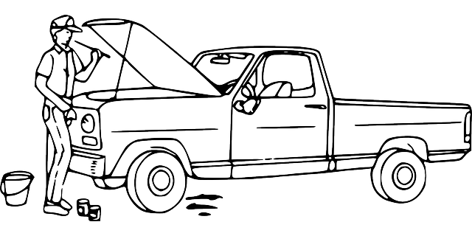

Mahir BARUT ……………….. İngilizce Öğretmeni Okul Müdürü