7th

Değerlendirme:

Writing & Reading Oturumu 50/100: …………

Speaking & Listening Oturumu:50 /100 …..….…

Sınav notu 100/100 …………. ……..….

Name/Surname: …………………………………….….

Circle your class x below Student No:……………..

No: ……..

|  |  |  |  |  |  |  |  |
| --- | --- | --- | --- | --- | --- | --- | --- |
| **A** | B | C | D | E | F | G | H |

**1- Read paragraph about Ana and her family and answer the questions (5x5= 25p)** E7.1.R1. Students will be able to understand a simple text about appearances, personalities, and comparisons including explanations and reasons.

**(5x5=25)**

Hello! My name is Ana. I have got long, black, curly hair and big, brown eyes. My best friend is Lily. Lily has got short, brown hair and green eyes. I am very quiet and shy, but Lily is talkative and funny. People say I am creative because I like to draw and paint. I never like to be in loud places. Lily is very smart and good at solving puzzles. She is also generous, always sharing her things with others. I think Lily is funnier than me, but I am more artistic. We both have got hobbies. I like to read books and Lily likes to play games. Lily hates waiting, and she is never late. I am optimistic about everything, but Lily can be a bit stingy sometimes.

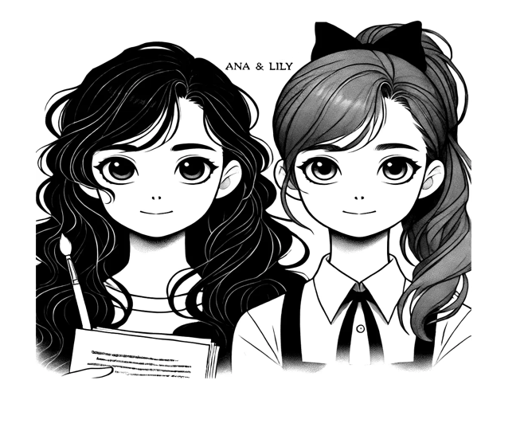

1. What type of hair does Ana have?

Ana has got long, black, curly hair.

2. What is Lily' like?

Lily is talkative and funny.

3. What does Lily hate?

Lily hates waiting.

4. What hobby does Ana enjoy?

Ana likes to read books.

5. What color are Lily's eyes?

Lily has got green eyes.

**2 After reading the paragraph answer the questions that follow. Each question will ask you to compare different family members. (5x5= 25p)** E7.1.W1. Students will be able to write simple pieces to compare people.

Hello! I want to tell you about my family. My name is Emma. My mom has got long, straight black hair and big brown eyes. She is very kind. My brother, Jake, has got short, curly black hair. He is younger than me but taller. My dad is not very tall, but he is stronger than Jake. He has got a short beard and always wears glasses. He is smart and fun. I think my mom is prettier than my aunt, but my aunt is more outgoing than my mom. Everyone says I look like my dad because I have got glasses too and short hair.

1. Who is taller, Emma or her brother Jake?

Jake is taller than Emma.

2. Who is stronger, Emma's dad or her brother Jake?

Emma's dad is stronger than Jake.

3. Who is prettier, Emma's mom or her aunt?

Emma's mom is prettier than her aunt.

4. Who is more outgoing, Emma's mom or her aunt?

Emma's aunt is more outgoing than her mom.

5. Who does Emma look like more, her dad or someone else?

Emma looks like her dad.

**3. Read the paragraph about the Turkish National Women's Volleyball Team carefullya and answer the questions given below. (4x5=20p)** E7.2.R1. Students will be able to understand short and simple texts on sports.

**. (5x4=20p)**



The Success of the Turkish National Women

The Turkish National Women's Volleyball Team is a great team. They won the European Championship in 2019. These strong women have different backgrounds, but they all play together. They teach us about teamwork and determination. They begin their training with stretching in the morning. They practice four times a week. They always eat healthy meals to stay strong. They train hard and with a lot of energy.

Challenges can happen in life, but we can solve them. If we have dreams and work hard, we can achieve anything. The Turkish National Women’s Volleyball Team shows how to live without giving up.

1. Who won the European Championship in 2019?

The Turkish National Women's Volleyball Team won the European Championship in 2019.

2. What do they do first in their training?

They begin their training with stretching in the morning.

3. How often do they practice each week?

They practice four times a week.

4. What kind of food do they always eat?

They always eat healthy meals to stay strong.

**4. Write about your daily morning routine. Use frequency adverbs like 'always,' 'usually,' 'sometimes,' and 'never' in your sentences. You should use 5 sentences min. (5x6= 30p)** E7.2.W1. Students will be able to write pieces about routines/daily activities by using frequency adverbs.

**. (5x4=20p)**

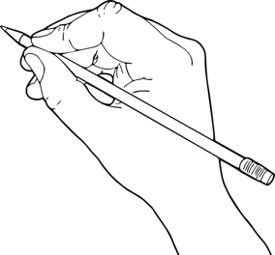

STUDENTS’ OWN ANSWERS

Mahir BARUT ………………………

İngilizce Öğretmeni Okul Müdürü