**1- Find what Tom and Anna prefer watching, then write which days they are watching them in the table according to the paragrapg given below. One is done for you (5x4=20p) E7.5.R1.** Students will be able to understand simple texts about daily routines and preferences

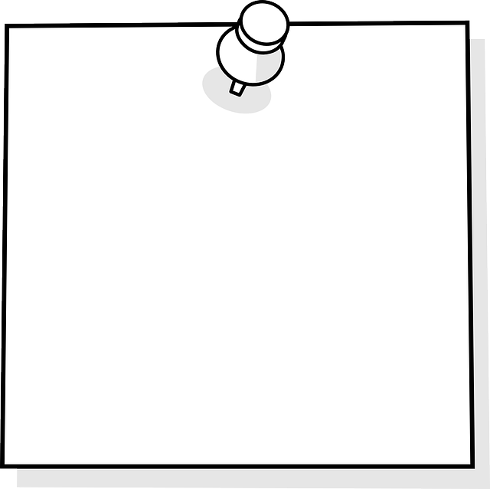

On Mondays, Anna watches TV series because she likes exciting stories, but Tom prefers documentaries because he thinks Mondays should be calm. On Tuesdays, Anna enjoys comedy movies because they make her laugh, but Tom watches cartoons because he likes funny characters. On Wednesdays, Anna likes talk shows because the people are interesting, but Tom chooses news because he wants to know what’s happening. This is how they enjoy their week!

***ANNA TOM***

|  |  |  |
| --- | --- | --- |
| Documentary |  | Monday |
| TV Series | Monday |  |
| Comedy | Tuesday |  |
| Cartoon |  | Tuesday |
| Talk Show | Wednesday |  |
| News |  | Wednesday |

**2- Answer the questions according to the paragraph below. (5x4=20p) E7.5.R2**. Students will be able to understand simple texts about past events.

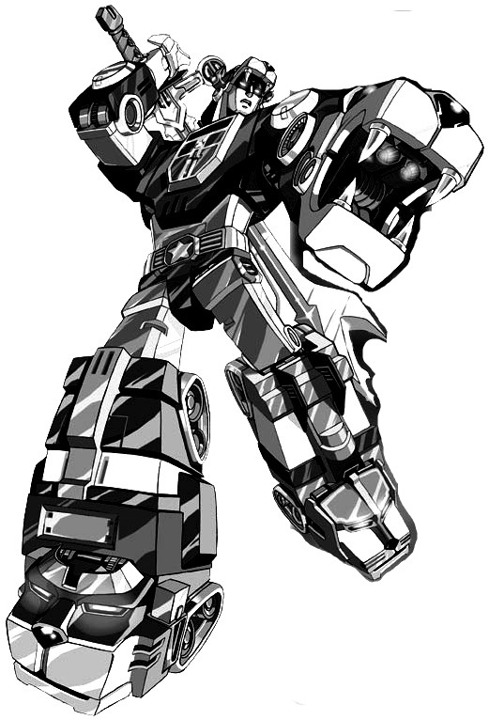

Many years ago, in 1984, a cartoon called 'Voltron: Defender of the Universe' started on TV. It was about five pilots. They lived on the planet Arus. They had big robot lions and fought bad aliens. The pilots worked together and made one giant robot called Voltron. They saved planets from King Zarkon, an evil leader. Kids loved the show because it had exciting battles. It stopped in 1985 because the story ended, but people still remember it today.

1.When did "Voltron: Defender of the Universe" start on TV?

……………………in 1984…………………………………….…………

2. Where did the pilots live?

…………………On the planet Arus…………………………………

3. What did the pilots use to fight the aliens?

…………………………Big robot lions…………………………………

4. Who was the evil leader in the show?

…………………………King Zarkon………………………………………

5. Why did the cartoon stop in 1985?

……………………Because the story ended…………………………

**3- Answer the questions according to the paragraph below. (5x3=15p) E7.6.R1.** Students will be able to understand texts about celebrations.

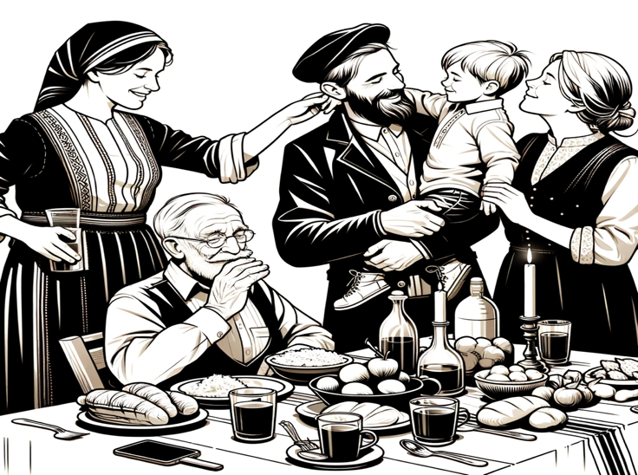

Ramadan Feast in Turkey is a special time. It comes after Ramadan month. People fast in Ramadan. They do not eat or drink from sunrise to sunset. After Ramadan, they have the Ramadan Feast. It lasts three days. Families visit each other. They eat good food. Children get gifts and candies. It is a happy time for everyone.

1. When does the Ramadan Feast start?

…………It starts after Ramadan month…………….

2. How long does the Ramadan Feast last?

……………………It lasts three days…………………….

3. What do families do during the Ramadan Feast in Turkey?

……They visit each other and eat good food…………….

………………Children get gifts and candies………………………….

**4- Answer the questions according to the party invitation below. (5x4=20p) E7.6.R1.** Students will be able to understand texts about celebrations.

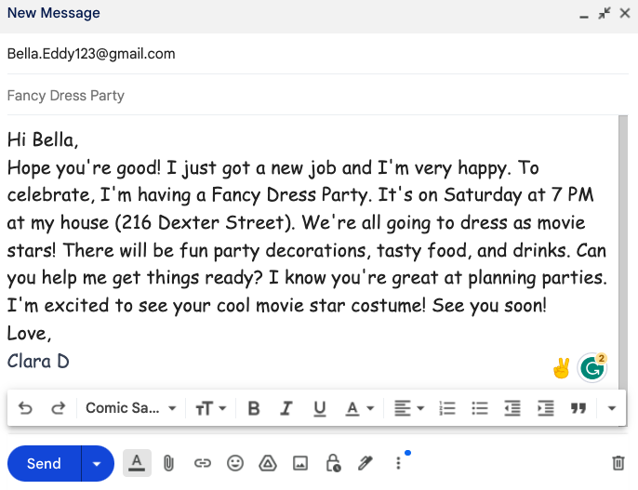

1.Who has a Fancy Dress Party?

………………Clara D……………………………….

2. Where is the party?

………Clara’s house, 216 Dexter Street….

3. Who invited Bella?

……………………Clara………………………….

4. Who is good at planning a party?

……………………Bella………………………….

5. Who will wear a movie star costume?

………………………Bella ………………………….



**5- Guess what kind of part it is and make an invitation card according to the picture. (5x5=25p) imaginary date, time, place and a P.S. E7.6.W1.** Students will be able to write invitation cards.

GRADUATION

DATE: 28 MAY

TIME: 5pm

PLACE: Willmort Cafe

PS: Remember to bring your smile and good cheer. We will take lots of photos!

Mahir BARUT ……………….. İngilizce Öğretmeni Okul Müdürü