**1- Write a short paragraph about the internet habits given for Emily, Jack and Sarah in the chart below (5x4=20p) E8.5.R2. Students will be able to find specific information about the Internet in various texts.**





The Internet has many exciting firsts. Ray Tomlinson sent the first email in 1971. He wrote a simple message to himself. That same year, a virus called Creeper appeared and moved between computers. After that, 11 years later, in 1982, Scott Fahlman created the first smiley :-) to show happy feelings online. Then, in 1994, Justin Hall started the first blog and wrote about his life. These moments made the Internet fun and famous!

4.Who started the first blog?

1.Who sent the first email?

Justin Hall

Ray Tomlinson



5.What did Justin Hall write about in his blog?

2.What year did the first virus appear?

His life

In 1971



3.When did Scott Fahlman create the first smiley?



In 1982

**2- Write a short paragraph about the internet habits given for Emily, Jack and Sarah in the chart below (6x5=30p)** E8.5.W1. Students will be able to write a basic paragraph to describe their internet habits.

**Emily Jack Sarah**



|  |  |  |  |
| --- | --- | --- | --- |
| Checking Social Media | √ |  |  |
| Watching Videos | √ | √ | √ |
| Doing online shopping |  | √ |  |
| Reading news |  |  | √ |

**3- Answer the following questions according to the interview (5x4=20) E8.6.R1.** Students will be able to understand short and simple texts to find the main points about adventures.

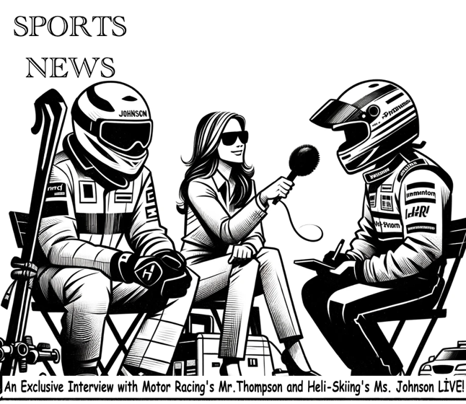

**Reporter:**  Motor racing is very exciting, Mr. Thompson. Why do you do it, and what is your best race? What is the biggest danger?

**Mr. Thompson:** I like the speed and racing against others. When I drive, I feel like I'm flying. My best race was in Monaco last year. I won it. But motor racing can be dangerous. The biggest danger is crashing at high speed.

**Reporter:**  What is heli-skiing, Ms. Johnson? What does someone need to know to start? How dangerous is it?

**Ms. Johnson:** Heli-skiing is skiing on fresh snow that we reach by helicopter. You need to be good at skiing on different kinds of snow. It's quite dangerous because the mountains can be unpredictable and far from help.





1. **How does Mr. Thompson feel when he's racing?**

Mr. Thompson feels like he's flying when he's racing.

1. **What is the biggest risk in motor racing?**

The biggest risk in motor racing is crashing at high speed.

1. **What do heli-skiers use to reach the top of the mountain for skiing?**

Heli-skiers use a helicopter to reach the top of the mountain for skiing.

1. **What skills should someone have before they start heli-skiing?**

Someone should be good at skiing on different kinds of snow

1. **How dangerous is heli-skiing, according to Ms. Johnson?**

It is quite dangerous because the mountains can be unpredictable and far from help.

**4- Fnd who prefers which adventure and fill in the in adventure cards according to the dialogue (name=2p, adventure=2p, reason=6p - 3x10=30p in total )** E8.6.W1. Students will be able to write a short and simple paragraph comparing two objects.

**Mike:** Hey, do you like hot air-balloon rides? **Sara:** No, I prefer jeep safaris in the desert because they're more adventurous. **Mike:** I see. I like hot air-balloon rides because seeing the world from up high is more amazing. **Sara:** I understand, but air ballons can be very dangerous. **Kevin:** For me, climbing Mount Everest is more exciting because it's more challenging.

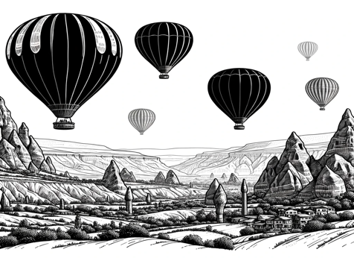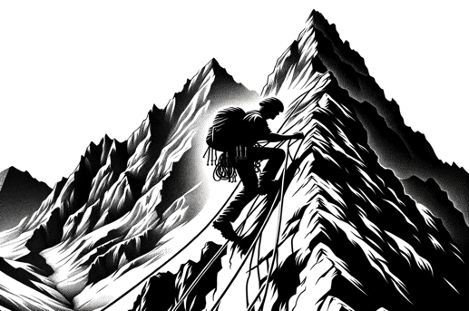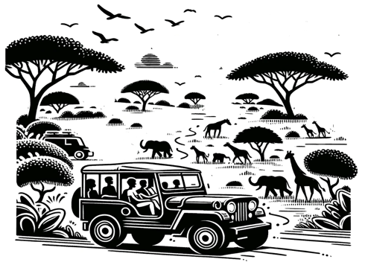

Name: ……Sara……..

Adventure: …Jeep Safari

Why do you prefer this adventure? because they're more ……… .adventurousi ………………….

Name: …Kevin…….

Adventure: …Climbing..

Why do you prefer this adventure?

because it's more challenging ………………………………………………….

Name: …Mike…….

Adventure: Hot air-ballon

Why do you prefer this adventure?

because seeing the world from up high is more amazing ………..

Mahir BARUT ……………….. İngilizce Öğretmeni Okul Müdürü