8th

Name/Surname: …………………………………….….

Circle your class x below Student No:……………..

No: ……..

Writing & Reading Oturumu (%50) 100/ …………

Speaking (%25) 100/……….…

Listening (%25) 100/ …..….…

|  |  |  |  |  |  |  |  |
| --- | --- | --- | --- | --- | --- | --- | --- |
| **A** | B | C | D | E | F | G | H |

**1- Write a short paragraph about the internet habits given for Emily, Jack and Sarah in the chart below (5x4=20p)**





4.Who started the first blog?

The Internet has many exciting firsts. Ray Tomlinson sent the first email in 1971. He wrote a simple message to himself. That same year, a virus called Creeper appeared and moved between computers. After that, 11 years later, in 1982, Scott Fahlman created the first smiley :-) to show happy feelings online. Then, in 1994, Justin Hall started the first blog and wrote about his life. These moments made the Internet fun and famous!

1.Who sent the first email?

……………………………

……………………………



5.What did Justin Hall write about in his blog?

2.What year did the first virus appear?

……………………………

……………………………



3.When did Scott Fahlman create the first smiley?

……………………………

**2- Write a short paragraph about the internet habits given for Emily, Jack and Sarah in the chart below (6x5=30p)**

**Emily Jack Sarah**



|  |  |  |  |
| --- | --- | --- | --- |
| Checking Social Media | √ |  |  |
| Watching Videos | √ | √ | √ |
| Doing online shopping |  | √ |  |
| Reading news |  |  | √ |

**3- Read the blog and answer the following questions.. (5x4=20)**

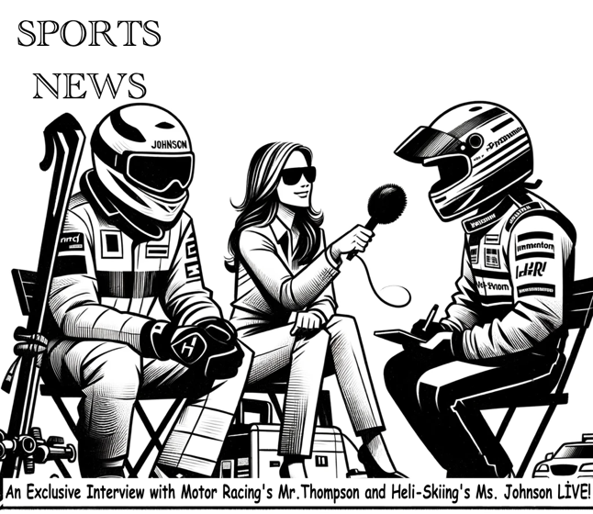

**Reporter:**  Motor racing is very exciting, Mr. Thompson. Why do you do it, and what is your best race? What is the biggest danger?

**Mr. Thompson:** I like the speed and racing against others. When I drive, I feel like I'm flying. My best race was in Monaco last year. I won it. But motor racing can be dangerous. The biggest danger is crashing at high speed.

**Reporter:**  What is heli-skiing, Ms. Johnson? What does someone need to know to start? How dangerous is it?

**Ms. Johnson:** Heli-skiing is skiing on fresh snow that we reach by helicopter. You need to be good at skiing on different kinds of snow. It's quite dangerous because the mountains can be unpredictable and far from help.





1. **How does Mr. Thompson feel when he's racing?**

………………………………………………………………………………………………………………………………………….

1. **What is the biggest risk in motor racing?**

………………………………………………………………………………………………………………………………………….

1. **What do heli-skiers use to reach the top of the mountain for skiing?**

………………………………………………………………………………………………………………………………………….

1. **What skills should someone have before they start heli-skiing?**

………………………………………………………………………………………………………………………………………….

1. **How dangerous is heli-skiing, according to Ms. Johnson?**

………………………………………………………………………………………………………………………………………….

**4- Fnd who prefers which adventure and fill in the in adventure cards according to the dialogue (name=2p, adventure=2p, reason=6p - 3x10=30p in total )**

**Mike:** Hey, do you like hot air-balloon rides? **Sara:** No, I prefer jeep safaris in the desert because they're more adventurous. **Mike:** I see. I like hot air-balloon rides because seeing the world from up high is more amazing. **Sara:** I understand, but air ballons can be very dangerous. **Kevin:** For me, climbing Mount Everest is more exciting because it's more challenging.

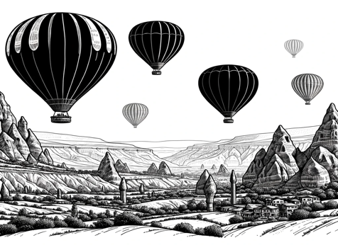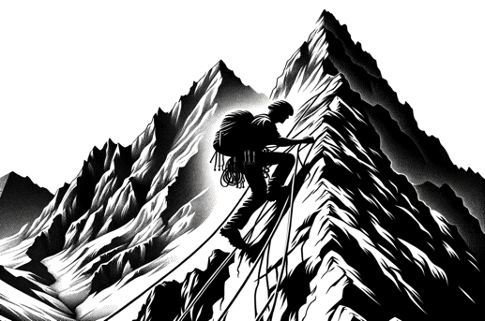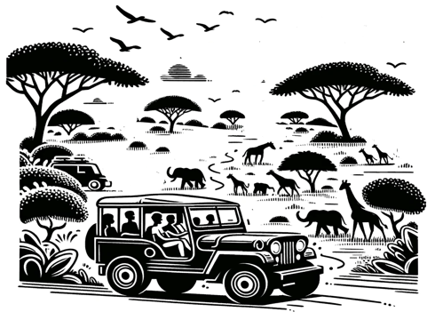

Name: ………………….

Adventure: …………………..

Why do you prefer this adventure? ……………………………………………………………………………..

Name: ………………….

Adventure: …………………..

Why do you prefer this adventure? ……………………………………………………………………………..

Name: ………………….

Adventure: …………………..

Why do you prefer this adventure? ……………………………………………………………………………..

Mahir BARUT ……………….. İngilizce Öğretmeni Okul Müdürü