9th

ANSWER KEY

**1- Answer the questions according to the postcard given below (4x5=20)**



1. Which country is Emily visiting?

…She is visiting France………..

2. What language is spoken in the country that Emily is visiting?

…………French……………..

3. What is the nationality of someone from the country Emily is visiting?

……………French……………………

4. What did she see there?

……………The Eiffel Tower………………….

**2. Imagine you are going to England to take an English course this summer, and one of your friends lives in London. Email him or her to get the information you need before you arrive. (30p)**

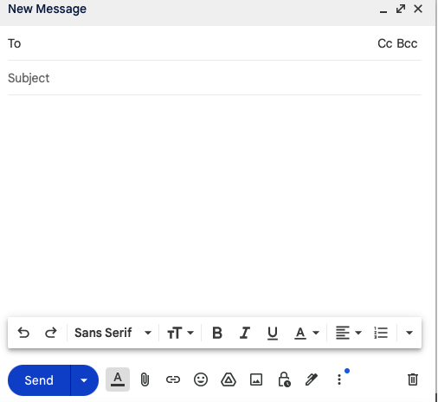

1. start with a greeting. (6p)

2. introduce yourself. (6p)

3. ask questions. (6p)

4. keep your message short (6p)

5. end with a sign-off. (6p)

Students’ own answers

**3. Answer the questions according to the paragraph given below ( 26p)**

1. Where does Anakin live? (5p)

… Anakin lives near the central park….

2. What can you watch at the theatre? (5p)

…You can watch plays and musicals at the theatre…

3. What is there next to the theatre? (5p)

… There is a library is next to the theatre….

4. What is located near the library? (5p)

… There is a small café near the library…

5. How far are the restaurants from the park? **(5p)**

… he restaurants are a five-minute walk from the park…

Hello, my name is Anakin. I live near the central park in my neighborhood. There is a theatre across from the park where you can watch plays and musicals. Next to the theatre, there is a library where many people from here go to study and read. There is also a small café by the library where students and teachers often meet for a snack and to chat. Several restaurants are located near the river, just a five-minute walk from the park. The park itself is big and right next to the river. You can play or relax there. If you come to our city, you should visit these places.

**4. Write the key characteristics of the three cities listed in the chart according to the text (12x2=24p)**

Welcome to my travel journey where I explore some of the world's most iconic cities! Today, I want to talk about three fascinating cities: Istanbul, Rome, and Tokyo. Istanbul, a bustling metropolis in Turkey, is home to over 15 million people. You can visit historic places like Hagia Sophia and the Grand Bazaar there. The weather in Istanbul is mild, with an average temperature of about 14 degrees Celsius. Rome, located in Italy, has about 2.8 million residents. It is famous for its historic landmarks such as the Colosseum. Rome enjoys a slightly warmer climate, with an average temperature of 16 degrees Celsius. Tokyo, a vast and vibrant city in Japan, also has more than 14 million inhabitants. It features modern skyscrapers and historic temples like Senso-ji. Tokyo's climate is similar to Rome's at 16 degrees Celsius on average, but it feels different because it is more humid. Each city offers unique sights and experiences.



|  |  |  |  |
| --- | --- | --- | --- |
| **Category** | **Istanbul, Turkey** | **Rome, Italy** | **Tokyo, Japan** |
| Population | 15 millon | 2.8 millon | 14 millon |
| Main Attractions | Hagia Sophia and the Grand Bazaar | the Colosseum | Senso-ji. |
| Average Temperature | 14 degrees Celsius | 16 degrees Celsius | 16 degrees Celsius |

Mahir BARUT …………………. İngilizce Öğretmeni Okul Müdürü