**1. Write the possibile questions and answers according to the text “The Pyrmaids of Egypt” given below. (4x5=20p) E9.7.R1.Students will be able to ask and answer the questions about a text related to the world heritage.**

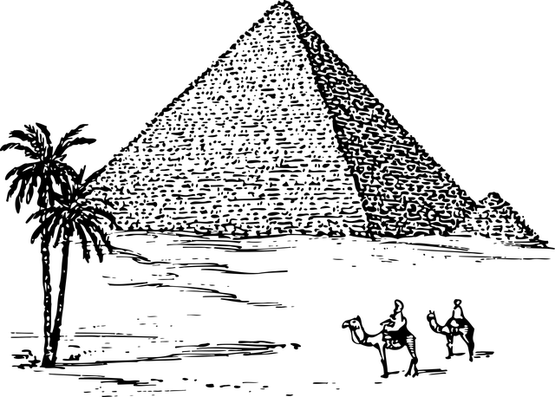

**The Pyramids of Egypt**  
The Pyramids of Egypt are in Giza. They are very old. They are 4,500 years old. People made them for kings. The big pyramid is the Great Pyramid. It is for King Khufu. It has 2 million stones. People used ropes to move the stones. Many tourists visit the pyramids. They like to see the old stones. They learn about Egypt.

1. Where are the Pyramids of Egypt?

…. The Pyramids of Egypt are in Giza……………..

2. How many stones are in the Great Pyramid?

…. The Great Pyramid has 2 million stones……….

3. How old are the Pyramids of Egypt?.....................

The Pyramids of Egypt are 4,500 years old.

4. Why do tourists visit the pyramids?......................

Tourists visit the pyramids to see the old stones

**2. Read the passages and write the main ideas of the passages in 1-2 sentences. Use your own words. (2x5=10p) E9.8.R1. Students will be able to find the main idea of a text about health problems/emergency situations that have happened recently.**

In April 2025, big floods have hit Kentucky in the USA. The water has come from the Ohio River. It has made many roads and houses wet. Some people have been in danger because the water is very high. Many families have moved to safe places. Volunteers have given food and water to people. The floods have been a big problem for Kentucky. People have worked together to stay safe and clean up the water.

In March 2025, many people in Brazil have had COVID-19 again. This virus makes people sick. They have a high fever and a bad cough. Some people also have a sore throat. Doctors have worked a lot to help. They have given medicine to sick people. They have told everyone to stay home and wear masks. COVID-19 has been a big problem in Brazil this year. People are scared, but they have started to feel better with the doctors’ help.

COVID-19 has made people in Brazil sick with fever and cough ………………………………………………………………………….

Big floods from the Ohio River in Kentucky in April 2025 have made life hard. …………………………………………………..

**3. Read the passage "Health Rules at School." You will create a poster about health rules at school to help students stay healthy (20p) Include the followings. E9.8.W1. Students will be able to prepare posters/leaflet/brochures about safety and health at work.**

* Write a title (5p)
* Include the three health tips (5p)
* Add one reason (5p)
* Use simple and clear language (5p)

STUDENTS’ OWN ANSWERS



Following health rules at school helps everyone stay safe and happy. Students should wash their hands with soap before lunch and after playing outside to stop germs from spreading. It’s also important to eat healthy snacks like apples or carrots instead of candy, so you have energy for learning. Another good rule is to cover your mouth with a tissue when you cough or sneeze, so you don’t make others sick. These rules are easy to follow and make school a better place for everyone.

**4.** **Read the passage "Carnival in Brazil: A Famous Festival." Find four supporting ideas that explain why Carnival in Brazil is famous or special (4x5=20p). E9.9.R1. Students will be able to find the supporting ideas in a text.**

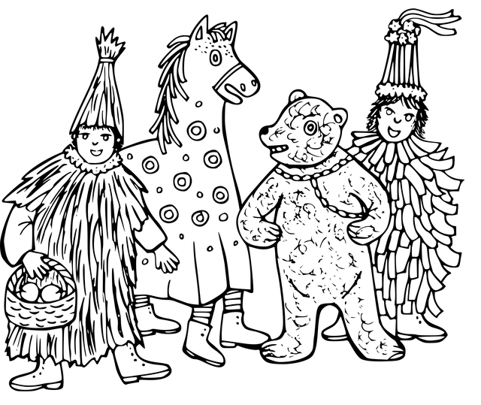

Carnival in Brazil is one of the most famous festivals in the world, held every year in February or March. People love it because of its exciting street parades with colorful costumes and big floats. The festival is also famous for its lively samba music, which makes everyone dance and feel happy. Another reason Carnival is special is the huge crowds—millions of people from Brazil and around the world join the celebration. Finally, it’s a time for fun traditions, like wearing masks and throwing confetti, which create a joyful atmosphere for everyone.

1. Carnival has exciting street parades with colorful costumes and big floats.

2. The festival is famous for its lively samba music that makes everyone dance.

3. Huge crowds of millions of people from Brazil and around the world join Carnival.

4. Carnival has fun traditions like wearing masks and throwing confetti.

**5.** Everyone has dreams and plans for the future. Maybe you want to be a doctor, travel the world, or learn a new skill. Write a short paragraph about your future plans. (3x10=30p) **E9.9.W2.Students will be able to write a short paragraph about their future plans.**



• One or two things you want to do in the future (e.g., a job, a hobby, or a place to visit). (10p)

• Why you want to do these things (e.g., because it makes you happy, or it’s your dream). (10p)

• What you will do to achieve your plans (e.g., study hard, save money).10p)

Mahir BARUT …………………. İngilizce Öğretmeni . Okul Müdürü